General Information for Hillcrest Terrace Facility Use



***Event Confirmation:***

Events are scheduled on a first-come, first served basis. A date can be reserved at the Fullerton Community Center (FCC) upon completion of a signed contract and collection of a deposit totaling to 50% of the rental fees. The remaining 50% of the rental fees will be due 60 days prior to the event date. All refundable deposits are due no later than 30 days prior to the event.

***Staff Fees:***

***Staff Fee $25/ hr per staff***

FCC requires 1 staff member to be on site during event rentals. All other set-up and clean-up will be the responsibility of the renter(s) and their vendors. Facility maintenance will be provided by the on-site Center Staff and include maintaining restrooms, and deposing of the trash at the end of the evening.

***Catering Options:***

***Kitchen Fee $20***

Gives renters access to the kitchenette located inside Hillcrest Recreational Building. Kitchenette includes refrigerator, sink with counter space. Home-made food is permitted.

***On Site Cooking***

Hillcrest Terrace allows on-site cooking equipment to be used in a pre-zoned parking lot location near the Red Cross Building. Detailed instructions with a list of guidelines and an outlined map will be provided.

***Alcohol Guidelines:***

***Alcohol Fee $150***

The City of Fullerton will allow the use of alcohol under controlled circumstances. The event is responsible for obtaining all necessary State of California beverage control licenses. All alcohol must be served to persons over the age of 21 and by a **certified bartender**. These documents must be submitted to and approved by FCC’s Facility Rental office. The service of alcohol is limited to a maximum of 4 hours. No glass bottles are to be served to any guests at any time.

***Security Guards:***

***$22/hr per guard***

A security guard is required for all events with alcohol service and will be ordered by FCC. Guard is required to be present upon guest arrival, and stay until the end of clean-up time.

***Rental & Security Damage Deposits:***

Below listed refundable security damage deposits may be required, and if so, will be due 1 month prior to the event date.

***Terrace $150:*** Returned if no damage is done to the property, space is left cleaned, and rental is completed on time.Rental time frame must be adhered to, setting up at the facility earlier than what I stated on your contract will result in a deduction of your security deposit.

***Music $250:*** Returned if music is kept to a decibel of less than 55 and the police are not called. Music must end by 9:00 pm.

***Alcohol $500:*** Returned if there are no issues related to alcohol, and the Police Department is not called or needed throughout the event duration.

Tables and chairs are not provided by the City of Fullerton.

714.738.6575 | fullertoncommunitycenter.com

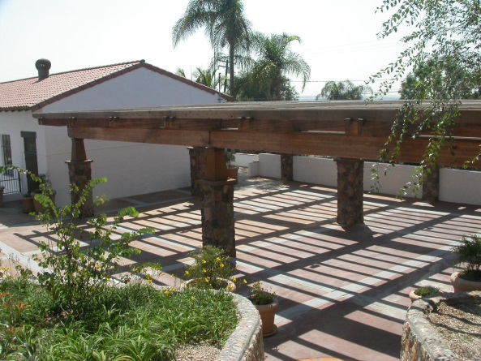

Hillcrest Terrace

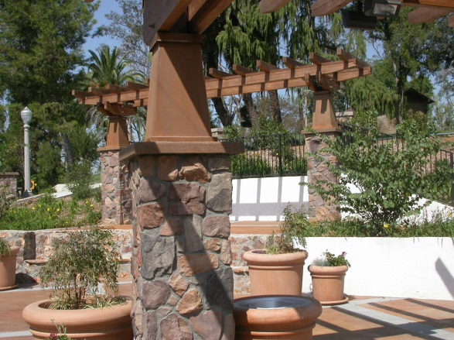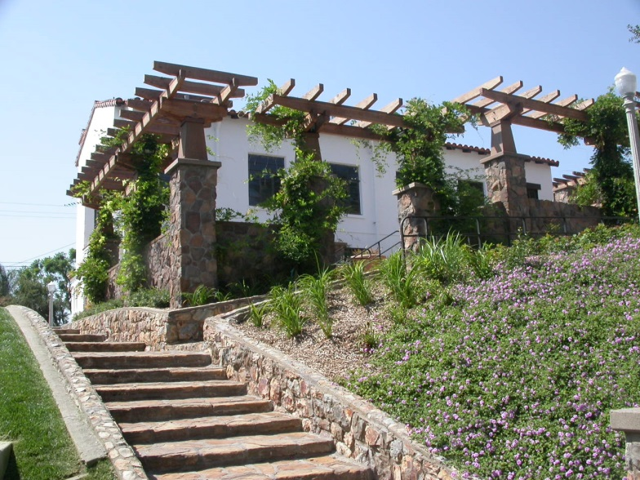

**The Hillcrest Terrace is one of the City of Fullerton’s most historic park locations. Saturday’s are rented in blocked times. All other days are rented on an hourly basis with a 2 hour minimum and 5 hour maximum. Terrace rentals must be completed and cleaned up by 10pm Monday-Saturday with amplified music off by 9pm, and completed by 6pm on Sunday’s. 30 minutes of complimentary set-up and tear-down time is provided with all hourly rentals.**

|  |  |  |
| --- | --- | --- |
| ***Hillcrest Terrace Pricing:*** | | |
| ***Blocked Time &***  ***Hourly Options*** | ***Fullerton***  ***Resident*** | ***Non-Residents***  ***or Groups*** |
| **Sat: 11am-3pm Block** | **$500** | **$670** |
| **Sat: 3pm-10pm Block** | **$1,050** | **$1,350** |
| **Mon-Thurs Hourly** | **$50** | **$60** |
| **Fri/ Sun Hourly** | **$75** | **$90** |

***Additional Fees:***

**· Staff Fee $25/hr per staff**

***(1 Parks and Recreation staff member required for all Terrace rentals)***

**· Kitchen Fee $20**

**· Alcohol Fee $150**

**· Security Guards $22/hr per guard**

***(Required for all events with alcohol)***

**· Refundable Security & Cleaning Deposit $150**

**· Refundable Music Deposit $250**

**· Refundable Alcohol Deposit $500**

714.738.6575 | fullertoncommunitycenter.com