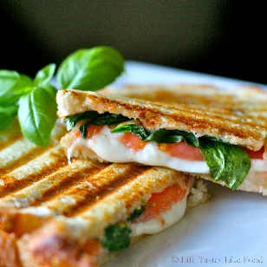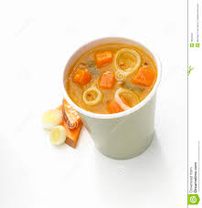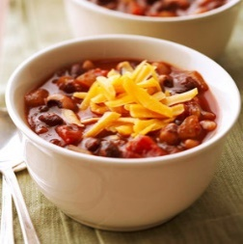

**Salad Choices  
Bistro Salad - Fruit Salad – Antipasti Salad - Cranberry Pecan Chicken Salad\***

**Soup Choices  
Tomato - Chicken, Veggie, Rice – Broccoli Cheddar – Loaded Potato* – Vegetarian Chili – Chili – Mac and Cheese**

**Sandwich Choices  
Apple Walnut Chicken Salad -Three Grilled Cheese -BLT - Breakfast Sandwich - Cheese and Apple – Ham and Bacon – Reuben – Cuban - Turkey Pesto**

**Side Choices  
Chips – Loaded Potato Salad* – Sautéed Vegetables – Fresh Fruit – Yogurt**

**Breakfast Buffet 7.00 Soup and Salad Buffet 9.00 Salad and Sandwich 10.00   
Includes: Includes: Includes:**

**Assorted Pastries and Toast One choice of salad One choice of Salad  
Eggs, Bacon, Sausage Up to two choices of Soup Up to 3 choices of Sandwiches  
Home fries Sliced Garlic Bread One Choice of Side  
Fresh fruit and Yogurt**

**Specialty Bars (Prices vary) Deluxe Buffet 12.00  
Options Include: Includes:   
-Pastry Bar -Appetizer Bar One choice of Salad  
-Salad Bar -Baked Potato Bar Up to two choices of Soup  
 – Chicken/Beef Fajita Bar Up to three choices of Sandwiches  
 One Choice of Side**

**Drink options include: (Prices Vary) - Free water – Pitchers of Lemonade, Tea, Coffee, - Box of Joe (Single Serve drinks available separately**

**\*Choices include .50 cent upcharge – Prices are per person, 8 person minimum – Gluten Free options available**

315-218-6066 wholelygrounds@gmail.com 4845 West Seneca Turnpike

**Deliciously Fresh Catering Menu: Made Just For YOU**

**Breakfast ~ Lunch ~ Dinner**

Wholely Grounds