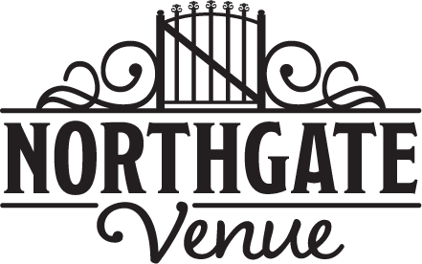

Thank you for considering **NorthGate Venue** for your special occasion. **NorthGate Venue** is a beautiful canvas, perfect for any décor. Our floor-to-ceiling windows offer the perfect amount of natural lighting, the shades allow you to control both lighting and privacy. Our venue is 3600 square feet of open floor space and will accommodate 180 guest with plenty of room for dancing, dinning, fellowship and entertainment.

You can rent **Northgate Venue** by the hour or select a package. Hourly rates include tables, chairs and the use of the kitchenette area; linens are priced at $10 per table. Packages include tables, chairs, white linens and the use of the kitchenette area. There is a $100 nonrefundable Booking Deposit required to hold your date and the rental fee must be paid in full two months before your event. Last minute bookings (less than two months to event date) need to be paid in full at the time of booking.

**Sunday**

**Northgate Venue** is $60 an hour on Sunday or we can offer you the following packages:

7am - 3pm $350

4pm - 12am $475

All-Day 7am - 12am $750

**Monday –Thursday**

**Northgate Venue** is $50 an hour on weekdays or we can offer you the following packages:

7am - 3pm $250

4pm - 12am $325

All-Day 7am - 12am $623

**Friday**

**Northgate Venue** is $65 an hour on Friday or we can offer you the following packages:

7am - 3pm $350

4pm - 12am $550

All-Day 7am - 12am $750

**Saturday**

**Northgate Venue** is $95 an hour on Saturday or we can offer you the following packages:

7am - 3pm $575

4pm - 12am $800

All-Day 7am - 12am $1275

If you are interested in booking the Venue for the entire weekend or multiple days for special events please contact our office for special pricing. It will be our pleasure to work with you.

In addition to our rates we do charge a refundable security deposit, the amount is set according to your event and can range between $100 and $250. This is to insure there is no damage to the venue, and guests follow guidelines.

Alcohol restrictions do apply. Contact our office for more details.

**Northgate Venue - 129 Vandiver Drive, Lincolnton NC 28090 - 704.452.7333**

**Email: info@northgatevenue.com www.northgatevenue .com**