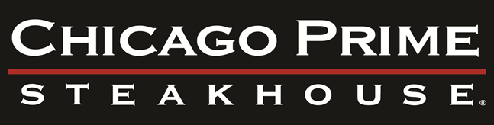

**CHICAGO PRIME STEAKHOUSE PRIVATE DINING FACTS**

* Liquor, Wine, & Beer is charged per consumption
* Award winning wine selections available, ask your event coordinator
* Complimentary valet service, coat check, Wi-Fi
* Customized temperature, lighting and audio controls in private dining room

(All A/V needs are guest’s responsibility, referrals available upon request)

* Live entertainment in the Lounge (Tuesday – Saturday) cover charge not required
* A **$500 non-refundable deposit** is required to book a private room; deposit is deducted from the final bill on the day/evening of your event
* Current sales tax will automatically be added to final bill
* Final payment is due at the conclusion of your event

(Personal or business checks cannot be accepted as final payment)

* For tax-exempt groups, tax-exempt letters must be provided one week prior to event
* Menu selections, bar options, rentals, any changes to contract and/or menu, and additional information must be finalized one week prior to event
* Due to health codes, only food & beverages provided by Chicago Prime Steakhouse may be served at your event. Outside food or beverage may not be brought into the restaurant. You may bring in a cake from a licensed bakery. (**Cake cutting fee $2 per person**).
* Menu selections and prices are subject to change due to market conditions and availability
* Guaranteed final count must be provided **1 week** prior to event
* Lunch events are available for larger groups
* Food & beverage minimum applies (subtotal) per private room
* 3% Banquet Fee on Every Event

Room Capacity

**Walnut Room**  **State Room**

Maximum: 32 people ($1500 Minimum) Maximum: 35 people ($1500 Minimum)

**Walnut & State Room** **Main Dining Room**

Maximum: 85 people ($3000 Minimum) Maximum: 130 people

* Please note: Floor plan options may change capacity of room.

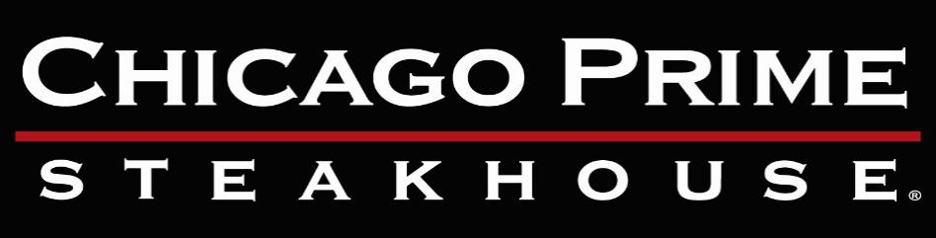

Appetizer Package

**Priced Per Piece**

Bruschetta ($2 per Piece)

Spinach Pies ($3 per Piece)

Fried Calamari ($13 per Order)

Tenderloin Sliders ($6 per Piece)

Crab Cake Sliders ($6 per Piece)

Stuffed Mushroom Caps ($5 per Piece)

Sweet and Sour Egg Rolls ($3 per piece)

Chicken Skewers ($5 per Piece)

Mini Beef Wellington ($6 per Piece)

Assorted Fresh Vegetables & Dip ($150)

Assorted Cheese Platter ($150)

**Served Buffet Service OR Butler Passed**

**Cocktail Bar Package**

(Minimum 50 People)

$20.00 Per Person 1st Hr

$15 Per Person Every Hr There After

Estimated

(2) Drinks per person

House Wines

Well Cocktails

Domestic & Imported Beers

Additional 3% Banquet Fee and Suggested 19% Gratuity

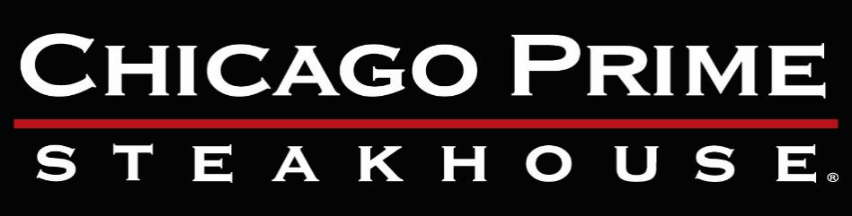

Buckingham Lunch Package

ONLY AVAILABLE DURING **LUNCH HOURS** UNTIL 3PM

**39.95 Per Person (3 Course)**

**Appetizers (Priced Per Piece)**

**Minimum 10 Pieces**

Fried Calamari($13 per order)

Spinach Pie ($2.00 per piece)

Thai Buffalo Shrimp ($4.00 per piece)

Stuffed Mushroom Caps ($4.00 per piece)

Mini Crab Cake ($3.00 per piece)

Bacon Wrapped Scallops ($4.00 per piece)

Cajun Scallops ($4.00 per piece)

Shrimp Cocktail ($4.00 per piece)

**Entrée Selections (Please Select Three)**

Steak Diane

Steak Au Poivre

Chicken Marsala

Chicken Scallopini

Chicken Picatta

Scottish Wild Caught Salmon

Fried Shrimp

16oz Berkshire Pork Chop

10oz Filet Mignon ($10 per person)

13oz New York Strip ($11 per person)

Bacon Wrapped Filet Mignon ($11 per person)

Filet Mignon and Stuffed Shrimp ($11 per person)

**Desserts (Please Select One)**

Key Lime Pie

Tiramisu

Amaretto Cheesecake

Haagen-Dazs Ice Cream (Chocolate or Vanilla)

**Soup and Salads (Please Select One)**

Soup of the Day (Homemade Prepared Fresh Daily)

House Salad

Caesar Salad

Wedge Salad

Beet Salad ($2.00 per person)

Chopped Salad ($2.00 per person)

**Side Dishes (Please Select Two)**

Potato Au Gratin (Served Family Style)

Broccoli with Hollandaise Sauce

Mashed Potatoes

Home Cut Steak Fries

Steamed Broccoli

Sautéed Mushrooms

Herbed Wild Rice

Sweet Potatoes

French Cut Green Beans

Sauteed Spinach

Grilled Asparagus ($2 per person)

Wasabi Mashed Potatoes ($2 per person)

Julienne Vegetables ($2 per person)

Double Baked Potato ($2 per person)

Buckingham Lunch Package

**Fresh brewed coffee. assorted teas and soda are included in package**

Tax and gratuity are not included. Menu is subject to seasonal availability

Additional 3% Banquet Fee and Suggested 19% Gratuity



Skyline Package

**59.95 Per Person (4 Course)**

**Appetizers (Please Select Three)**

Fried Calamari

Grilled Portabella Mushroom

Spinach Pie

Thai Buffalo Shrimp

Crab Cake ($5.00 per person)

Shrimp Cocktail ($6.00 per person)

Bacon Wrapped Scallops ($5.00 per person)

Cajun Scallops ($5.00 per Person)

Stuffed Mushroom Caps ($5.00 per Person)

**Entrée Selection (Please Select Three)**

Steak Diane

Steak Au Poivre

Chicken Scallopini

Chicken Marsala

Chicken Picatta

16oz Berkshire Pork Chop

Scottish Wild Caught Salmon

Fried Shrimp

Seared Sushi Grade Ahi Tuna ($6 per person)

10oz Filet Mignon ($10 per person)

13oz New York Strip ($11 per person)

Bacon Wrapped Filet Mignon ($11 per person)

**Soup and Salads (Please Select One)**

House Salad

Soup of the Day (Homemade Prepared Fresh Daily)

Chopped Salad

Beet Salad

Caesar Salad

Wedge Salad

**Side Dishes (Please Select Two)**

Potato Au Gratin (Served Family Style)

Herbed Wild Rice

Mashed Potatoes

Sweet Potatoes

Sautéed Mushrooms

Broccoli with Hollandaise Sauce

French Cut Green Beans

Steamed Broccoli

Home Cut Steak Fries

Sauteed Spinach

Grilled Asparagus ($3.00 per person)

Double Baked Potato ($3.00 per person)

Julienne Vegetables ($3.00 per person)

Wasabi Mashed Potatoes ($3.00 per person)

**Desserts (Please Select One)**

Key Lime Pie

Tiramisu

Amaretto Cheesecake

Haagen-Dazs Ice Cream (Chocolate or Vanilla)

Skyline Package

**Fresh brewed coffee, assorted teas and soda are included in package**

Tax and gratuity are not included. Menu is subject to seasonal availability

Additional 3% Banquet Fee and Suggested 19% Gratuity



Millennium Package

**79.95 Per Person (5 Course)**

**Appetizers (Please Select Three)**

Fried Calamari

Spinach Pie

Thai Buffalo Shrimp

Grilled Portabella Mushroom

Bacon Wrapped Scallops

Crab Cake

Shrimp Cocktail

Cajun Scallops

Stuffed Mushroom Caps

**Sorbet**

Sorbet (Raspberry or Lemon)

**Entrée Selections (Please Select Three)**

Steak Diane

Steak Au Poivre

Chicken Scallopini

Chicken Marsala

Chicken Picatta

16oz Berkshire Pork Chop

Wild Caught Scottish Salmon

Fried Shrimp

Seared Sushi Grade Ahi Tuna

13oz New York Strip

10oz Filet Mignon

Bacon Wrapped Filet Mignon

10oz Filet Mignon and Lobster Tail (Market Price)

**Soup and Salads (Please Select One)**

House Salad

Wedge Salad

Chopped Salad

Beet Salad

Caesar Salad

Soup of the Day

Homemade Soup Prepared Fresh Daily

**Side Dishes (Please Select Three)**

Potato Au Gratin (Served Family Style)

Broccoli with Hollandaise Sauce

Steamed Broccoli

Mashed Potatoes

Double Baked Potato

Sweet Potatoes

French Cut Green Beans

Home Cut Steak Fries

Sauteed Spinach

Sautéed Mushrooms

Wasabi Mashed Potatoes

Julienne Vegetables

Grilled Asparagus

Herbed Wild Rice

**Desserts (Please Select Two)**

Chocolate Chambord Torte

Key Lime Pie

Amaretto Cheesecake

Tiramisu

Haagen-Dazs Ice Cream (Chocolate or Vanilla)

Millennium Package

Fresh brewed coffee, assorted teas and soda are included in package

Tax and gratuity are not included. Menu is subject to seasonal availability

Additional 3% Banquet Fee and Suggested 19% Gratuity