Welcome,

Thank you for contacting the Majors Golf Club regarding your upcoming event.  Our award-winning Arnold Palmer designed course is set among beautiful, native Florida terrain.  The course boasts an 18-hole, 72 par layouts, which is bound to impress all your guests.  This combined with a fully stocked pro-shop, lounge, covered patio, restaurant/banquet room and unlimited outdoor seating ensures your events success.

Our professional and friendly staff will provide your event with outstanding service and hospitality to complete your Majors experience.

Our banquet facilities can accommodate your venue whether inside or outside.  We offer all-inclusive event packages and personalized menus for any event at every budget.  Thank you for your interest and we look forward to providing all your venue needs.

Please contact your event coordinator for individual pricing, services or questions you may have in regards to your special day.

Blessings,

Majors Golf Club



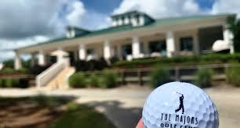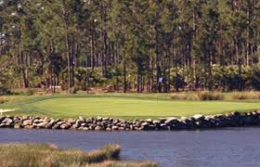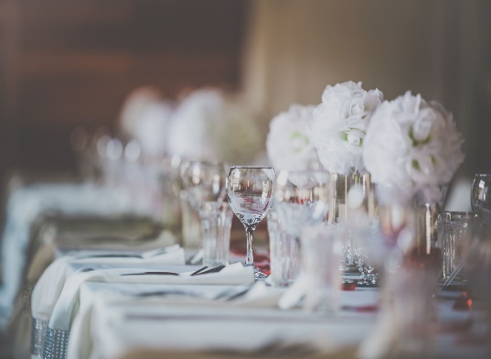

***Appetizers***

**\*Bruschetta Crisps**

**\*Caprese skewers with balsamic drizzle**

**\*Mini crab cakes**

**\*Smoked white fish dip n chips**

**\*Pigs in a blanket**

**\*Petite Shrimp Salad mini rolls**

**\*SweetAhi Tuna wontons w/wasabi +$5**

**Smoked Salmon/Cream Cheese Crunch**

**\*Charcuterie +5**

**\*Seafood Stuffed Mushrooms +$2**

**\*Spring Rolls or Egg Rolls**

**Chicken or Beef Skewers**

**Proscuito & Melon**

**Seafood Tower +19**

***Salads***

**\*Mixed Greens, tomato, cucumber, carrot w/ Raspberry Vinaigarette or Ranch**

**\*Caesar Salad**

**\*Black Bean & Corn Salad**

**\*Antipasto Salad**

**\*Caprese Salad**

**\*Apple & Gorgonzola Salad**

**\*Italian Pasta Salad**

**\*Macaroni Salad**

**\*Coleslaw**

***VEGETABLES***

**\*Green Beans**

**\*Asparagus**

**\*Baby Carrots**

**\*Sweet Corn**

**\*Baked Beans**

**\*Brocolli**

**\*Zuccini & Squash**

**\*Brussel Sprouts**

**\*Sweet Peas**

***SIDES***

**\*Carribean Rice**

**\*White Rice**

**\*Red or Black Beans and Rice**

**\*Roasted Red Bliss Potatoes**

**\*Garlic & Butter Mashed Potatoes**

**\*Side-winder Fries**

**\*Onion Rings**

**\*Macaroni & Cheese**

***Side Pasta***

**\*Linguini**

**\*Spahetti**

**\*Bow Tie**

**\*Ziti**

**\*Elbow**

**\*Angel Hair**

**\*Penne Pasta**

***Side Sauces***

**\*Pomodora**

**\*Garlic Butter**

**\*Alfredo**

**\*Marsala**

**\*Picatta**

**\*Tequila Lime**

**\*Satay Peanut**

***Main Dishes***

**\*Lobster Macaroni & Cheese +$7**

**\*Grilled Shrimp & Grits**

**\*Flame grilled Portabella mushroom topped with roasted red peppers, goat cheese and balsamic reduction**

**\*Tri-colored tortellini w/creamy Alfredo**

**\*Blackened Mahi w/tequila lime sauce +2**

**\*Baked Orange Teriyaki Salmon +2**

**\*Meatballs & Sausage w/Pomodoro Sauce**

**\*Blackened Chicken Alfredo**

**\*Grilled Chicken Florentine**

**\*Grilled Chicken Piccata**

**\*Baked Chicken Cordon blue**

**\*Grilled Chicken Marsala**

**\*Tender, delicious hand-cut filet 6oz +4(p)**

**\*Filet and Lobster Tail +12(p)**

**\*Herb Crusted Prime Rib +4**

**\*Sliced Beef Tenderloin +4(p)**

**\*Baked Ziti w/ Pomodoro Sauce**

***Entrée Station (+4)***

**\*Taco Bar(Beef)**

**\*Pasta Bar(2 pastas, 2 sauces)**

**\*Carved Ham**

**\*Carved Turkey**

**\*Mini Desert Bar**

**\*Custom Vegan Options Available**

**(p) plated service only**

**Major’s Event Pricing Per Person**

**Appetizer Buffet**

**Choose any (6) Appetizers $15.95**

**Choose any (8) Appetizers $17.95**

**Bronze Buffet $22.95**

**Choose (2) Two Entrees**

**Choose (1) of each:**

**Salad**

**Side**

**Vegetable**

**Silver Buffet $26.95**

**Choose (2) Two of each:**

**Appetizers**

**Salads**

**Sides**

**Vegetables**

**Entrees**

**Gold Buffet $29.95**

**Choose (3) Three Appetizers**

**Choose (2) Two of each:**

**Salads**

**Sides**

**Vegetables**

**Entrees**

**Platinum Buffet $34.95**

**Choose (3) Three Appetizers**

**Choose (2) Two of each:**

**Salads**

**Sides**

**Vegetables**

**Entrees**

**Complimentary Asti Spumante or Sparkling Cider Toast**

**Additional Entrée (+ per item varies)**

**Includes:**

*Banquet Room Tables & Chairs

*Additional tables and chairs extra

*Private Serving Room

*One Wait staff per 30 guests

*Two (2) hours of wait staff service including buffet

*Butlered appetizers (not included on appetizer buffet)

*Water and Iced Tea Pitchers

*Table coverings for the Main, Serving, and Cake Tables

*Quality White Napkins

*China, Silverware and Glassware

*Catering Equipment

*Four (4) hour rental block to include set-up/down time.

*Additional rental time $200 perhr

**Add On’s:**

$1.25 per plate seated service

$250 private banquet room bartender

$10 table coverings each

$4 table sashes each

$150 custom music (2hrs)

$5 per folding table

$1 per folding chair

(table and chair rentals includes patio or room delivery and pick-up)

**Not Included:**

Venue or Ceremony Fees

Clean-up and Set-up fees

Soda or Alcoholic Beverages

Bar Side Room

Dance Floor

Private Outdoor Lounge & Game Zone

Gratuity and Taxes

**Major’s Bar Menu**

**Bronze Bar**

**Unlimited Soda, Tea, Water**

**$2.50**

**Silver Bar**

**Unlimited Soda, Draft Beer & HouseWine**

**$20**

**Gold Bar**

**Unlimited Soda, Hard Seltzer, Beer (Draft, Domestic & Imported , HouseWine and Liquor (Well & Call only)**

**$25 (2hrs)**

**$32 (3hrs)**

**$39 (4hrs)**

**Platinum Bar**

**Unlimited Soda, Hard Seltzer, Beer (Domestic & Imported), UpgradedWine and Premium Liquor**

**$30 (2hrs)**

**$37 (3hrs)**

**$44 (4hrs)**

**Set Price**

**You pick the amount you want to spend.**

**Once limit is met, the bar becomes cash bar paid for by each person.**

**Cash Bar**

**All drinks are paid for individually**

*All prices are calculated based on total person event count. Minimum 100 People. No exceptions.