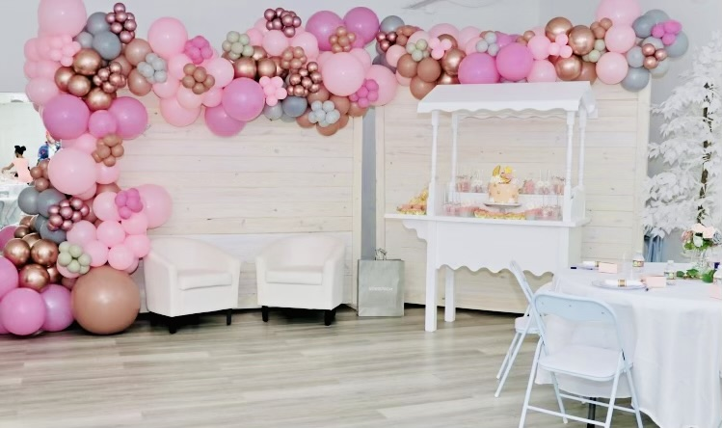

Rental Information: 817-372-0023
Room A: 2000 Sq. Feet $500.00 for 4 hours & $125.00 additional Hours
100 Guests Seated
Tables & Chairs - Included in the rental fee

Room B: 1400 Sq. Feet $500.00 for 4 hours & $125.00 additional hours
Private Restrooms
Reception area
Dressing Room
Kitchenette with Icemaker and Refrigerator
Tables & Chairs - Included in the rental fee
Cleaning Fee: $250.00
Table Linen Rental: $15.00 per Table
Services Available (additional fee):
Catering Bakery Bar Tender
Event Planner Event Setup Decorating
Event Wait Staff

