The Victoriana’s

Bar and Beverage Service

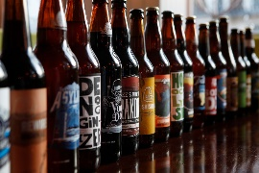

Policies

Our clients will provide their own soft drinks, beer, wine and liquor.

The Victoriana has 2 full-size refrigerators and a large beer cooler which will be used to chill beverages.

The Victoriana will provide disposable cups, ice, and self-serve glass dispensers which will have iced Spring Water and cups for your guests. We will also provide all bartending supplies (wine bottle openers, stainless steel ice scoops, etc.

The Victoriana will provide the bartender who also serves as the set up/clean up staff member which is a $100 fee.

All soft drinks, beer, wine and liquor will be served at our bar by our bartenders.

Terms and conditions apply to bar consumption.

