**Packages:**

**Special: $15.00pp, plus tax** (no substitutions) *Choose Package A or B

**Package A:** Angus Hamburgers and All-Beef Hot Dogs with relish, lettuce, tomato, onions, pickles, condiments and buns. Served with house slaw, baked beans variety chips and fresh baked cookies.

**Package B:** Wings in a variety of flavors with ranch and blue cheese dressing and celery. Served with French Fries or Tater Tots and Fresh Baked Cookies.

**Package C:** Deli Platter: Assorted Boar’s Head Meats and Cheeses, Signature Chicken Salad or Tuna Salad, 3 Fresh Bread Choices, Chips and Fresh Baked Cookies

**Package 1: $18.00 pp, plus tax**

1 Entrée with 2 Sides, Dinner Rolls and 2 Signature Desserts

**Package 2: $ 22.00 pp, plus tax**

2 Entrées with 3 Sides, Dinner Rolls and 3 Signature Desserts

**Package 3: $28.00 pp, plus tax**

2 Appetizers, 2 Entrees, 4 Sides, Dinner Rolls and 4 Signature Desserts

**Entrée Choices:**

BBQ Pulled Pork, Parmesan Crusted Chicken Breast, Grilled or Breaded Chicken Strips with BBQ and Ranch Sauces, Chicken and Bacon Pasta, Marinated Brisket, Herb Roasted Loin of Pork, Pot Roast, Chicken Fried Steak and Gravy, Meat and Cheese Lasagna, Vegetable Lasagna, Roasted Turkey Breast, Glazed Baked Ham, Encrusted Parmesan Herb Pollack

**Steak and Chicken Fajita Bar: $20.00 pp, plus tax**

Includes: Grilled Peppers and Onions, Spanish Rice, Refried Beans, Shredded Lettuce, Shredded Cheddar Cheese, Sour Cream and Pico de Gallo. Served with Chips, Salsa and 2 Signature Desserts

**Appetizers:**

Sausage Balls with Honey Mustard and BBQ Sauce

Baked Phyllo Shells with Signature Pimento Cheese and Red Pepper Jelly

Phyllo Shells with Signature Chicken Salad

Candied Bacon Signature Cheese Straws

Bacon and Cheddar Cheese Ball with Crackers Oat Biscuits with Blue Cheese

Cream Cheese drizzled with Brown Sugar and Spice Glaze topped with Toasted Pecans paired with assorted crackers or Spicy Pimento Cheese paired with assorted crackers

**SIDES:**

Baked Potatoes Baked Beans

Mashed Potatoes with Gravy Homestyle Cream Corn

Hash Brown Casserole Fresh Green Beans

Herb and Garlic Roasted Potatoes Fresh Asparagus with Lemon Butter

Baked Mac and Cheese Succotash

Signature Stuffing Peas and Carrots

Seasoned Rice Stir Fried Veggies

Brunswick Stew Coleslaw

**SALADS: Dressings: Ranch, Blue Cheese, Thousand Island, Balsamic Vinaigrette and Poppy Seed**

Mixed Greens Salad Spinach Salad

Strawberry Fields Salad Broccoli Salad

Tri Color Pasta Salad Seasonal Fresh Fruit Salad

**Desserts:**

Signature Chocolate Chip Cookies Signature Pecan Oatmeal Raisin

Reese’s Peanut Butter Chunk Cookie Sugar Cookies

Decadent Brownies Lemon Bars

Lemon Bars Pecan Chocolate Bars

Bourbon Pecan Bars Signature Banana Pudding

Seasonal Fruit Cobbler served with Ice Cream Raspberry Walnut Torte Served with Whipped Cream

Sour Cream Pound Cake Triple Chocolate Mousse Cake

Homemade Cup Cakes: Double Chocolate Chip, White, Carrot, Red Velvet, Lemon Poppy Seed

*Menu subject to change at chef’s discretion*

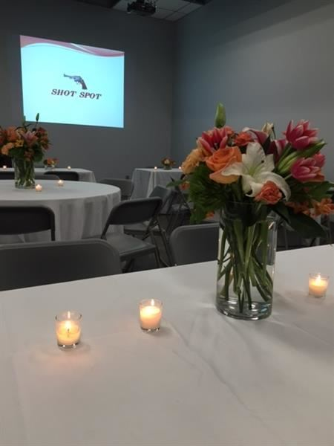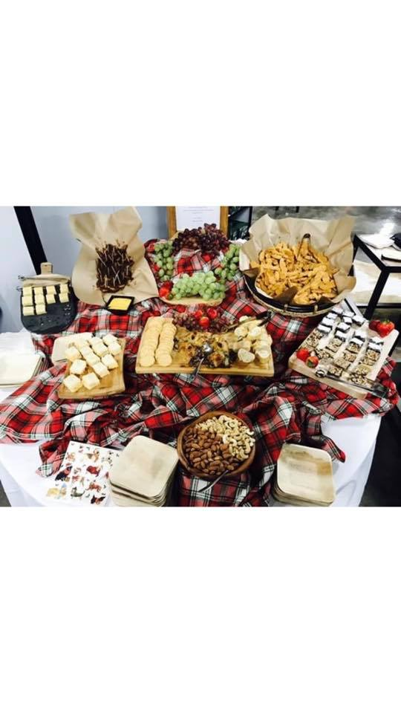

PRIVATE EVENTS

*From business meetings to catered parties, our dedicated events team brings a level of quality and service that only Shot Spot is known for.*

Shot Spot Gun Club is the ideal place for corporate & company picnics, private parties, church events, team building events and even bachelor/ bachelorette parties

Corporate Parties and Team Building Events

A day of shooting at our range can be a fun and exciting adventure to motivate your employees. It is an exciting way to build teamwork skills and camaraderie with your staff while having fun at the same time! Reward your employees to a fulfilling adventure that is sure to boost their morale and motivation in the workplace. Building confidence and motivation in yourself and others is the key point of our team building exercises and events.

Make Your Event Memorable

Shooting is a great choice and is an exciting adventure that you can share with all of your family, friends, or co-workers. Our facilities are the perfect choice to have your next celebration, no matter what size. Our range offers amenities such as a private group room, a full catering kitchen, and a friendly and professional staff as well as rental guns and ammo for all your needs.

Let Shot Spot Gun Club help you plan your next event with a day that is full of excitement and memories that are sure to last a lifetime!

For availability, fees, and additional information for your event, such as available amenities and services, please contact the Special Events staff. Please be sure to include your name, phone number, type of event, and preferred event date(s) in your message. Email: events@shotspotllc.com

Catering is provided exclusively by Chef Leigh Thornton with Shot Spot Bakery & Café.

Event Restrictions:

-Please note after hours events must be scheduled 1 month in advance to allow for staffing.

-Production companies are not allowed.

-No outside food or alcohol is permitted during the event.

-Alcohol service must begin after all shooting is completed. The alcohol service must end 15 minutes prior to the end of the event. Alcohol service must be approved 2 weeks prior to event and event must be a private function.