***The Part Time***

*If you’re looking for a fun pack with some light snacks to munch on this one’s for you.*

*Priced at $15 per person, this package includes 2hrs unlimited bowling, rental shoes, and the following food option:*

* *Munchie Sampler includes one order each Nachos, Fries, and Cheese sticks.*

*or*

* *Nacho bar includes chips, chili, cheese, and assorted toppings.*

*Food options are based on approximately 1 filler from our menu for every 4 people in the group and include 1 pitcher of soda.*

***The Executive***

*This ultimate package includes everything you need for a fun filled event. Priced at $25 per person, you will have 3 hours of unlimited bowling, rental shoes, a full meal served buffet style, including soft drinks, and a sheet cake with your choice of design.*

*Minimum of 25 people*

*Also receive 10% off purchases from our add-on catering menu.*

*This buffet is served ½ after the start of the event and is removed ½ hour prior to the finish. Food is replenished as needed. There are no carry-out containers allowed.*

*Choose your buffet package from the following:*

***The All American***

*Burgers, dogs, and pulled pork BBQ served with a generous variety of fixings.*

*Wings with choice of sauces*

*Cole Slaw, Potato Salad, and Pasta Salad*

*Veggie tray with dip*

***.***

***South of the Border***

*Enchiladas*

*Soft tortillas with a generous variety of fillings including beef, chicken, refried beans, shredded cheese, sour cream, and guacamole.*

*Nacho chips and Fresh homemade Salsa*

*Black beans and seasoned rice*

***A Taste of Italy***

*Lasagna (can be vegetarian or meat)*

*Spaghetti with meatballs (meatless sauce served as well)*

*Chicken Parm*

*Salad and Garlic bread*

***The Breakfast***

*Scrambled eggs, Ham, Sausage, and Bacon*

*Grits and home fried potatoes/Gravy*

*Biscuits/Muffins/French Toast/Fresh Fruit*

*Juice/Coffee/Assorted Teas*

***The Full Time***

*This is the perfect choice if you would like a little more than light snacks.*

*Priced at $20 per person, this package includes 2hrs unlimited bowling, rental shoes, and the following food option:*

* *Chicken Sampler includes one order each Tenders, Wings, and Popcorn chicken, with a variety of dipping sauces.*

*Or*

* *Pizza – toppings include pepperoni, sausage, ham, beef, bacon, onions, peppers, mushrooms, or pineapple.*

*Food options are based on approximately 1 filler from our menu for every 4 people in the group and include 1 pitcher of soda.*

*Also receive 10% off purchases from our add-on catering menu.*

***Add ons***

*Wings – Seasoned, fried, and served with a variety*

*of dipping sauces. 50ct $50*

*BBQ Meatballs – 5lbs of marinated meatballs*

*served hot and ready for snacking $30*

*Finger Sandwiches – Generous portions of ham,*

*turkey, homemade chicken or tuna salad,*

*served on a fresh roll. 25ct $25*

*Dessert tray – an assortment of bite-size*

*homemade cookies and chocolate brownies*

*50ct $20*

*For groups of 150 or more you may want to consider a buy-out package and have the whole place to yourselves!*

*Prices do not include tax or gratuity. $50 deposit is required to book the event.*

*For more information call Kevin Morris at 757-838-2121*

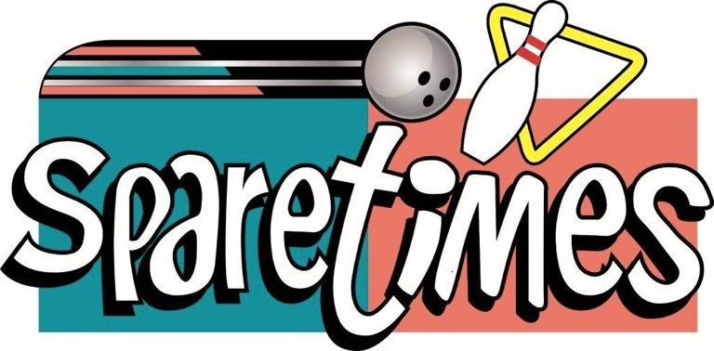

***Has just the party for you***

*Let us do the work while you relax with your group. Our Company Parties are a great way to reward your employees for doing such an amazing job at your establishment along with offering a great team building experience. We have 2 private meeting rooms, enhanced scoring system, full service bar, separate game room, and a wide variety of food packages to cater to you and your team members.*

*These prices are valid Sunday through Friday 7pm.*

*Saturday rates add $3 per person.*

*Glow Bowl – For this special time frame, your party will be 3 ½ hours of bowling during our high energy, fun-filled Glow Bowl. These parties are booked either Friday or Saturday from 10pm – 1:30am. Prices are $24/$26/$28 per person.*

*Sparetimes Bowling 1 Family Fun Pl. Hampton, Virginia 23666 www.sparetimesbowling.com*