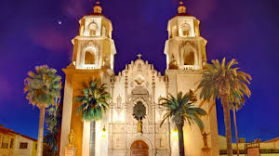

Our Lady’s chapel, a jewel nestled in downtown Tucson, newly renovated, is the recipient of three historical awards. This is a perfect place for a smaller ceremony, with a big cathedral feel.

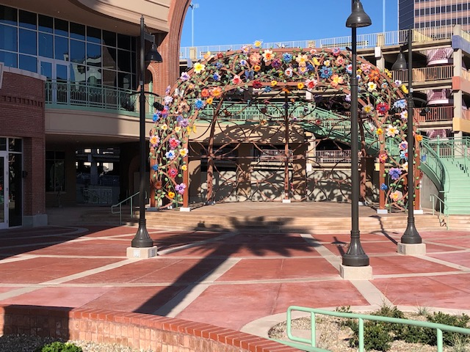

St. Augustine Cathedral, an Icon of downtown Tucson, rich in history and tradition. Offering a larger church for your Wedding, Quinceanera, Reunite your vows, or hold a concert.

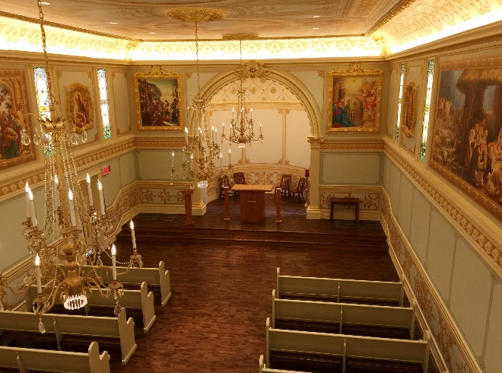

Monsignor Carrillo Plaza, a beautiful outdoor stage. A great place to hold concerts under the stars, a school function, or a corporate event with a live band. Can seat up to 300

Our outdoor patio is great place for an outdoor event. We can host a party for 200 or have a reception after a church ceremony. We can also gain access to the street for a true block party.

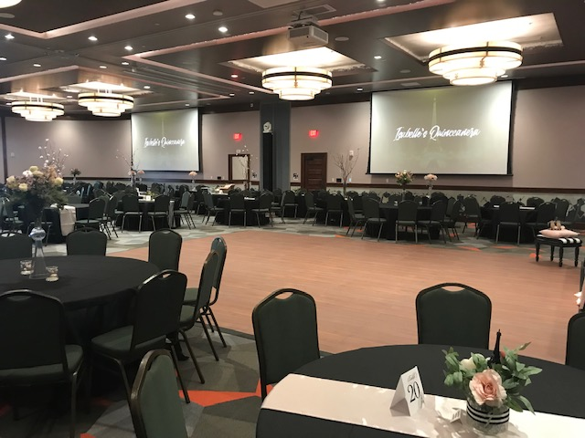

Use one of our four meeting rooms for client pitches, training, or a small gathering. All four rooms can be combined to one another or used separately. We can accommodate up to 40 people in this one room or 160 when all four rooms are combined. With easy connection to our 70” monitor you can connect your laptop for company presentations. We also have a podium and wireless microphones with a built-in overhead speaker system.

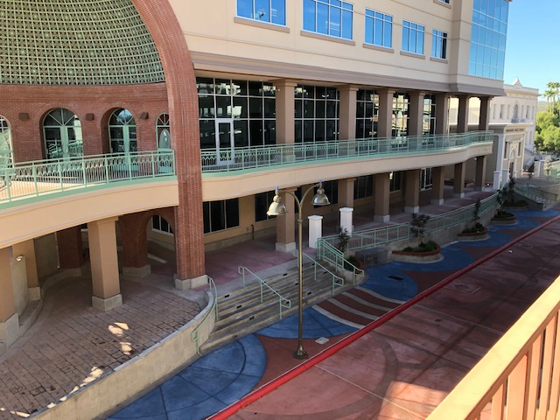

Cathedral Square Center, a spacious and versatile ballroom. Large enough to hold a dream Catholic wedding or quinceanera of up to 400 attendees. Includes two outdoor balconies, foyer, and dance floor. We also welcome company parties and corporate events. This room is equipped with wireless microphones, project screens and overhead speaker. One of the few places in town you can bring in your own Event Planner, License Cater, License Bartender, and DJ or Band

