Accessories:
Ceremony set up: $200.00 (outdoor) (Indoor $150.00)
Set up Includes: A Professional sound system, Stand mounted speakers, Choreographed ceremony music selections. For our “Outdoor ceremonies” an optional ***“Gazebo tent” can be added for an additional $79.00.00 (great for the interim time period before the dinner banquet begins!) The gazebo may be used for shade, refreshments, And Hors d'oeuvres etc. This incredible feature will provide up to (3) hours of provided music!
Elegant up lighting.
We offer premium led digital elegant up lighting for our clients. Up-lighting will turn any room into a “mesmerizing page from a story book fairy tale.” We can color match hundreds of unique combinations to your preferred preference or we can offer a color wash program that will change colors on a timed schedule. Each fixture can be purchased separately for $35.00 each
We offer (3) money saving options to choose from.
- Wedding party Head Table / Cake Table (“includes up to (5) special effect up lights.) $119.99
- Head & Cake table with additional room perimeter lighting. (Includes (10) “special effect” led up lights $300.00.
- The princess pristine elegance pkg (a total of (18) special effect led up lighting fixtures) $569.99
Personal Monogram gobo $195.00
“This feature boasts a remarkable unique visual effect that can produce a spectacular monogram or logo on to the dance floor or a wall”. Our upscale gobo projector (4) colored gels to choose from be projected to a wall (“A truly elegant popular special effect accessory) Great for first dance photographs and videography. This elegant accessory will truly reflect your personal essence.
Follow spot light $59.95
Would you like to add Class & Couture to your event? The follow spot light has that special effect of capturing the attention of your audience. The size and color of the projected spot can be adjusted. This special feature can be used at the Grand Entrance, the head table as well as for the special event family dances
Additional club dance lights $49.95 each
Add additional lighting to your chosen pkg for just $49.95 each piece
We invite you to visit our website and see each light in action.
https://djmilwaukeeareas.com/effects.php

Accessories:
Professional Sound System Upgrade. $175.00
This significant upgrade includes (2) Large 18”Sobwoffers and a rack unit of sound conditioning components. The Subwoofers’ have a powerful amplifier to drive them. This upgrade will add pristine sound quality as well as “punch” to the low tone bass sounds. A must have for medium to large size events! This system is included in our “Afternoon Delight” wedding pkg.

Awisco (3) microphone Wireless Sing Along/ Karaoke system. $149.95
Take your event’s entertainment to the next level with this exceptional highly entertaining interactive accessory. You and up to (3) guests can sing along to your favorite songs with the original artist (not some aftermarket non-lyrical copy of your song.) This accessory will provide the opportunity to capture memories that will last a lifetime. Better than a photo booth! Bring your own props or disguises! The choices are endless. Capture photos and video footage with your cell device. (In action not in a pose).A large colorful dance party back drop is included as well.
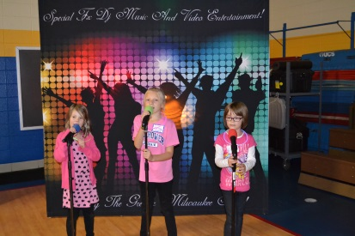
**Please note: This accessory is not a standalone option.
It is meant to be used with a traditional dj/ music pkg choice.

Video Projection
Professional DLP. HD Video Projection
*** (Includes a 7 x 8 ft. State of the art high tech spandex stretch screen that is visible from both sides!)
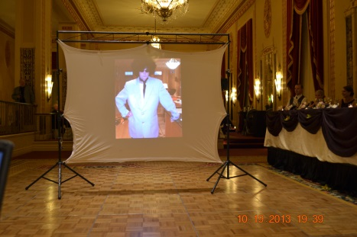
We can professionally project media from the following sources.
- DVD.
- SD card.
- Jump drive.
- Power point presentations.(lap top or CD rom)
We offer (2) options regarding this accessory.
Option (1) a onetime screening of a photo montage or slide show. $99.95 Option (2) DLP HD Projector / screen are set up in a different location of the banquet facility for continuous viewing. The Montage or slide show will loop throughout the evening on a 32” monitor $129.95

