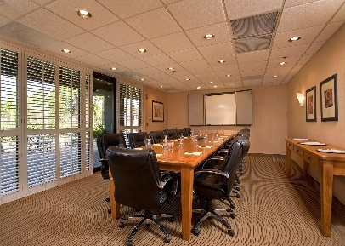The Complete “Conventional” Meeting Package

We serve the type of travelers and groups that are seeking conference/meeting space and overnight accommodations to fit their needs specializing in all aspects of social, sports, business, religious, fraternal and leisure activities where they can enjoy all the comforts full-service hotel.

Say hello to the only Tucson hotel with a streetcar stop. “Your Downtown Oasis in Tucson”, Full Service, AAA 3-diamond hotel located adjacent to the downtown. We are minutes away from the University of Arizona and Pima Community College, dining, shopping, golf, and major attractions with the Sun Link Streetcar System.

# banner.jpgThe Complete “Conventional” Meeting Package includes:

**Continental Breakfast**

Assorted Muffins & Danish, Sliced Fruit, Orange Juice, Coffee and Tea

# Mid-Morning Refresher

Granola Bars, Bottled Waters and Iced Tea

# Luncheon

# (Sandwiches and Burgers come with side and all selections include Iced Tea)

Deli Sandwich with Ham or Turkey and Cheese, Lettuce Tomato, Onion, Pasta Salad

Chicken Parmesan with a Green Salad with Dressing

Terrace Burger with Cheddar Cheese, Lettuce, Tomato, Onion,

Caesar Salad with Grilled Chicken

Chef Salad with Ham & Turkey, Swiss & Cheddar Cheese, Tomatoes & Diced Eggs with choice of Dressing

# Afternoon Break*

Assorted Cookies & Brownies, Popcorn & Trail Mix, Assorted Sodas & Iced Tea

# *Ask us about our Specialty Break options

# Enhancements

Energy Drinks $3

Yogurt Cups $2

Bagels & Cream Cheese $3

Whole Fruit $3.50

Conference Phone $50

Flipchart/Whiteboard $25

LCD Projector $150

Microphone $30

8’Screen $30

TV & DVD Player $65

Extension Cord/Power Strips $5

**$37.57++ per person = $49.00 inclusive**

**(Pricing includes a complimentary 8’ screen & Flipchart if applicable and Room Rental)**

++Price is subject to applicable taxes and service charge. Prices are per person. Package is subject to availability and change. Minimum 20 people.

*To check availability or book the space now please contact:*

*Beth Macnow-Marsh, Catering Sales Director*

*at (520) 239-2321 or* [*bmacnow@tucsonramada.com*](mailto:bmacnow@tucsonramada.com)