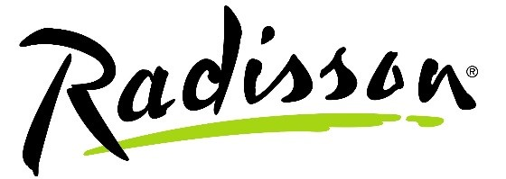

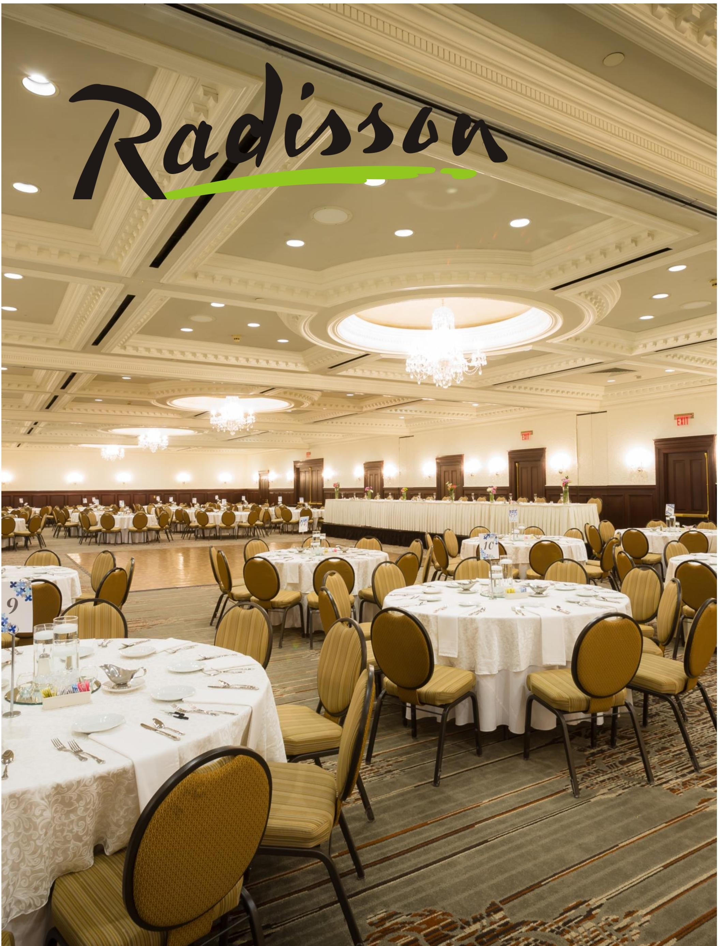

Wedding Package

*Your special day will include all of the following at no additional expense:*

• A Complimentary Spa Suite

• A Complimentary Hospitality Suite

• Complimentary Menu Tasting for up to Four Guests

• Our Bluegrass Ballroom to accommodate up to 450 guests

• A Champagne Toast for the Bridal Party

• Guest Book Table, Cake Table, and Gift Table

• Dance Floor

• No Room Rental Fees or Set Time Limit for Your Event

• Candle- Lit Centerpieces

• Wedding Cake Service

• Floor Length Table Linens with White Overlays

• Complimentary Parking Convenient to the Ballroom

• Convenient Downtown Location without the Hassles

• Breakfast for the Bride and Groom in our EIGHTEEN revolving restaurant

• Reduced Room Rates for Overnight Guests (rates and

Availability based upon season and occupancy level)

**Hors D’oeuvres Butler Passed or Displayed Served per 50 pieces**

• Smoked Salmon Display…$300

• Olive and Giardiniera Display with Olive Oil, Vinegar and Dipping Bread…$250

• Crudités…$250

• Jumbo Shrimp Cocktail…$300

• Roma Tomato, Mozzarella, and Pesto Bruschetta…$160

• Wild Mushroom and Blue Cheese Bruschetta… $250

• Spanakopita $200

• Crab Stuffed Crimini Mushrooms… $250

• Miniature Crab Cakes with Cajun Remoulade… $250

• Miniature Beef Wellingtons…$225

• Panko Crusted Bacon Wrapped Scallops…$300

• Miniature Quiche…$150

• Coconut Fried Shrimp…$170

• Miniature Goat Cheese Fritters with Tomato Jam…$200

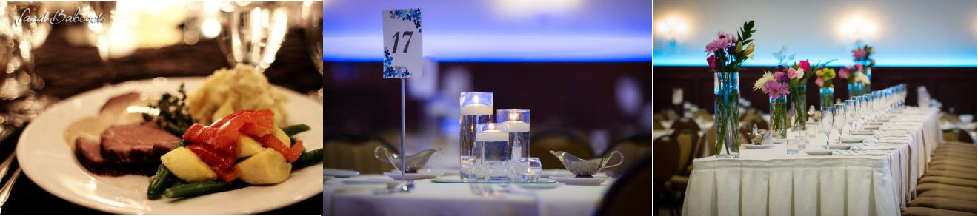

**Buffet or Plated Entrees:**

*All entrees are served with choice of (1) side salad, (1) starch, and (1) vegetable. Package includes (4) hours of House wine and Domestic beer.*

**Silver Package $45,$55,$60**

**Includes a complimentary cheese display**

• Almond Crusted Tilapia with Citrus Beurre Blanc

• Horseradish Crusted Sirloin with Caramelized Onion Balsamic Demi-Glaze

• Pork Loin w/ Apple Sage Cider Reduction

• Pork Loin w/ Dijon Cream

• Herb Marinated Chicken Breast w/ Lemon Thyme Beurre Blanc

• Chicken and Bacon Florentine Pasta

• London Broil w/ Mushroom Ragout

• Chicken Marsala

**Gold Package $65 ,$70,$75**

**Includes a complimentary cheese display**

* Dijon Crusted Salmon w/Sorrel Cream Sauce
* Filet W/Pinot Noir Sauce
* NY Strip with Boursin Demi-Glaze
* Stuffed Chicken w/ spinach, peppers, tomatoes, and Onions
* Beef Au Poivre(steak coated with loosely cracked peppercorns) with Cognac Cream Sauce

• Herb Marinated Air Line Chicken Breast with Roasted Red Pepper Mornay Sauce

• Lobster Ravioli with Vodka Cream Sauce

• Blackened Halibut w/ Pesto Cream Sauce

• Orange Roughy w/ Amaretto Cream

**Buffet:**

*All buffets are serve*

**Salads**

**Additions:**

|  |  |  |  |
| --- | --- | --- | --- |
| • | **Garden Salad**, Grape Tomatoes, Cucumbers, Shredded Carrots | **Chef-Attended Carving Stations** *A great addition to any plated or buffet option* | |
| • | **Caesar Salad**, Parmesan Cheese, |
|  | Croutons |
| • | **Spring Mix Salad**, Pine Nuts, Golden Raisins | •  • | Prime Rib, serves 40…Market Price  Roasted Turkey, serves 30…$240 |
| • | **Spinach Salad**, bacon, Red Onion, | • | Spiral Ham, serves 50…$250 |
|  | Walnuts, Feta | • | Top Round, serves 60…$250 |
|  |  | • | Pork loin, serves 40…$265 |

**Vegetables**

• Beef Tenderloin, serves 25…Market

|  |  |  |
| --- | --- | --- |
| • | Green Beans, Wax Beans and | Price |
|  | Carrots |
| • | Zucchini and Red Peppers | **Late Night Snack** |
| • | Country Green Beans | *All priced per person* |
| • | Green Bean Almandine |  |

• Carrots w/ Chipotle honey butter

glaze

• Broccoli and Cauliflower

**Starches**

• Blue Cheese Scalloped Potatoes

• French Onion Smashed Yukon

Gold Potatoes

• Roasted Garlic Red Bliss Mashed

Potatoes

• Home Style Mashed Potato

• Honey Pecan Mashed Sweet

Potatoes

• Roasted Red and Gold Potatoes

• Wild Rice

• Rice Pilaf w/ Asparagus Tips and

Roasted Tomatoes

• Wild Mushroom Orzo

**Cincinnati-style**

**Chili Bar…$11**

• Cincinnati Style Chili, Spaghetti, Conies, Cheddar Cheese, Diced

Onions, and Oyster Crackers

**Pretzel Bar…$12**

• Pretzel Sticks, Jumbo Pretzels, Beer

Cheese, Nacho Cheese,

Garlic Butter, Spicy

Mustard, Honey Bourbon Butter

**Sliders and Waffle Fries…$13**

• Fresh Grilled Mini Burgers, Fried Chicken, and Pulled Pork accompanied with Seasoned Waffle Fries

**Beverages**

**Hosted Bar by Consumption**

House Brands …$5.00

Premium Brands …$ 7.00

House Wine…$6.00

Premium Wine…$7.00

House Wine by the Bottle…$28.00

Champagne by the Bottle…$27.00

Domestic Bottle Beer…$4.00

Imported Bottle Beer…$5.00

Assorted Soft Drinks…$3.00

Bottled Waters…$3.00

**Cash Bar by Consumption**

House Brands…$5.00

Premium Brands…$7.00

House Wine…$6.00

Premium Wine…$7.00

House Wine by the Bottle…$28.00

Champagne by the bottle…$30.00

Domestic Bottle Beer…$4.00

Imported Bottle Beer…$5.00

Assorted Soft Drinks…$3.00

Bottled Waters…$3.00

*Cash Bar Pricing is Inclusive of

Service Charge and Tax

**Bar Packages**

*All prices per person, for (4) hours*

House Brand Liquor Service to Your Wedding Package…$10

Premium Brand Liquor Service to Your Wedding Package…$20

++ All Prices are Subject to a 22% taxable Service Charge and 6% Sales Tax.++

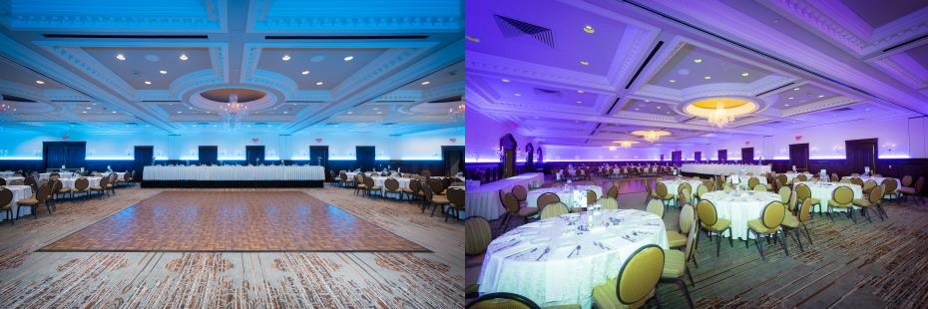

**Paying for your Wedding**

**Reception**

• $1000.00 Deposit is due with signed contract, no later than two weeks after receipt of contract.

• 25% of the Estimated total due 9 Months Prior to Your

• Event

• 50% of the Estimated Total due 6 Months Prior to Your

Event

• 75% of the Estimated Total due 3 Months Prior to Your

Event

• The Remaining Balance & Guaranteed Number of Guests are due One Week Prior to Your Event

• **All Deposits Are Non-Refundable**

• **We Also Require That You Have a Valid Credit Card Authorization on File for any Last Minute Charges and/or Incidentals That May Occur During Your Event**

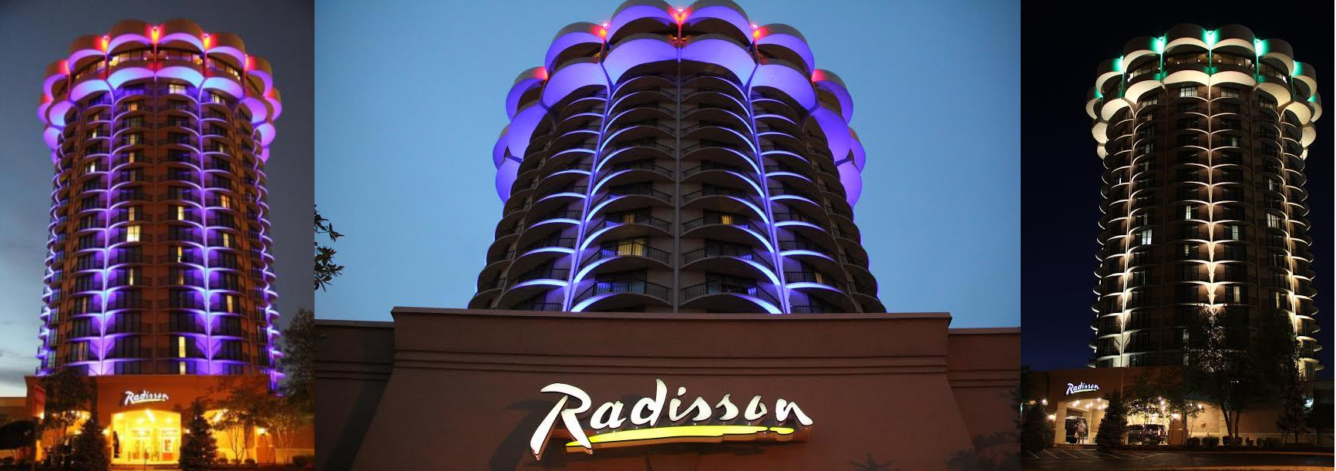

**Radisson Hotel Cincinnati Riverfront Policies**

*Our menus feature a selection of our most popular items. We are delighted to create menus to suit your particular needs. In order to assure you and your guests a well-organized event, we encourage you to read the following policies and discuss any questions with your Catering Representative.*

*1. A non-refundable deposit and signed contract are required to confirm your function on a definite basis. Final payment of the total estimated bill will be due three (3) full business days prior to the function date by cash, check, or credit card. Any balance owing the Radisson Hotel Cincinnati Riverfront is to be paid upon conclusion of the function; any overpayment will be refunded within three (3) weeks. Credit arrangements may be made by use of a major credit card.*

*2. A guaranteed number of attendees is required 72 hours prior to all food functions, and is not subject to reduction. In the event that we do not receive your final count, the minimum guarantee listed on the contract will be used. We will prepare 5% over your guarantee number.*

*3. The enclosed menu and service prices are subject to a 22% taxable service charge and 6% sales tax. Due to the seasonally of several items on our Banquet Menus, the hotel reserves the right to substitute items or increase menu prices as needed to cover our costs. Please consult your Catering Representative to confirm your menu pricing 60 days in advance of the event.*

*4. No food or beverage of any kind is permitted in function rooms unless provided by the hotel. (excluding wedding cake).*

*5. All buffets are scheduled for 1½ hours of service. Ala Carte hors d’oeuvres are scheduled for 1 hour of service. The*

*Hors d’oeuvres Package is scheduled for 1½ hours of service.*

*6. Function rooms are assigned according to the anticipated guarantee number of guests at the time the event is contracted. The hotel reserves the right to reassign rooms if the actual guarantee is significantly different than the original anticipated number.*

*7. Banquet rooms will be set according to contract and banquet event order specifications. Significant changes in room setup with-in 24 hours of the event may result in additional labor charges if the room has already been set. The hotel reserves the right to charge a service fee for extraordinary room setup requirements.*

*8. Banquet rooms are complimentary for 4 hours for all evening events involving a meal. Additional time may be*

*purchased through the hotel. Please speak to your Catering Representative for more details.*

*9. All decorations and signage must have prior approval of your Catering Representative. Some décor (open flamed candles, confetti) is prohibited in certain banquet rooms. A minimum labor charge of $50.00 will be assessed for excessive cleanup, if applicable.*

*10. The hotel will not be held responsible for the damage or loss of any articles or merchandise left in the room prior to, during, or following your event. Special arrangements for security can be made with proper advance noti ce.*

*11. The Radisson Hotel Cincinnati Riverfront is proud to have Prestige Audio-Visual as our full service, in house audio-visual company. Prestige Audio-Visual can handle all of your audio-visual, special setup, computer, and office needs. Should you decide to bring in an outside staging/audio-visual company, certain fees and policies will apply. Please obtain a copy of the guidelines from your Sales and Catering Representative.*

*12. It is illegal to serve alcohol to minors. The hotel reserves the right as dictated by state law to ask for identification from any individual who appears to be underage. The hotel will prosecute all individuals displaying false identification in order to obtain alcoholic beverages. Possession of alcohol by a minor on hotel property will result in immediate removal of the individual. The Radisson Hotel Cincinnati Riverfront is the only licensee authorized to serve and sell alcoholic beverages on the hotel property.*

*13. The client agrees to conduct an orderly event in compliance with the rules of the hotel, and the laws and regulations.*

*The hotel reserves the right to exclude or eject any and all persons exhibiting objectionable behavior from the hotel without liability.*

*14. Events involving ticket sales, invitation by flyer or invitation by general advertising are strictly prohibited.*

*15. The client agrees to hold the hotel harmless for any liability resulting from violations of any law, regulations or hotel rules by the client, the client’s guests or attendees. The client agrees to accept re sponsibility and pay for any damage to the hotel that is caused by the client, the client’s guests or attendees.*