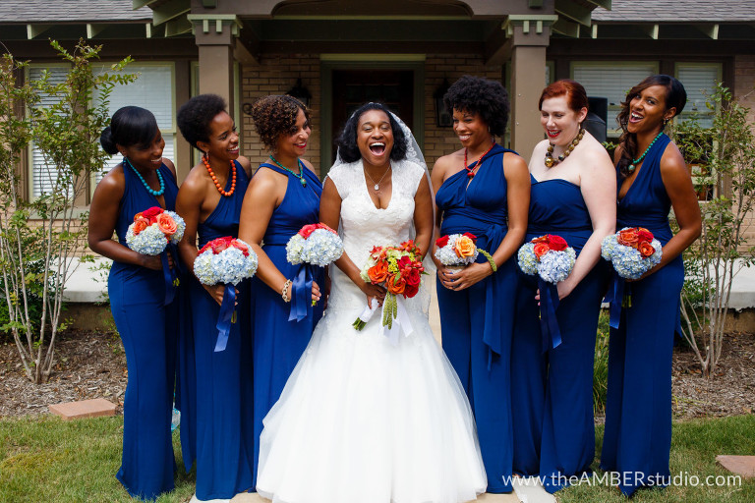
Wedding Party Floral Packages
Bridal Bouquet
$50.00—$75.00 Silk
$75.00—$100.00 Fresh

Bride Maid Bouquet
$25.00—$50.00 Silk
$50.00—$75.00 Fresh

Corsages
$8.00—$10.00 Silk
$10.00—$15.00 Fresh

Boutonnieres
$5.00—$8.00 Silk
$8.00—$10.00 Fresh

Complimentary
Bride’s Throw-Away Bouquet
Rental of Flower Girl Basket w/ Petals
Ringer Bearer Pillow or Bell

