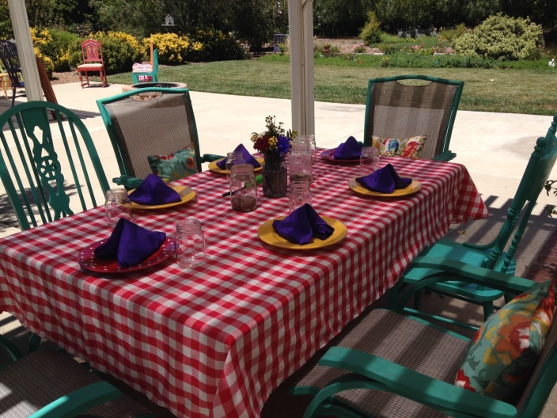Country Garden Event Venue

24670 5th Street

Murrieta, CA 92562

Nancy Landrum

714-931-3910

My vision was to create a venue for small parties that is colorful, cheerful and exudes an atmosphere of celebration. It begins with a lovely, peaceful yard complete with birds feeding at the feeders, and chickens clucking in the Hen House. The ambiance is enhanced by six tables with chairs that are

painted a variety of bright, fun colors and topped with red gingham tablecloths and purple napkins. Centerpiece flower arrangements in Mason jars may be added by request.

This is an alcohol and smoke free venue, with the possible exception of champaign. A clean, well-stocked bathroom is available. Soft, party-like patio lighting is turned on for evening events.

**Parking:** Please ask your guests to park either on my property (wherever there is gravel) or on the vacant lots across from the Country Garden.

**Time Limits:** This is a residential area, so in deference to my neighbors, noise is required to subside by 10 p.m. and all guests required to vacate by 11 p.m.

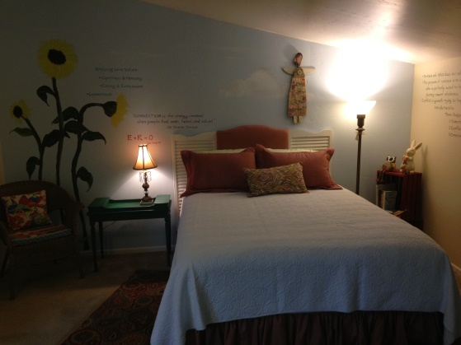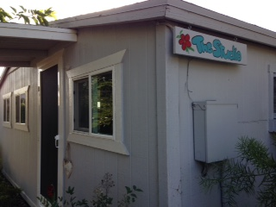**Studio Rental:** The Studio is a stand-alone building at the rear of the property with its own bathroom, sleeping for two, and kitchenette. For some events it may be an extra luxury for the guests of honor to have the pleasure of a two-night get-away as part of your event. The Studio bathroom must be accessible for all guests during the party.

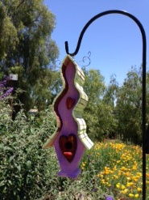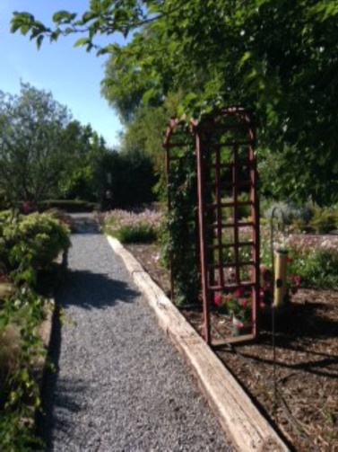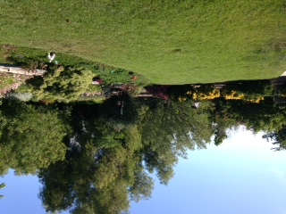

**Options:**

To use the yard alone $450

Plus tables, chairs and linens $8/ pp

Wedding Officiant (Nancy Landrum) $350

Studio Rental for two nights, 1 or 2 persons $150

**Financial Arrangement**: 50% of total due at booking with balance due 1 week before event date. Pay by cash, check, credit card or PayPal. A damage deposit of $250 is due at booking, and refundable 3 days after the event with no damage.

Please call to inquire about availability and for an appointment to preview the venue. I’ll do whatever I can to make your event fun and relaxing!

