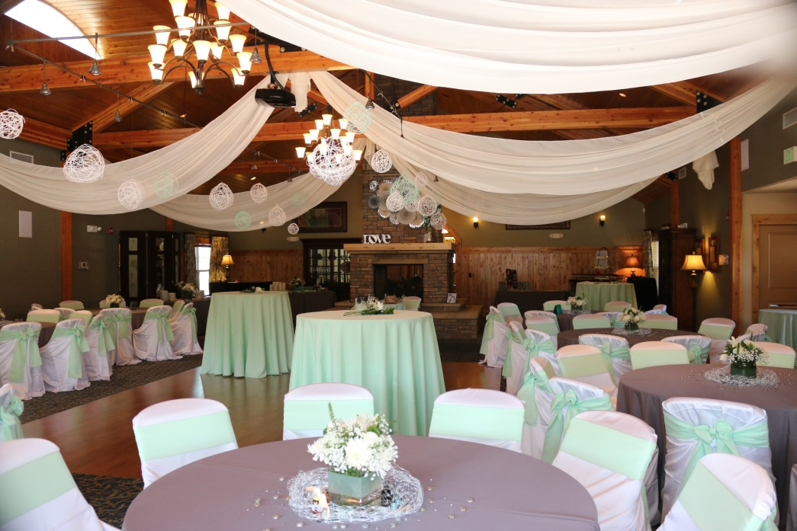



Event Planning Packet

Sarah Braden

4751 Pleasant Oak Drive

Fort Collins, CO 80525

970-207-1939

[mackenzieplacelodge@gmail.com](mailto:mackenzieplacelodge@gmail.com)

[www.mackenzieplacethelodge.com](http://www.mackenzieplacethelodge.com)

Summer 2018

**Rental Fees**

**\*Minimum rental of 2 hours**

**Day Rates – events ending by 3:00 p.m. Evening rates – events starting after 4:00 p.m.**

Monday-Thursday $100 per hour Monday-Thursday $125 per hour

Friday $125 per hour Friday $150 per hour

Saturday $225 per hour Saturday $250 per hour

Sunday $175 per hour Sunday $200 per hour

*Frequent user discount – receive 10% off regular room rental rates

***\*Each event includes 1 hour set up block and 1 hour tear down immediately following event. Extra time needed will be charged appropriate hourly rate.***

**Holiday Rates – Additional $100/hour for holidays & holiday weekends**

Holidays include: New Year’s Eve, New Year’s Day, Easter, Memorial Day, 4th of July, Labor Day, Thanksgiving Day, Christmas Eve, & Christmas Day

**Capacity**

Maximum capacity of the main room is 140 guests; the entire Lodge is 160 guests.

Meetings with classroom style set up: 90 guests

Theater style seating: 160 guests

Business rounds: 96 guests

**Catering**

MacKenzie Place is happy to cater for your next event. Please see back of packet for current menus & pricing. Our Executive Chef would love to meet with you to discuss additional menu options as well.

**Non-Alcoholic Beverages**

Unlimited beverages with accompaniments $1 per guest

**Includes coffee, hot tea, iced tea, & water with a 20 person minimum required

Bottled Water $1 per guest

Seasonal Drinks (lemonade, punch, hot chocolate) $15 per gallon (approximately 30 servings)

Assorted Sodas $1 per guest

Juices (orange, apple, tomato) $15 per gallon (approximately 30 servings)

**Prices listed do not include service charge (20%) or tax (7.4%). The service charge is NOT a gratuity for the staff. The service charge covers the essentials of the building.**

**Bar Service**

**No outside alcohol is permitted on premises.**

**Should alcohol be found, event will be terminated.**

**$75/hour for bartender, glassware, mixes, ice**

Domestic Beer - $3/bottle

Budweiser, Bud Light

Microbrew Beer - $4/bottle

Square Mile Cider, Odell IPA, Easy Street, 90 Shilling, Drumroll APA

House Wine - $5/glass or $20/bottle

Brands vary. Ask for most updated list.

Well Cocktails - $5/glass or shot

360 Vodka, Beefeater Gin, Cruzan Rum, Evan Williams Whiskey, Ballantine’s Scotch, Lunazul Tequila

Premium Cocktails - $7/glass or shot

Grey Goose Vodka, Bombay Sapphire Gin, Bacardi Rum, Malibu Rum, Jameson Irish Whiskey, Rittenhouse Rye Whiskey, Glenlivet Scotch, Cazadores Reposado Tequila

Champagne - $25/bottle

½ Barrel Domestic Kegs - $225

Budweiser, Bud Light, Busch, Blue Moon, Coors, Coors Light, Miller Light, Michelob

¼ Barrel Domestic Kegs - $125

Coors Light, Bud Light, Michelob Ultra

1/6 Barrel Domestic Kegs - $75

Blue Moon, Budweiser, Bud Light

½ Barrel Microbrew Kegs – $275

Odell, Black Bottle, Oskar Blues, New Belgium, Lagunitas IPA, Goose Island, Stella, Sam Adams, Breckenridge Brewing

¼ Barrel Microbrew Kegs - $150

Odell

1/6 Barrel Microbrew Kegs - $100

New Belgium, Black Bottle, Oskar Blues, Sam Adams, Breckenridge Brewing, Goose Island

**Rentals & A la Carte Pricing**

**Audio, Visual, & Staging**

LCD Projector & Screen 11’x6’ $50.00

Sound System $30.00

P.A. System, Podium $30.00

Microphone (Wireless handheld) $20.00

Internet Access (included in rental) Free

Dance Floor (included in rental) Free

Easel $5.00

Baby Grand Piano $150.00

Stage $50.00

Moveable Whiteboard $20.00

**Tables & Chairs**

Table, Banquet 6’ (seats 6-8) $10.00

Table, Glass 18”x54” (décor or sign in) $4.00

Table, Round 5’ (seats 8-10) $10.00

Table, Cocktail 30”x42” $9.00

Folding Chairs, White $1.00

Set Up Fee per chair $.50

Set Up Fee per table $1.00

**Poly or Satin Linens\***

Rounds 96” $15.00

Rounds 120” $18.00

Rounds 132” $22.00

Rectangle 90”x132” $22.00

Square 72”x72” $12.00

Square 84”x84” $14.00

Chair Covers $6.00

Chair Sashes $1.00

Napkins 20”x20” $1.00

*For all linen orders, please add $45.00 for damage waiver & delivery

**Serviceware**

China, White Dinner Plate $.50

Salad Plate $.50

Bread & Butter Plate $.50

Dessert Plate $.50

Soup Bowl $.50

Flatware Dinner Fork $.50

Dinner Knife $.50

Salad/Dessert Fork $.50

Soup Spoon $.50

Teaspoon $.50

Steak Knife $.50

Salt & Pepper Shakers (filled) $1.00

Carafe, 1 Liter $3.00

Electric Hot Box $50.00

Chafer, 4 quart round $10.00

Chafer, 8 quart rectangle $10.00

Sterno, 6 hours $2.00

Cupcake Tower $40.00

Cake Cutting Service $50.00

Table Numbers with 7” stand $1.00

Paper Products $3.00

Beverage Containers $5.00

**Tents**

Pop Up Canopy, 10x10’ 100.00

Frame Tent, 10x20’ 300.00

**Fountains**

Beverage Fountain, 3 gallon $90.00

Beverage Fountain, 5 gallon $105.00

Chocolate Fountain $120.00

Premium Chocolate, 2 pound bag $25.00

Wooden Skewers, 100 per bag $5.00

**Décor**

Aisle Runner, Disposable White 75’ $60.00

Aisle Runner, Carpet Red 25’ $75.00

Aisle Runner, Carpet Red 50’ $120.00

Arch, White Resin $85.00

Arch, Metal $85.00

Stanchions, Chrome $15.00

Stanchion Ropes, 8’ Red Velvet $15.00

Stanchions, White with 8’ White Chain $8.00

Vases, 22” Tower $12.00

Vases, 5.25x12” Cylinder $9.00

Votive, Glass Cups $2.00

LED Tea Lights $1.00

**Staff & Specialty Services**

Staff, Event Planner $30.00 per hour

Staff, Server (1 per 50 guests) $20.00 per hour

Staff, Dishwasher $20.00 per hour

Staff, Additional Bartender $50.00 per hour