

**Please use these menus as a guide only. We are happy to customize your menu specifically to your event**.

**Pricing does not include taxes or labor/gratuity charges-prices may vary based on event location. There is a 50% deposit due when the event is booked. Final payment and final guarantees are due 72 hours prior to the event. Mezza accepts, checks, cash, Visa, Master Card and American Express**

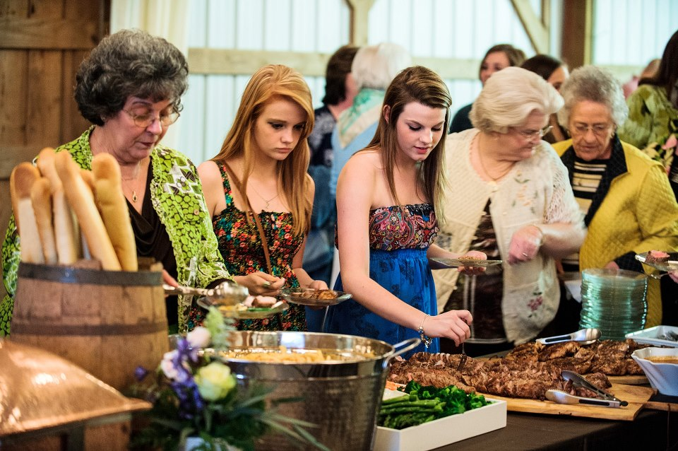

**Buffet Style**

Served with Caesar Salad, Bread, Disposable Plates, Silverware

$14.95 per person

* Shrimp & Polenta with Tomatoes, Capers, Lemon Butter Sauce
* Meatballs with Spicy Marinara
* Chicken Marsala with Creamy Polenta, Mushrooms, Truffle Oil, Tiny Green Beans
* Chicken Scaloppini with Creamy Polenta, Tomatoes, Capers, Green Beans & Lemon Butter Sauce
* Creamy Chicken Alfredo

$18.95 per person

* Grilled Sirloin with Herb Roasted Potatoes, Asparagus, Chimichuri Sauce
* Roasted Pork Loin with Smashed Potatoes, Green Beans, Grainy Mustard & Tomato Chutney
* Mezza Luna Lasagna
* Mezza Pasta Bolognese
* Southern Fried Gulf Fish with Tartar Sauce
* Mini Crab Cakes with Spicy Remoulade