Gold Buffet Menu

baby leaf salad
w/roasted red pepper, tomato, cucumber,
pine nuts, marinated olives
italian dressing
*

grilled salmon
w/ parmesan sauce
*
beef tenderloin OR pork medallion
w/ mushroom sauce
*
baby carrots & garden fresh green beans
*
fingerling potatoes in butter & italian parsley
*
fresh baked bread w/ butter
***

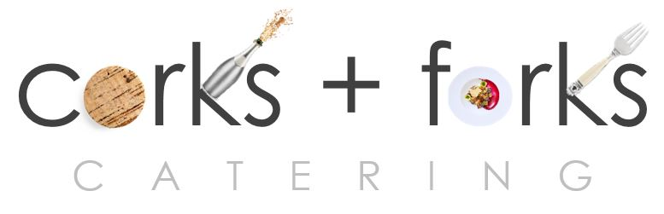

PO Box 8762 WPB FL 33407 PH: 561 339 2444
www.corksandforkscatering.com

