**Brunch Menu**

**~ Farmers Table ~**

***fruit, grilled vegetables , bagels, assorted cheeses, muffins, pastries***

**Salad Choices for Farmers Table (choose 2)**

***Chopped Salad***

***Warm pear salad***

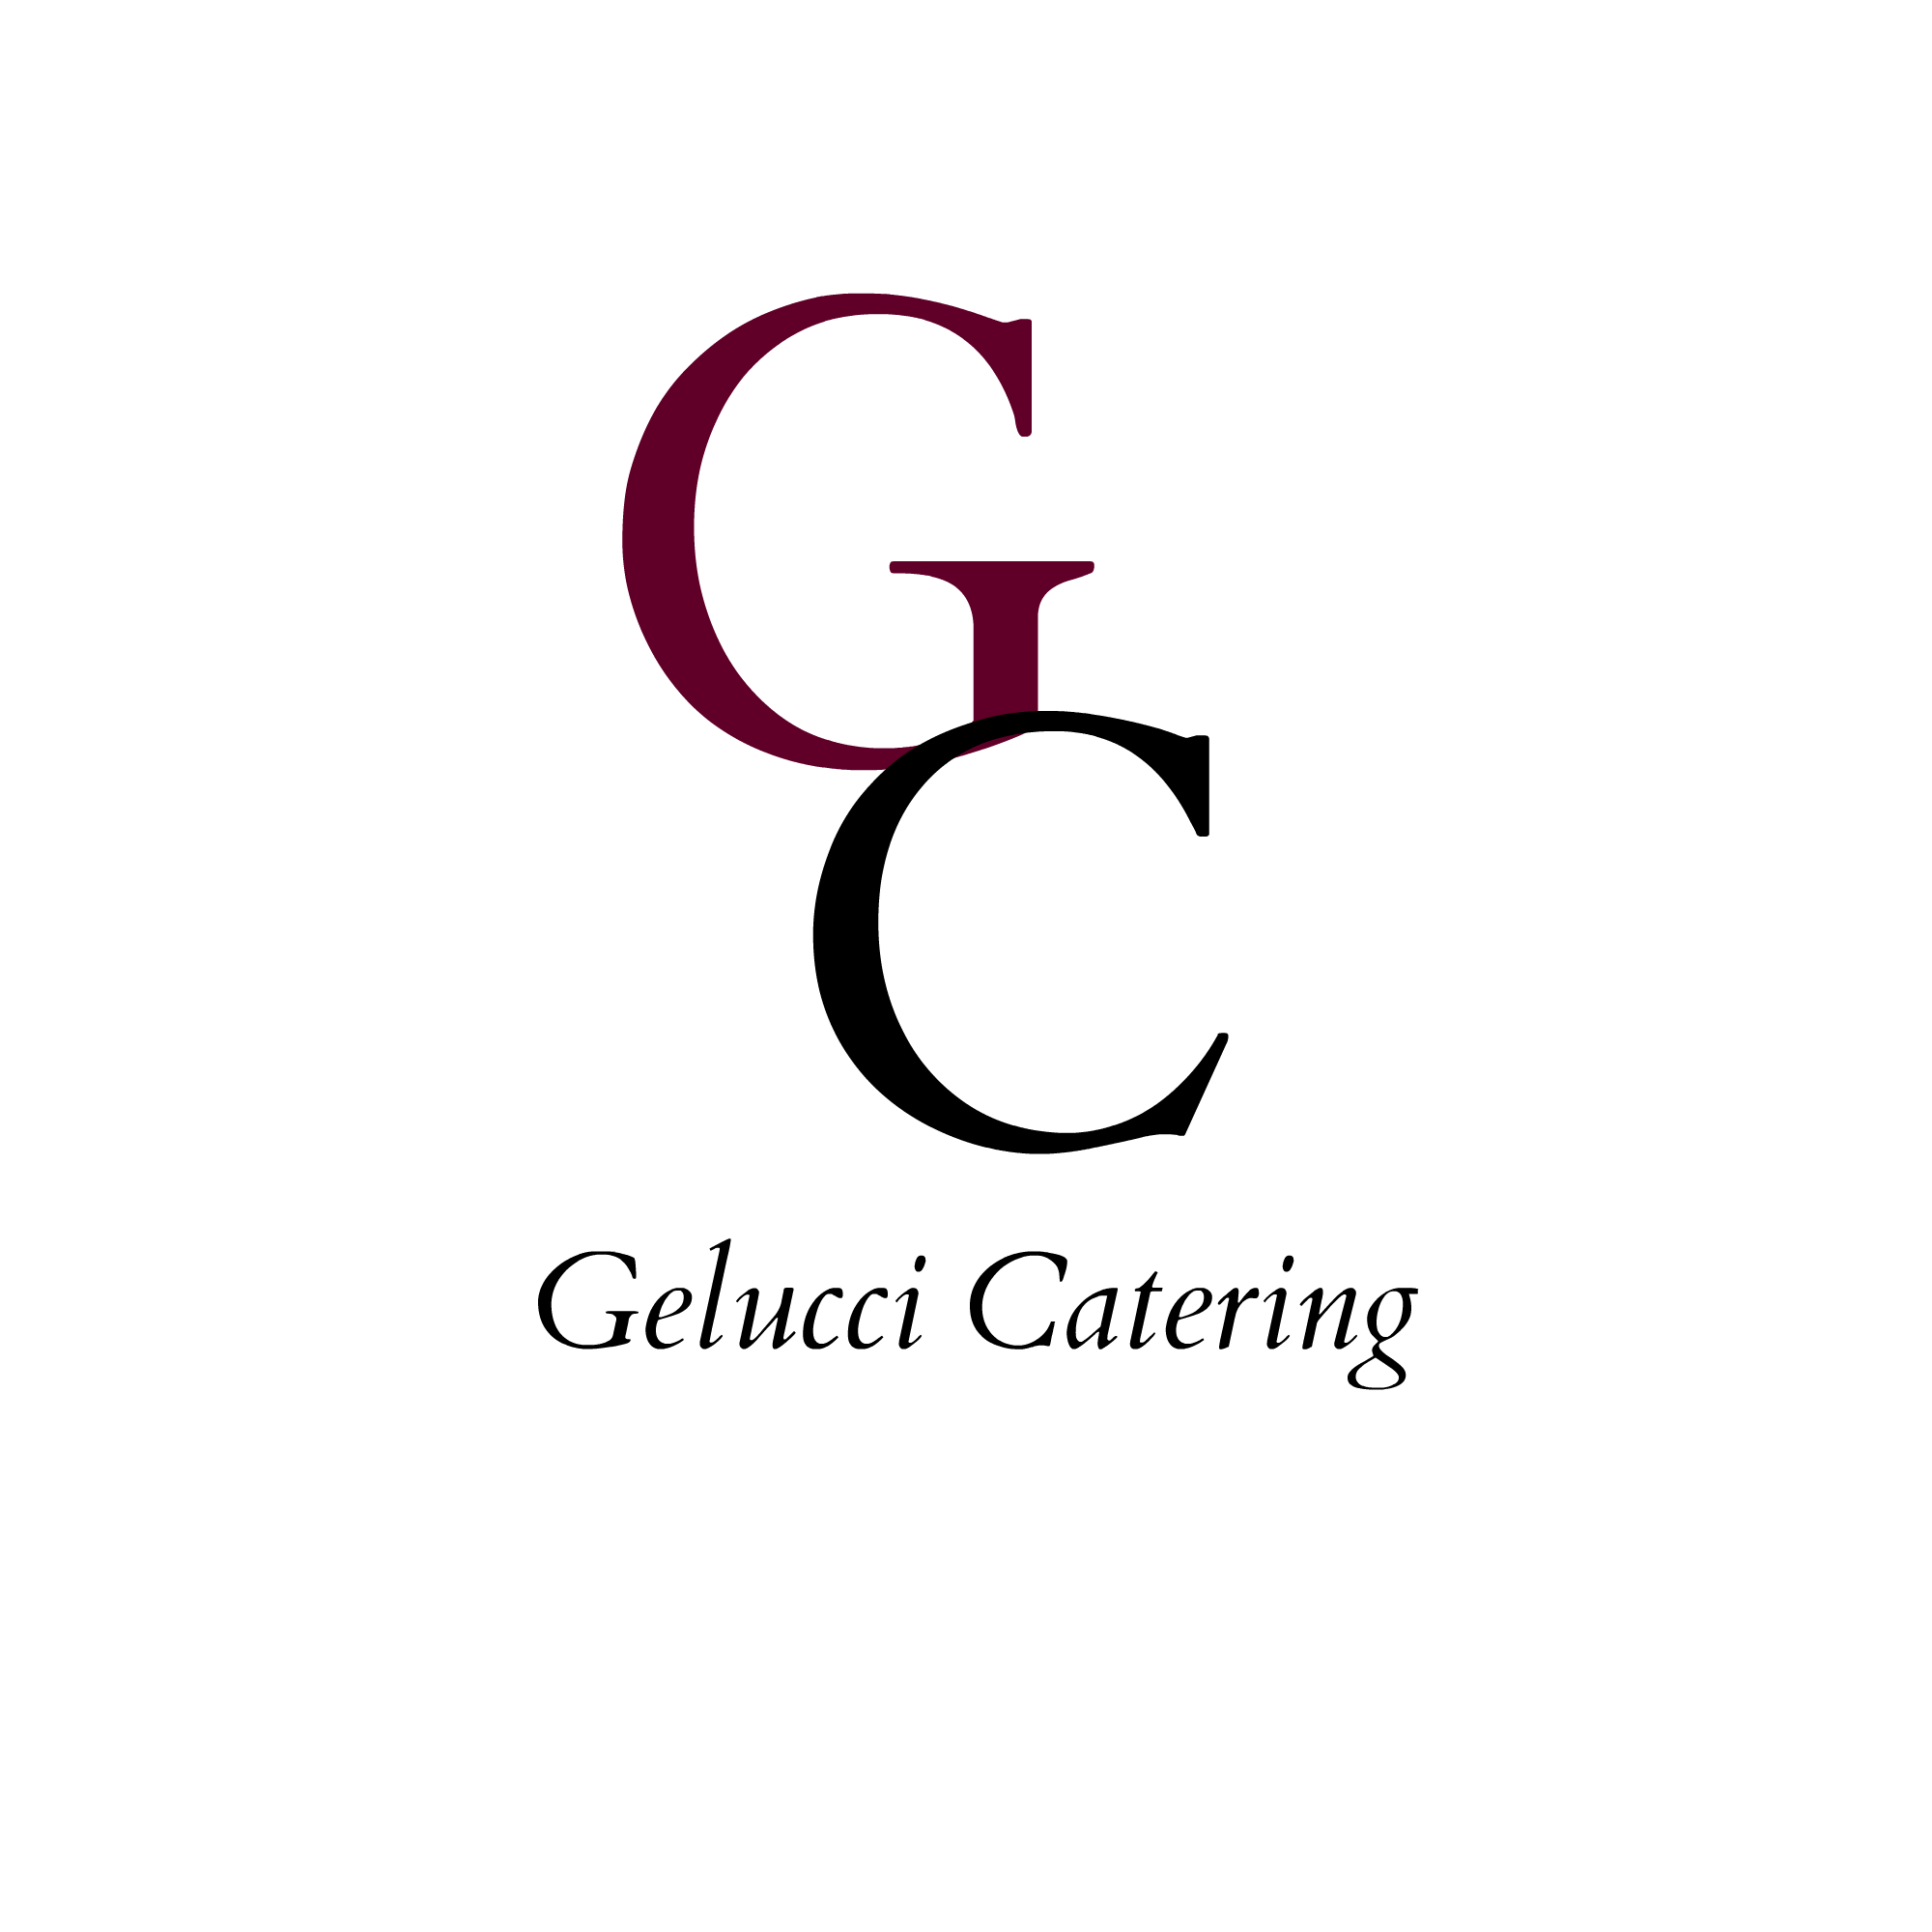***Caesar Salad***

***House Salad***

**ENTREES**

**host chooses 5. Guest has individual choice**

**SPINACH AND CHEESE OMELETTE**

**Three egg spinach and cheese omelet served with home fries & thick slab of bacon**

**BACON & EGGS**

**Thick cut bacon served with eggs over medium and homefries**

**CHICKEN POMODORO**

**Egg washed chicken with mozzarella cheese and a tomato sauce drizzled on top over penne pasta**

**GRILLED SALMON**

**Served in a lemon caper sauce with asparagus**

**LOBSTER QUESADILLA**

**Served with homefries and a chiptole sauce**

**PASTA PRIMAVERA**

Penne pasta served with grilled vegetables in a homemade red sauce

**HAM & CHEESE BURRITO**

**Diced ham served with scrambled eggs, shredded monterey jack cheese wrapped in a flour tortilla served with home fries**

**EGGS FLORENTINE**

**Three eggs baked with sauteed spinach and topped with truffle cheese sauce**