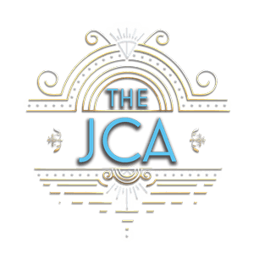
Jefferson Center for the Arts
1124 Pine Grove Drive Mt Shasta CA 96067 Wendy James Director cell: 917-371-7594 E-Mail: booking@jeffersoncenterforthearts.com
RENTAL FEES AND INFORMATION
2024
The JCA is available for rent for parties, weddings, concerts, rehearsals, performances and other special events. All renters must carry their own liability insurance. Once your date is confirmed, there is a $150 non-refundable fee to reserve the space. Renter must cancel at least 30 days before the scheduled event to be refunded the reservation fee.
Based on availability, the JCA is available to rent on the following days and times…

What would you like to rent? | Standard Fee | Non-Profit Fee
JCA theatre space only | $65 hr | $55 hr
JCA theatre space and kitchen | $75 hr | $65 hr
JCA theatre space, sound system, lights | $85 hr plus | $75 hr plus
JCA Full Weekend Rate 5+ hours each day, space only | $900 total Fri 3pm-Sun 8pm | $800 total Fri 3pm-Sun 8pm
JCA Full Weekend Rate w/kitchen, sound system, lights | $1200 total Fri 3pm-Sun 8pm | $1100 total Fri 3pm-Sun 8pm
JCA Special weekday summer rates, space only 8am-4pm | $50 | $40
Please Note: If stage lights and/or sound is needed, there is an additional charge of $30 per hour for our technical engineer.
The following items may be available for use, some items may be an extra charge: 22 meeting chairs, beautiful rugs, full sound system, grand piano, full kitchen including plates, cups, glassware and silverware, bakeware and cookware, dishwasher, 8mm projector, projection screens (2), Bluetooth short-throw projector, scrim, stage lighting, popcorn machine, rolling room separators, portable tables (6), outdoor tables, canopy.
Outdoor stage and field available for rent at $50 per hour. Half price if renting the theatre space as well.
Contact Wendy at info@jeffersoncenterforthearts.com for more info
www.jeffersoncenterforthearts.com
JCA is a 501 c3 nonprofit organization. Rental fees are completely tax-deductible

