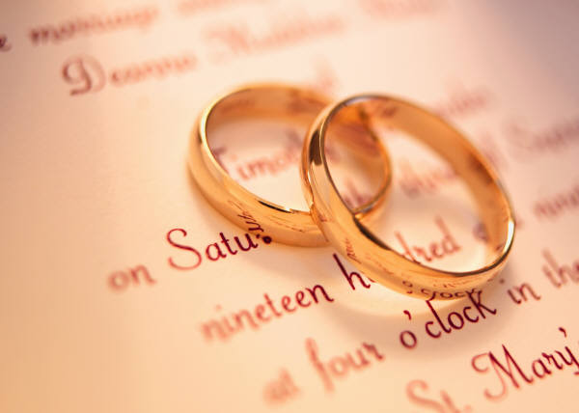
Bridal Party Entry Information
These questions will allow us to make your day much more simple!
Hey! Mr. DJ! Entertainment Services
3403 College Dr
Louisville, KY 40299
(502) 296-3950

Bride’s Grandparents:___________________________________________
Groom’s Grandparents:__________________________________________
Bride’s Parent's_________________________________________________
Groom’s Parents:________________________________________________
Flower Girl(s):____________________Ring Bearer(s)__________________
Flower Girl(s):____________________Ring Bearer(s)__________________
Flower Girl(s):____________________Ring Bearer(s)__________________
Bridesmaid:______________________Groomsmen:___________________
Bridesmaid:______________________Groomsmen:___________________
Bridesmaid:______________________Groomsmen:___________________
Bridesmaid:______________________ Groomsmen:___________________
Bridesmaid:______________________ Groomsmen:___________________
Maid/Matron of Honor:_____________Best Man:______________________
Bride:___________________________ Groom:_______________________
Please write exactly how you want to be introduced:____________________

Bridal Party Bio Info
Please be sure to place bios as they would be introduced
Bridesmaid:______________________________________________________________________________________________
Groomsmen:_______________________________________________________________________________________________
Bridesmaid:_______________________________________________________________________________________________Groomsmen:_______________________________________________________________________________________________Bridesmaid:_______________________________________________________________________________________________
Groomsmen:_______________________________________________________________________________________________

Bridesmaid:______________________________________________________________________________________________
Groomsmen:_______________________________________________________________________________________________
Bridesmaid:_______________________________________________________________________________________________Groomsmen:_______________________________________________________________________________________________Bridesmaid:_______________________________________________________________________________________________
Groomsmen:_______________________________________________________________________________________________
Bridesmaid:______________________________________________________________________________________________
Groomsmen:_______________________________________________________________________________________________
Bridesmaid:_______________________________________________________________________________________________Groomsmen:_______________________________________________________________________________________________Bridesmaid:_______________________________________________________________________________________________
Groomsmen:_______________________________________________________________________________________________
Maid or Matron of Honor: ________________________________
____________________________________________________
Best Man: ____________________________________________
____________________________________________________
Bride:___________________________________________________________________________________________________
Groom:_________________________________________________________________________________________________

