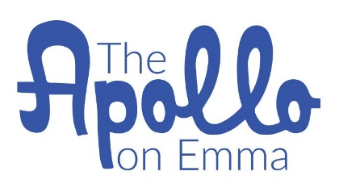

All Inclusive Wedding Packages

50 Guests or less $4700
Includes:
2 tier cake from Shelby Lynn’s Cake Shoppe
50 petite fours from Shelby Lynn’s Cake Shoppe
Venue 3 hours
White Chiavari chairs with white cushions
Reception tables
Linens for 10 tables
Dancefloor
Micro-Eats from Cara Marsh Catering
Day of Coordination (Including set up/break down + styling)
Ceremony backdrop
Champagne
Champagne glasses

Other additions that can be added to package for additional costs (this does not include tax).

$350 Floral arrangements including bridal bouquet
$300 Bar-tender
$280 Fork & Crust pie or bite size pies for 50 guests
$250 Acrylic cake table
$100 Cake plates + forks
$600 DJ for 3 hours or $400 for 2 hours
$800-1500 Photographer
Photographers to choose from at least 1 month in advance:
Steph Smith Weddings http://stephsmithweddings.com/
Keely Montoya Photography https://www.themontoyacollective.com/
Jason Hudson Photography https://www.hudsonphotos.com/
Benfield Photography https://benfieldphotography.com/
$100 Officiant

*We do not carry a liquor license so you may bring in your own.

To book contact Heidi Ann Faires at theapolloonemma@gmail.com
We require 50% of the total amount due in order to reserve your date.
Remaining balance is due 60 days prior to your event date.

