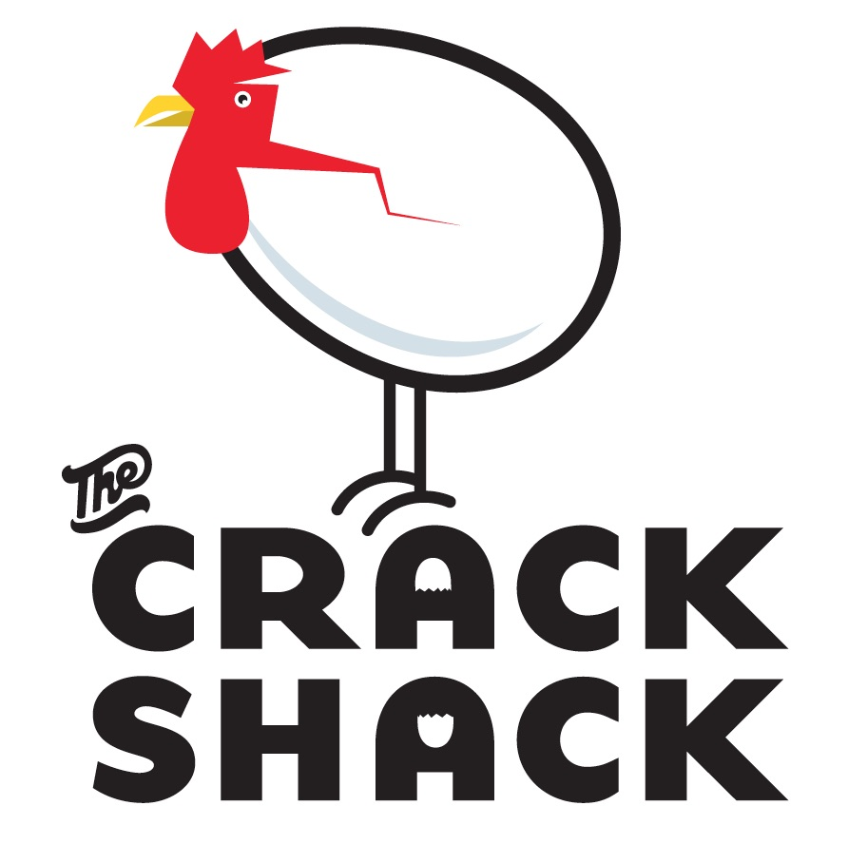

CUSTOMER
Name: _________________________
Event: __________________________
Phone: _________________________
E-mail: __________________________

PROPERTY
The Crack Shack (location)
Address
Phone
E-Mail

We’re delighted to host you and your group! Before we get to the fun stuff, let’s make sure we agree on the details.

This letter is confirmation that the requested space is being reserved on your behalf. Signing this letter will serve as your agreement to all The Crack Shack policies, procedures and cancellation clauses. Your hold on the space is contingent on your signing this agreement and, if applicable, paying a deposit.

EVENT DATE: ______________________________________________
EVENT TIMEFRAME: ________________________________________

FOOD & BEVERAGE: Due to licensing requirements and for quality control, all food and beverage served at The Crack Shack must be supplied and prepared by the restaurant.

The Crack Shack does not charge a space rental fee. Instead, the minimum revenue anticipated by The Crack Shack under this agreement (before taxes and other charges) is _$_________________, committed to food and beverage revenue. This minimum amount must be met, or exceeded, prior to the addition of state tax, gratuity and administrative fees. If these minimums are not met through food and beverage, the difference will be charged as a room fee and are also subject to tax, gratuity, and administrative fees. The room fee is non-negotiable and will not be substituted for gift certificates.

Food and beverage costs will be confirmed on the provided BEO. All food and beverage totals are subject to 7.75% state sales tax. A gratuity of 18% of the total food and beverage revenue (plus all applicable taxes), will be added to all food and beverage charges.

It is our intent to accommodate any requests due to dietary restrictions. These requests must be submitted seventy-two (72) hours prior to the scheduled event date. Severe food allergies must be shared in advance so that the kitchen can take any necessary precautions when preparing food; otherwise The Crack Shack will be held harmless from, and against, any and all liability or claim of liability for any personal injury that occurs as a direct result of our negligence or any of our representatives.

It is the policy of The Crack Shack to support all state and local laws regarding the sale of alcoholic beverages. Everyone in attendance who is drinking will be required to have a valid ID. If an individual does not have a valid ID, no service of liquor, beer or wine will be made.

PAYMENT & DEPOSITS:
A 50% security deposit must be provided to The Crack Shack and processed in order to secure a specific space for the date of your function. All deposits provided prior to the event date will be applied to the final bill at the conclusion of the event. Payment for all remaining charges are due at the conclusion of the event. The physical card or another form of payment onsite must be used to pay all final charges at the completion of the event. We accept the following forms of payment: Cash, Check, American Express, VISA and MasterCard.

CANCELLATION:
You may cancel the event subject to the following charges. An authorized representative of The Crack Shack must receive your notice of cancellation in writing.
- 30 days or less prior to scheduled event: Client will forfeit the deposit (50% of total minimum revenue)
- Within 24 hours of scheduled event: Customer will be charged 100% of total minimum revenue
Should The Crack Shack need to cancel this event for any reason, the restaurant will provide written notice to the Customer, and refund all deposits paid.

GUEST COUNT:
Final confirmation for the number of guests attending your event is required by 12pm, three days prior to your event.

DECOR/VENDORS:
The Crack Shack must be informed of any and all decor, flowers, vendors, etc. to be brought in for your event. The Crack Shack does not provide any decor of any kind for events (including plates or china and linens), but can source for an added fee.

AUDIO/VISUAL:
All requests for Audio Visual equipment must be received seven (7) business days prior to the scheduled event. Any A/V requests outside of our current capabilities may be subject to an installation or equipment fee.

PHOTOGRAPHY:
Photography is permitted, and welcomed! If you’re open to The Crack Shack sharing photos from your event, feel free to send them our way or put us in touch with your photographer.
LIABILITY:
The Crack Shack reserves the right to inspect and control all private functions. The guest agrees to be responsible for any damage to the restaurant. The Crack Shack shall not be responsible for damage or loss of any merchandise or articles brought into the restaurant, or for any items left unattended.

DEFAULT:
The failure and/or refusal by you to make payment as specified in the Agreement, at the option of The Crack Shack, shall constitute cancellation of the event by you. The restaurant shall retain all deposits and advance payments.
EVENT PAYMENT PLAN:
 | DEPOSIT AMOUNT | DATE DUE
Initial Deposit | $____________  (50% of Food and Beverage Minimum) | _____/_____/_________  With signed agreement, required to hold requested space
Final Deposit | $____________  Final estimated balance due (based on guest count and estimated costs) | _____/_____/_________  To be charged to credit card on file at event conclusion

Authorized Signer: ____________________________
(Print Name)

Signature: ____________________________________

Date: ________________________________________​

