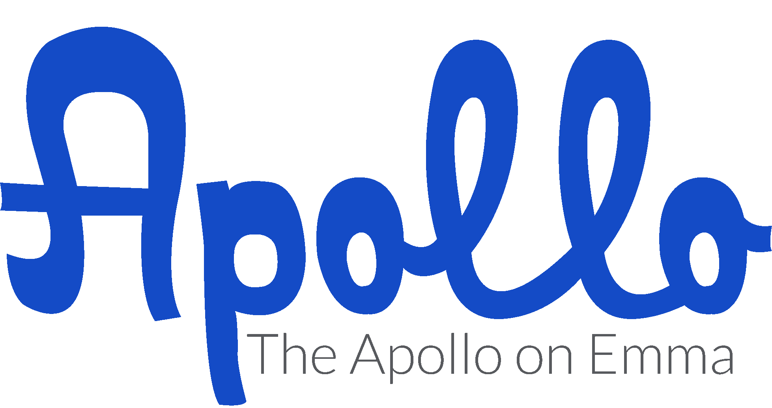

The Apollo on Emma

Pricing Information

**Monday through Thursday**

**$1500.00 (Under 100 Guests)**

**$2000.00 (Over 100 Guests)**

9:00 am through 11:00 pm

This includes access to all areas of venue excluding the Garden Patio

(*additional charges for use*)

**Full Facility: Saturday - $6500.00**

***Ask about details on renting The Grove Cottage for additional cost as a***

***Bridal Suite | Bride & Groom sleeping quarters | Family Air bnb***

* 9:00 am through 11:00 pm (Have until Midnight to have everything out)
* Chairs and tables for 400 (Including cushions for all your chairs)
* Catering kitchen with ice machine & commercial fridge
* Garden Patio that seats up to 200 & is covered year round
* Signature Cocktail Lounge with built in bar
* VIP Room overlooking the main ball room
* Full access to all A/V for show casing movies or photos or dance screens
* Movie marquee to place special messages for your big event
* Two hour photo session with your photographer before your event date
* Bluetooth and Wi-Fi connections to all house speakers

**Full Facility | Friday - $3500.00**

***Ask about details on renting The Grove Cottage for additional cost as a***

***Bridal Suite | Bride & Groom sleeping quarters | Family Air bnb***

* 9:00 am through 11:00 pm (Have until Midnight to have everything out)
* Chairs and tables for 400 (Including cushions for all your chairs)
* Catering kitchen with ice machine & commercial fridge
* Garden Patio that seats up to 200 & is covered year round
* Signature Cocktail Lounge with built in bar
* VIP Room overlooking the main ball room
* Full access to all A/V for show casing movies or photos or dance screens
* Movie marquee to place special messages for your big event
* Two hour photo session with your photographer before your event date
* Bluetooth and Wi-Fi connections to all house speakers

**Full Facility | Sunday - $2,500.00**

***Ask about details on renting The Grove Cottage for additional cost as a***

***Bridal Suite | Bride & Groom sleeping quarters | Family Air bnb***

* 9:00 am through 11:00 pm (Have until Midnight to have everything out)
* Chairs and tables for 400 (Including cushions for all your chairs)
* Catering kitchen with ice machine & commercial fridge
* Garden Patio that seats up to 200 & is covered year round
* Signature Cocktail Lounge with built in bar
* VIP Room overlooking the main ball room
* Full access to all A/V for show casing movies or photos or dance screens
* Movie marquee to place special messages for your big event
* Two hour photo session with your photographer before your event date
* Bluetooth and Wi-Fi connections to all house speakers

**There is a mandatory $250.00 cleaning fee for those accessing the full venue.**

**The Apollo on Emma is happy to break down your chairs & tables at the duration of your event for an additional $200.00 each.**

**Full Facility Rental Includes:**

* Full use of the facility (Only Friday through Sunday has Patio included)
* Full use of the catering kitchen
* Metropolis Room|Bridal quarters
* 400 White Chivari chairs
* 35 60” Round tables
* 4 6ft. Rectangle tables
* 2 8ft. Rectangle tables
* Free Wi-Fi & Blue-Tooth
* Access to audio|video
* Access to large 7000 lumens high-def projector
* Over 5,000 square feet of space
* Local vendor recommendations
* Access to movie marquee board and lettering
* Upscale cocktail lounge

**Friday through Sunday the Garden Patio is included in package.**

* 9am through 11pm
* Tables & Chairs for 150 guests
* Covered year round with White Tent
* Food Truck Service Area
* Client can bring in own food or hired vendor
* Restrooms located inside the building

**If you would like your chairs and tables set up by an Apollo representative, there is a $200.00 additional fee for each, this DOES NOT include Weddings. Ask about prices for Day of Coordination.**

**Metropolis Room & Cocktail Lounge 55 capacity in each room| Ideal for small corporate meetings or parties | Baby Showers | Private Dinners**

**Monday through Thursday - $500.00 for 4 hours**

* 9:00 am through 2:00 pm or 5:00pm through 10:00pm
* Capacity is 55 guests
* Includes 2 flat screen smart TV’s for presentations
* Includes tables and chairs for 40 guests
* Space has 2 built in coffee bars

**Cocktail Lounge | Parlor 55 capacity | Ideal for bridal showers | Brunch | Baby shower | Rehearsal Dinners | Cocktail Parties | Bridal Luncheon | Engagement Dinners**

**Monday through Thursday - $500.00 for 4 hours**

* Includes chairs and tables
* Built in bar
* Crystal chandeliers
* Custom Art Work on walls
* Mini fridge with sink
* A/V speakers for background music

**Garden Patio: Monday through Thursday**

**$1000.00 (Under 100 Guests)**

**$1500.00 (Over 100 Guests)**

This space also rents at 4 hour increments at $500.00 for 4 hours.

9 am to 2 pm or 5pm to 10 pm

**There is a mandatory $100.00 cleaning fee for those accessing the Metropolis Room or Cocktail Lounge and Garden Patio.**

**The capacity for each room is:**

Outer Lobby 42

Cocktail Lounge 55

Ballroom 551

Metropolis Room 55

Garden Patio 200

*We offer a 10% discount on our Friday, Saturday and Sunday rates to all non-profit and fundraising organizations.*

Time variations and pricing available upon request. Email or call us with any questions regarding renting the space during the Sunday through Thursday time frames.

Located in historic downtown Springdale, the vintage building makes for great photography. **We offer photo sessions** **at The Apollo on Emma starting at $100 per hour**. All brides that book with us for a Friday through Sunday will have a 4 hour at no extra cost, bridal or engagement shoot with their photographer. This 2 hour shoot must be taken during Monday through Thursday with a scheduled appointment.

**Holiday Pricing for the following Holidays will be set at a varied rate. For details please email us at theapolloonemma@gmail.com**

New Years

4th of July

Christmas

Labor Day Weekend

Memorial Weekend

There are several breweries and a few local bistros that are within walking distance. Arkansas Missouri Railroad is only a block and ½ away from The Apollo on Emma and offers rides from downtown Springdale to Dickson Street.

There are several shops that offer great gift for weddings & events.

We have a local florist | Organic Creations, cake shop | Shelby Lynn’s, & Catering | Catering Unlimited. There are also a few food trucks that offer services | Big Sexy Food & Natural State Sandwiches. We are happy to offer any recommendations as needed.