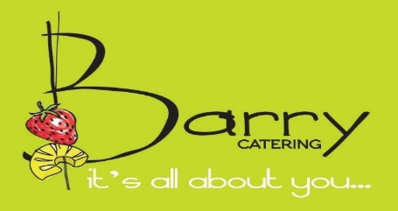
Document Edit Date: |  | Adults: |  | Kids:

To: |  |  | Event Type: | WEDDING

Event For: | DINNER STATIONS/  SIT DOWN |  | Event Day & Date:

Location: | E LOUNGE |  | Event Time:

Reference is made to the above and your recent inquiry. The following information is meant as a guideline for determining our pricing for catering your event.

FOOD:

ADULT MENU:

Appetizer Station | 1 During the Cocktail Hour Included

Appetizer Courses before Entrée (i.e. Salad, Soup) | Included

Dinner Stations or sit down | Chicken, Fish, Beef, Starch, Vegetable(Select 2entrees)

Fresh Baked Breads | Included

Wedding Cake | Included

BEVERAGE SERVICE:

Daytime:
Full Top Shelf Liquor Bar | $ 20.00 Per Person

Beer, Wine and Vodka | $ 16.00 Per Person

Beer and Wine | $ 14.00 Per Person

Set Ups Only (Client Provides Alcohol | $ 4.00 Per Person
Evening:
Full Top Shelf Liquor Bar | $ 22.00 Per Person

Beer, Wine and Vodka | $ 18.00 Per Person

Beer and Wine | $ 16.00 Per Person

Set Ups Only (Client Provides Alcohol | $ 4.00 Per Person

BARTENDER $185.00 PER BARTENDER

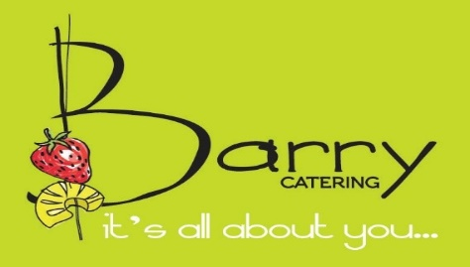
AVAILABLE MENU OPTIONS & UPGRADES:

Filet Mignon $ Market Price per person

seafood station $ Market Price per person

Standard icing Celebration Cake: $ INCLUDED per person

Wine Service TABLE SIDE Priced Accordingly

MARTINI BAR (+ $200 Bartender Fee)$ 8.50 per person

SUSHI BAR $ 10.00 per person

LAMB CHOP CARVING STATION $ 8.50 per person

ADDITIONAL STANDARD STATIONS $ 8.50 per person

LAVISH DESSERT BUFFET (Viennese Table) $ 8.50 per person
**MENU AND SERVICE COST: (includes China, Silverware, Glassware)
(Price Quote Based Upon 100 Adults Attending)

ADULT PRICE, FOR THE ABOVE | $49.00 | PER PERSON

LINEN TABLE CLOTHES AND NAPKINS AT COST

SERVICE CHARGED ON FOOD AND BEVERAGE | 22%

NEW JERSEY SALES TAX | 7%

**VENUE RENTAL IS NOT INCLUDED IN THE ABOVE PRICE ($550 DAYTIME, FRIDAY NIGHT AND SUNDAYS; $750.00 SATURDAY EVENING)

How can we reserve our date?
A $ 1500.00 DEPOSIT is required to schedule your Event Date on our catering calendar.

What is included in our station set ups?
All Stations are Draped to the floor, Propped and Elegantly Decorated.

What is the best way to finalize our plans?
We should meet to discuss your event plans and detail what options to include in your event plan.

What do we need to do to provide meals for our hired vendors: Bands; DJ; Photographers;
Videographers?
Meals for hired vendor service personnel must be ordered in advance of your event and are charged
Separately.

THANK YOU.
Barry Catering

