Private Events Informational Packet
No Matter the Occasion Let us Help to Make it a Memorable One

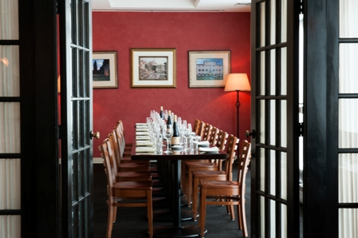

Here at Tomasso, we have many options ranging from our private dining room to a full restaurant buyout, which means no party is too big or too small for us to accommodate! We host all types of events, from corporate dinners to bridal showers and everything in between. Our friendly and knowledgeable staff is dedicated to ensuring that events are executed to perfection. Take a look through this informational packet which will guide you through our different venue options to see if Tomasso is the right place for your next event!

The Venue
Our most frequently booked room is our Private Dining Room. With space large enough to accommodate 30 guests, it also has a cozy feel that allows a party of 10 to feel comfortable. Our Private Dining Room has its own private entrance so if you are planning a party that is sure to mean lots of gifts and/or decorations it makes loading and unloading the car a breeze.
Equipped with a built in pull down projection screen and an onsite projector, our Private Dining Room makes it easy to put on a business presentation or slideshow for a recent graduate during dinner. All this equipment is available for use at no additional cost! Depending on the number of guests this room also allows for an array of table configurations to best suit your needs.
Conference Style – Arrangement Seats up to 16
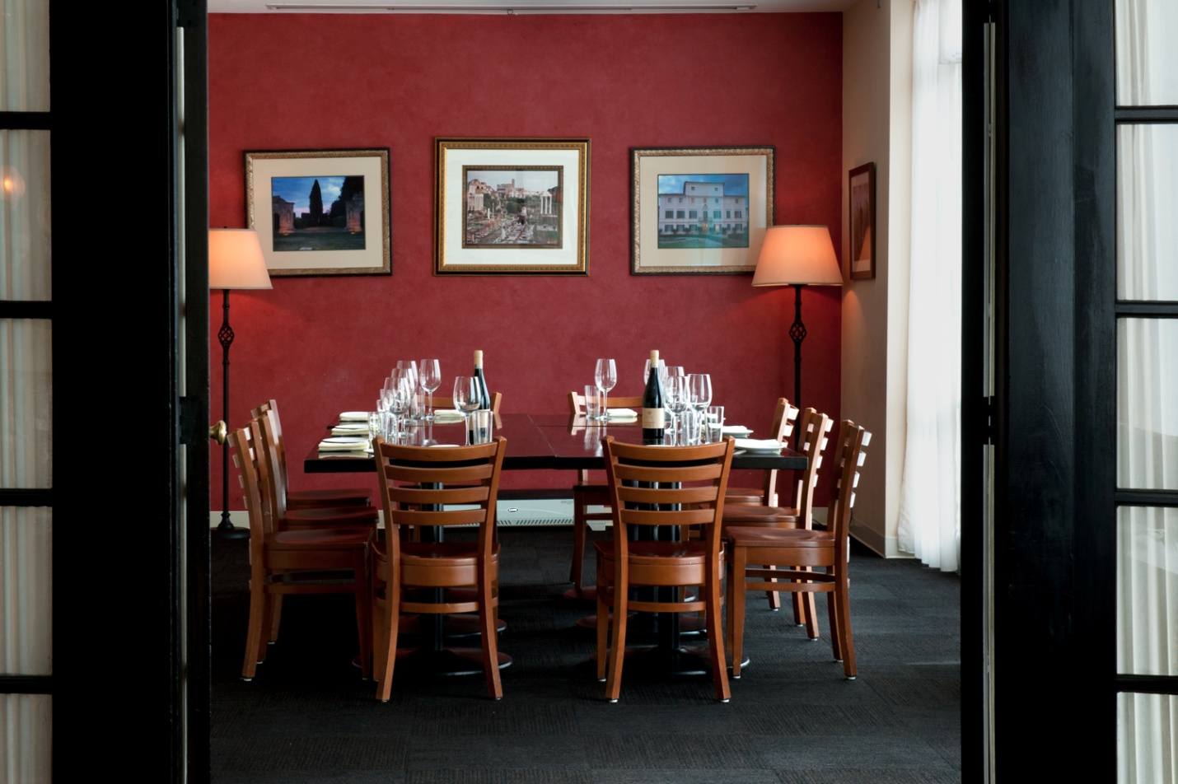

Banquet Style – Arrangement Seats up to 20
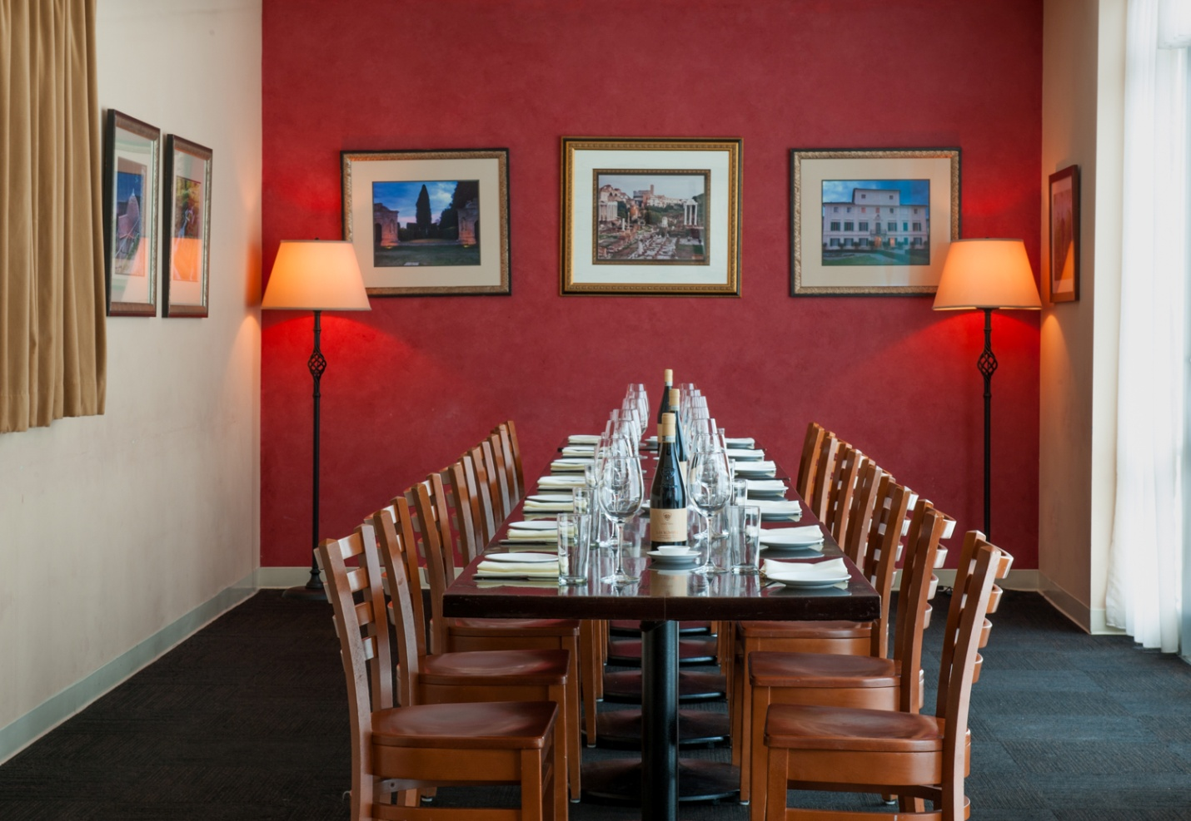
Multiple Table Format – Arrangement Seats up to 30
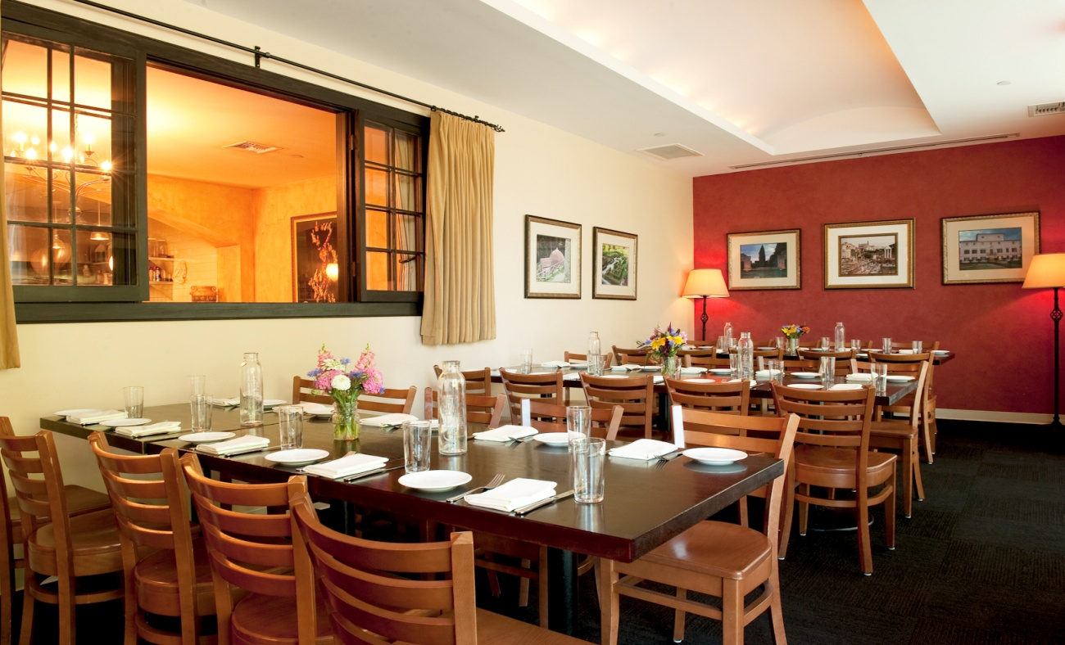

Another popular choice for private dinner parties is our Kitchen Alcove. This room is a semi-private dining area that is attached to the main dining room which overlooks our open kitchen. This dining area allows for privacy from other guests while still being part of the action. It can hold up to 24 people and two different style table arrangements to choose from depending on the number of guests.
Banquet Style – Arrangement Seats up to 18
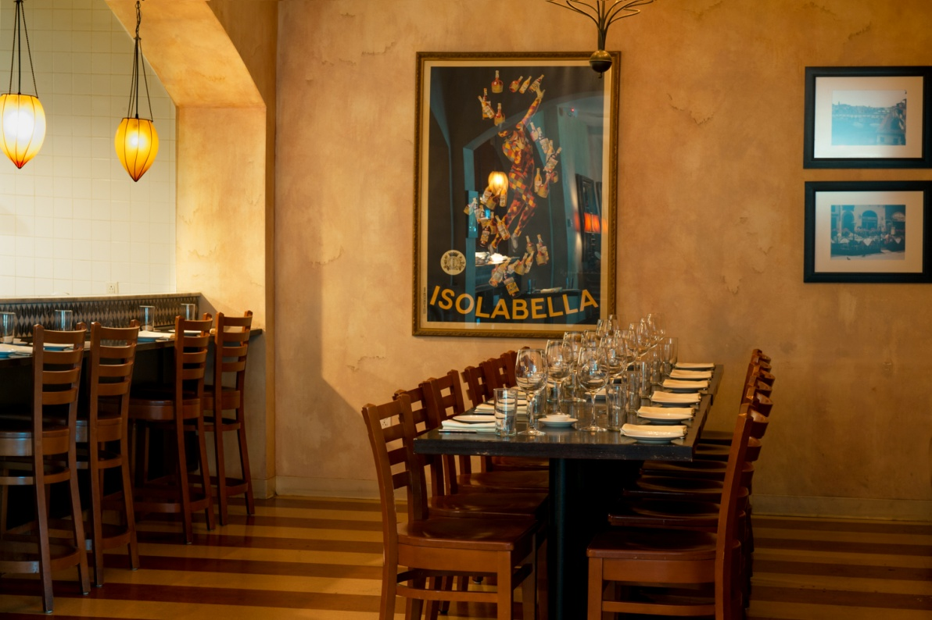
Multiple Table Format – Arrangement Seats up to 24
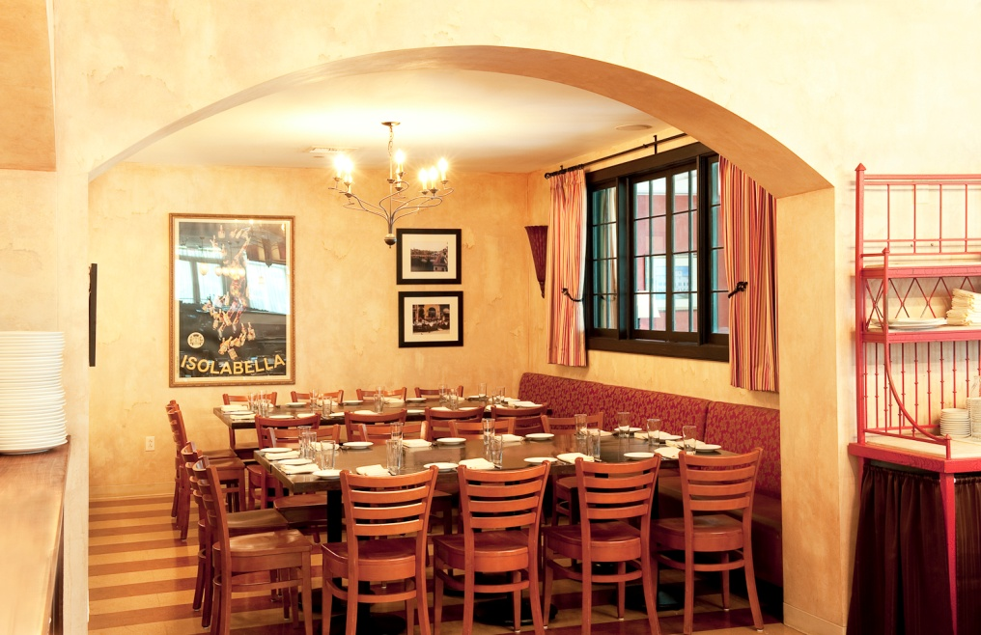

Have a big company outing you’re planning or a large family to host? Don’t worry, we can help with that too. We also offer private parties in our Main Dining Room which can hold up to 50 guests! Have a group that’s even larger than that? Not a problem, we can work with you by added the Kitchen Alcove and/or the Private Dining Room as well! Table arrangements will vary according to how many people you have and your personal preferences.
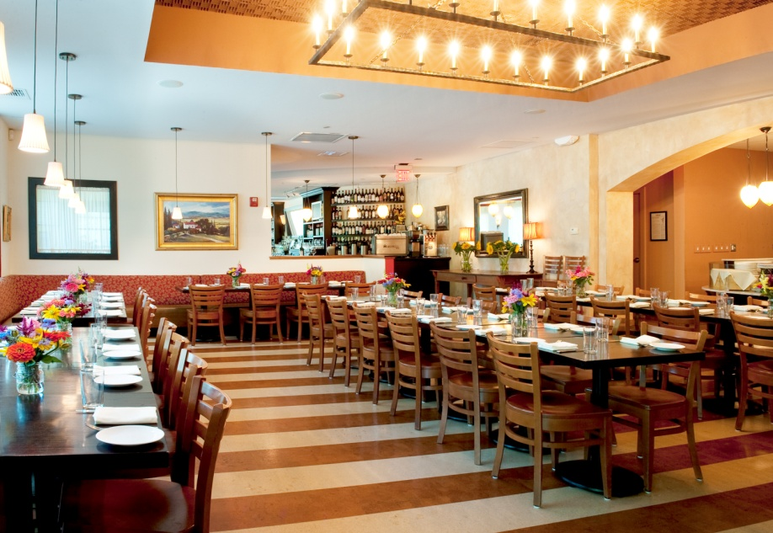
Want to plan something a little less formal than a traditional sit down dinner? Our Enoteca is perfect for cocktail parties! Great for networking in a fun more casual atmosphere, we are able to accommodate up to 60 guests in our bar and lounge for drinks and passed and stationary appetizers! The Enoteca is also available for sit down dinners which can seat up to 28 guests in a multiple table format. 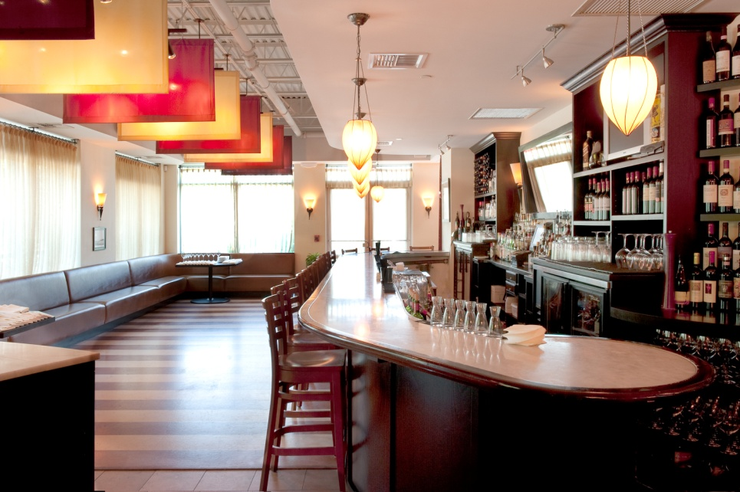

Private Event Experience
Private Events at Tomasso Trattoria not only come in all different sizes but are booked for various reasons. We offer a unique atmosphere which allows us to tailor to our guest’s needs no matter the occasion. Most commonly our Private Dining Room is booked for company dinners, often for business meetings and presentations followed by or during dinner; other times companies book us for outings with their team to celebrate a great quarter, office holiday parties, retirement parties, or to entertain clients with a fantastic meal.
Other types of frequently booked events include birthday parties, wedding rehearsal dinners, baby showers, bridal showers, anniversaries, graduations, family or class reunions, even entire weddings from ceremony to reception, we have done it all! You may be thinking, some of these events are typically celebrated on Saturday afternoons or Sundays and Tomasso is not usually open, but we will open just for you when you book at either of those times. It’s a wonderful feeling to be able to come into the restaurant and know that the entire staff is devoted entirely to you and your guests! Having a restaurant that is filled with only friends and family truly creates a memorable experience. We also have a special relationship with Gulbankian Florist in Southborough and they do an exceptional job with flower arrangements for any occasion and we can handle all the work for you!

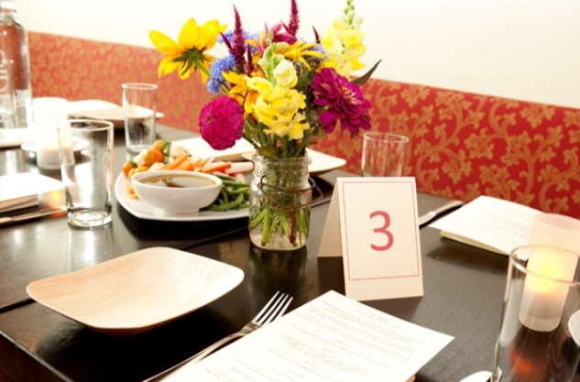

Executive Chef Daniele Baliani and Chef de Cuisine Joao Neto can put together a menu that will have all your guests asking for the recipes! We also have a fulltime Pastry Chef Jennifer LaRosa, she is a true master of her trade and can whip up just about anything for your party. Combine our all-star kitchen crew with our experienced waitstaff your party is guaranteed to be success!
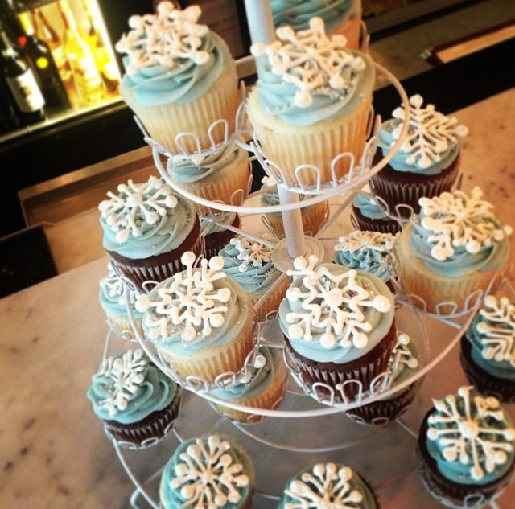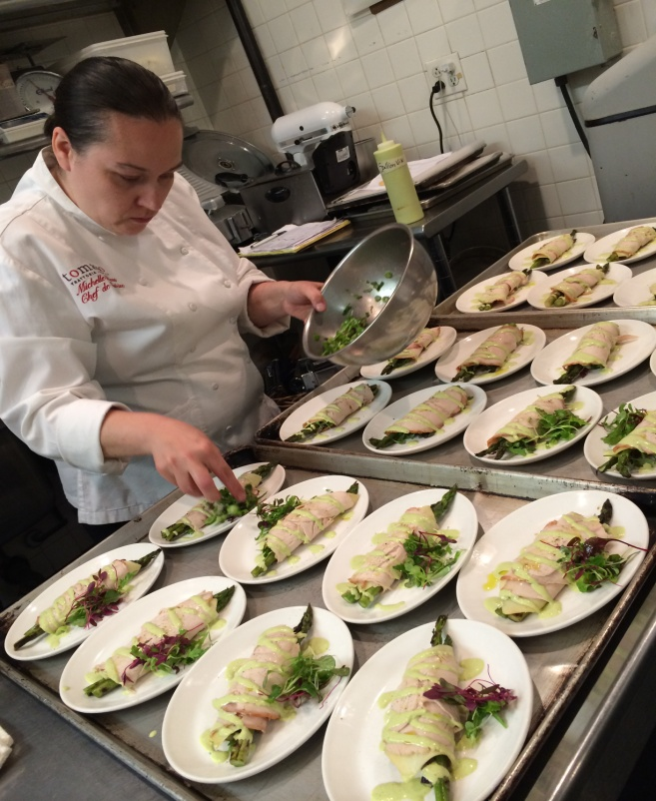
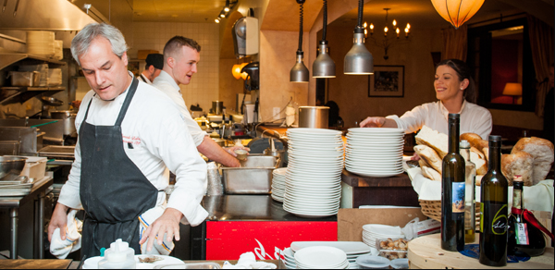

Apart from your traditional sit down dinners, we also offer wine education series, wine tastings, cocktail reception parties, networking events, and off-site events as well. Our Assistant General Manager and Beverage Director ,Jeremy Margwarth, is an expert when it comes to Italian wines and his education series and wine tastings make for a night you will never forget.

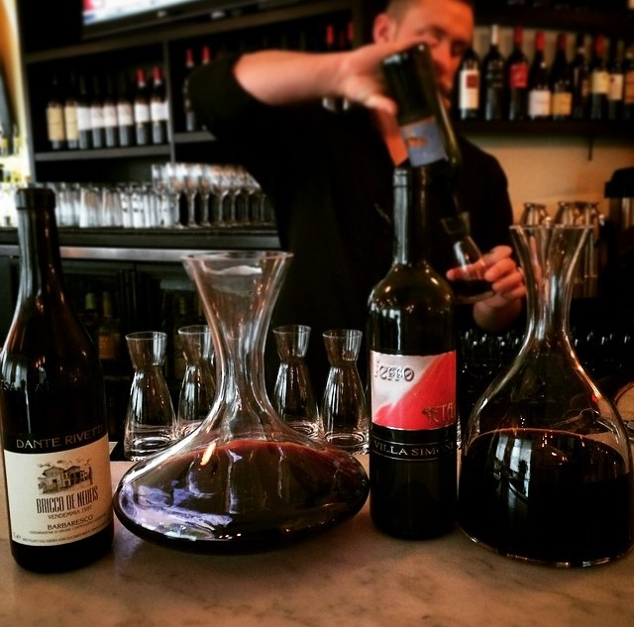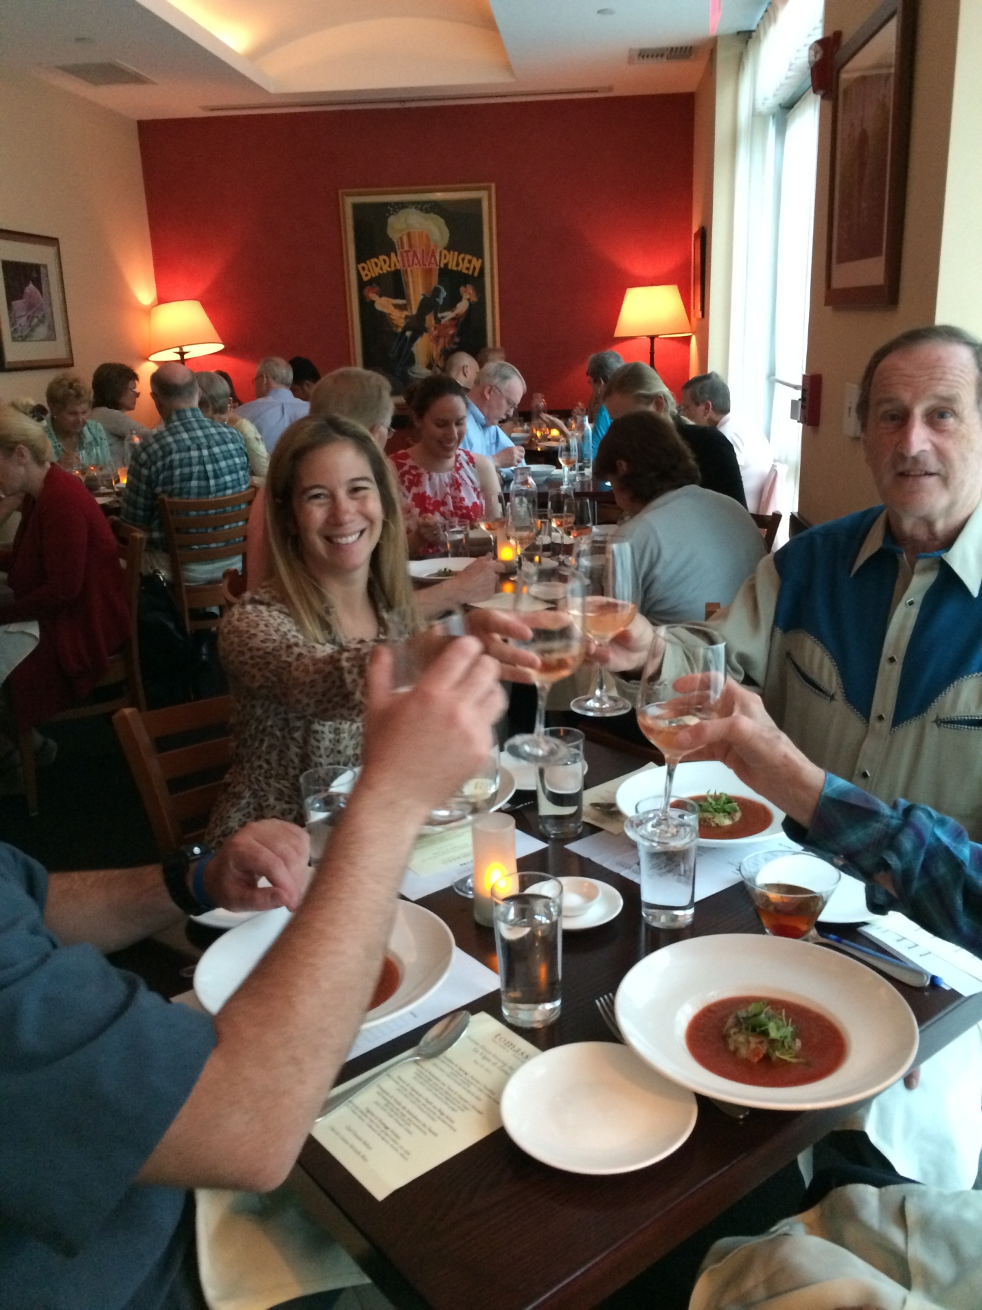
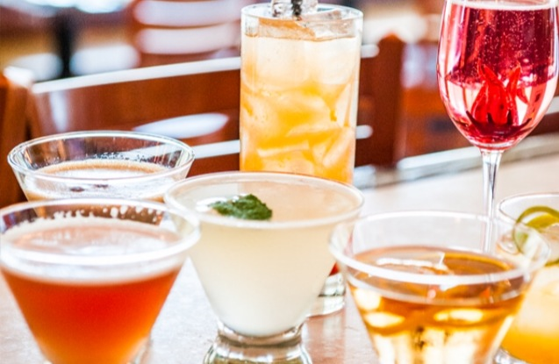

To find out more about availability and pricing call
508.481.8484
or email Jeremy Margwarth at
jeremy@tomassotrattoria.com
More information is also available on our website
www.tomassotrattoria.com
Don’t forget to like us on Facebook and follow us on twitter and instagram!
- /tomassotrattoria
@tomassotrattoira
@tomassotrattoria

Sample Menu

antipasto Chef’s Antipasti Platter cured italian meats, artisanal cheeses, assorted small bites
insalata
Insalata Verde baby arugula, pickled shallots, Pecorino Toscano, lemon thyme vinaigrette
pasta
Penne alla Pomodoro penne pasta, traditional tomato sauce
secondi
Bistecca herb roasted fingerling potatoes, arugula, red wine reduction
Pollo free range statler chicken breast, mushroom sugo, pan jus
Pesce Spada grilled swordfish, sautéed broccoli rabe, lemon caper butter
Napoleon di Melenzana lightly fried crispy eggplant, fresh mozzarella, pomodoro sauce, braised greens

dolce
Torta di Cioccolata flourless chocolate cake, chocolate mousse, ganache, chocolate shavings berry sauce, whipped cream
Tiramisu lady fingers, espresso, whipped mascarpone, chocolate shavings

Executive Chef Daniele Baliani
Chef de Cuisine Joao Neto

