Endless Possibilities & Timeless Charm
It's all about the experience!

2020 & 2021 Wedding Special - $3225.00

For parties with 40-120 guests
Only $500 down to reserve your date!
The remainder is due 30 days before the wedding.

This Wedding Special Includes:

10-Hour Full Building Rental for Wedding Ceremony & Reception
Logan Room, Sylvester Lounge, Bridal Suite, Groom's Room,
McElroy Room, Kitchen, Outdoor Reception/Patio
Additional hours may be added at a discounted rate of $120/hour.
Some of this time may be used for rehearsal night before ceremony.

Tables & Chairs
Round tables (5-ft) and rectangle tables (8-ft) for use indoor or outdoor
Padded chairs for use indoor or on the outdoor patio (not for use on the lawn)
Tablecloths & Cloth Napkins
Various color options available
Audio/Visual
ShareLife® wall in Logan Room with stunning backdrops
Microphones
Access to our overhead sound system

Set-up/Cleaning
We'll set up tables/chairs/dishes/linens/napkins as you wish and take care of cleaning when you're done.
At the end of the night, all you've got to do is take down your decorations!
Custom Layout Design
Using our CAD program, we'll help you design the optimal layout for your expected number of guests.
Choose your own caterer or bring your own food and beverages.
Our full commercial kitchen will be perfect for any caterer.
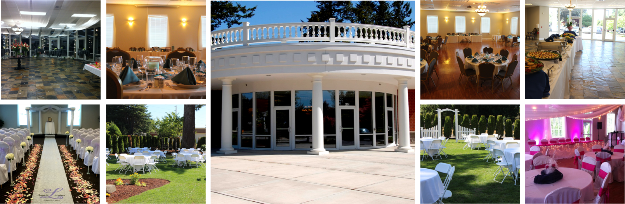

Complimentary Facility Features
On-site staff member during event
Free High-Speed Wi-Fi
Fully ADA-accessible
Ample Free Parking
Accommodating Restrooms
Alcohol Allowed
Optional Rentals
Dish Package with Wine Glasses for $3.50/person
Dish Package without Wine Glasses for $3.00/person
White chair covers- $2.00/chair in Logan Room; $3.00/chair in McElroy Room; Not allowed outdoors
Use of projector and screen in McElroy Room for $50.00

TERMS & CONDITIONS
This offer is for Weddings scheduled for 2020 or 2021.
To reserve a date and ensure this package price, client must sign a contract
and pay $500 non-refundable reservation fee by 12/31/20. The $500 fee will
be applied toward the total cost of the contract. Sales tax may apply to some items.
Additional cleaning fee may apply due to carpet in Logan room if food or beverages are served.
For parties larger than 120 guests, additional charges will apply.

Don't need all of this? Call today to discuss your specific needs.
We also offer hourly rates with no time minimums.

Call (360) 236-0395 with any questions or to schedule an appointment.

