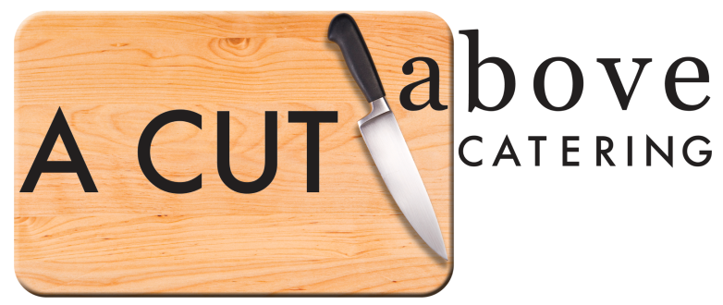
COCKTAIL HOUR ENHANCEMENTS
-Artisan Stations-
Flatbread Station-Grilled Chicken, Basil Pesto, Fire Roasted Red Peppers & Shaved Parmesan w/Prosciutto, Arugula, Tomatoes, Boursin Cheese, Local Mushrooms, Baby Spinach Balsamic Drizzle on Warm Pita Bread………$4.95 per guest
“Build Your Own” Sliders-Angus Beef Burgers and BBQ Pulled Pork w/Lettuce, Cheddar, Fried Onion Crisps, Chipotle Mayo, Gorgonzola, Ketchup, Sliced Tomatoes, Pepperjack Cheese, Bacon, Dill Pickles, Red Onions, and Pineapples…..$4.95 per guest
“Grown Up” Grilled Cheese & Soup-Sourdough stuffed w/Bacon & Muenster Cheese Served w/Creamy Tomato Soup & Loaded w/Your Choice of Toppings: Bleu Cheese, Parmesan & Herb Croutons, Sliced Jalapenos, Shredded Mozzarella Cheese, Butter Crackers, Fried Onion Straws, Crumbled Bacon & Wonton Strips……….$4.95 per guest
Gourmet Biscuit Bar-Plump White & Sweet Potato Biscuits w/Local Honeys & Jams, Sausage, Gravy, Assorted Savory Butters, Cinnamon & Apple Butter & Maple Syrup…..$2.95 per guest
-Pasta Pizzazz Stations-
Smothered Mac & Cheese Bar-White Cheddar Mac & Pepperjack Mac Loaded w/Your Choice of Mix Ins: BBQ Pulled Pork, Cornbread, Apple Smoked Bacon, Crushed Kettle Chips, Broccoli, Sweet Candied Pecans, Diced Roma Tomatoes, Crumbled Gorgonzola & Fried Onion Straws…..$5.95 per guest
Chili & Baked Potato Bar-Gourmet Angus Beef Chili w/Large Baked Potatoes & Choice of Toppings: Macaroni Noodles, Assorted Crackers, Steamed Broccoli & Sauteed Vegetables, Butter, Sour Cream, Shredded Cheddar, Black Olives, Jalapenos, Green Onions, Sliced Ham, Shredded Turkey & Crispy Bacon…..$5.95 per guest
Risotto Bar-Creamy Risotto w/Your Choice of Fixings: Sauteed Mushrooms, Fresh Asparagus, Baby Peas, Prosciutto, Grilled Chicken, Parmigiano Reggiano, Smoked Gouda & Shredded White Cheddar Cheese…..$6.95 per guest
-Around The World-
Sushi Block-Variety of Custom Sushi of Your Choice Ranging From Fresh Nigri/Sashami, Maki Rolls, & Traditional Japanese Rolls, Soy Sauce, & Wasabi Paste w/Seaweed Salad…..Market Price
Fajita Fiesta-Mini Taco Salad Shells w/Seasoned Beef & Grilled Chicken, Shredded Lettuce, Tomatoes, Black Bean Corn Salsa, Sauteed Peppers, Guacamole, Sour Cream, Salsa, & Fiesta Rice…..$4.95 per guest
Mediterranean Cuisine-Shaved Lamb or Marinated Chicken, Fresh Baked Pita, Assorted Hummus, Baby Lettuce, Diced Tomatoes, Red Onion, Kalamata Olives, Peppercinis, Feta Cheese & Fresh Tzatziki Sauce (*Option to do Kabobs for $1.50 per person)……….$4.95 per guest

