Jarvis Hunt Room ……… ………………………………..$650
*Rental rates are not available by the hour.
*Event must conclude by 11 p.m.
*Access to the room is given 1 hour prior to the start time of the event.
*maximum of 6 hour event timeframe within the room rental rate.
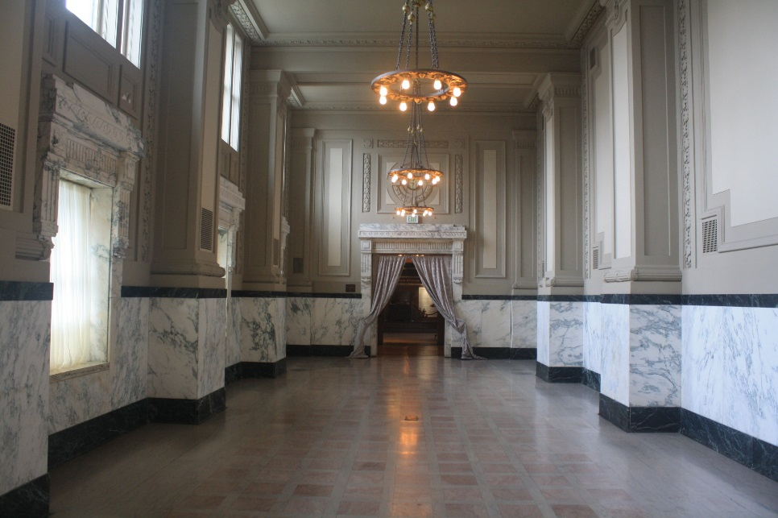

Theatre Seating Capacity: 104
Reception Capacity: 120 (standing)
Banquet Capacity: 60 (rounds of 10)
Classroom Capacity: 45 (3 per table)
U-Shape Capacity: 35

Room Rental Includes the following furniture:
(provided based upon set up selection)
6- 66” round tables for banquet seating of 60
104 Chairs for max ceremony seating.
10’ drape across entrance doors and rear doors.
*linens are not included

Audio/Visual:
Room is not equipped with Audio Visual but equipment may be rented with Union Station if needed.
Private entrance and foyer.

Catering:
Catering must be provided by one of Union Station’s approved caterers. (no outside vendors or food/beverage permitted.)
Brancato’s Catering
Pierpont’s at Union Station
Q39 BBQ
Lon Lane, Inspired Occasions
Westin/ Sheraton Crowne Center
Cakes/Cupcakes for wedding receptions, bridal showers may be brought in by client.
No alcohol may be brought in to the room. Alcohol services must be contracted with one of our in-house providers, Brancato’s Catering or Pierpont’s at Union Station.
Selected caterer must provide their own tables/linens for food and beverage tables, trash cans and staffing.

Other Amenities:
Adjustable lighting with dimmer switch
Electrical Outlets in floor and walls
Beautiful marble floor and half walls
Historical Chandeliers
Restrooms just outside of room entrance

Other considerations:
Ceiling height for lobby outside Jarvis Hunt 9’ x 10” tall; doorway 9’ tall and chandeliers are 12’ from floor)
For wedding ceremonies, the average aisle is 4’ wide x 47’ long (measuring from placement of first row of chairs to threshold of entry).
Window sills in Jarvis are 1’ deep by 4’ wide. Window height is 6’ x 1”.
Room set up is provided one time, (i.e., we cannot flip a room from wedding ceremony to reception).

Parking:
Guests will park in the Union Station Visitor Garage and pay posted rates. ($4-$8)
Parking vouchers for guests may be purchased with Event Coordinator in advance for $5

Décor Policy:
No helium balloons
No open flamed candles. (must be LED/battery operated)
No glitter, confetti or silly string.
No taping or attaching to any surface or floor in the room.

