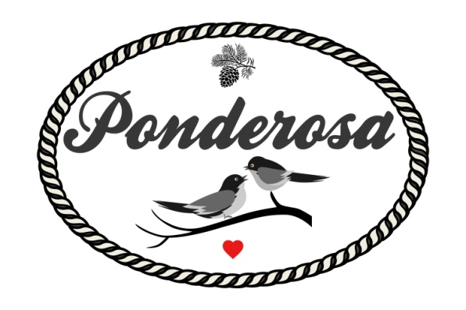
Micro Wedding Packages 2022-2023
*plus tax & applicable service fees
All Inclusive of - Venue Rental, Bar Staff,
Catered Dinner & Table Linens
30-40 Guests $3999
40-50 Guests $4299
50-60 Guests $4599
60-70 Guests $4899
*Add in Cocktail Hour appetizers starting at $6 pp
*Add in Month of coordination - Day of planner for $875
*Add in a Professional DJ $1200
*Add in a Margarita Machine $250 (alcohol not provided)
*Add in pro photographer - $225 Per Hour

