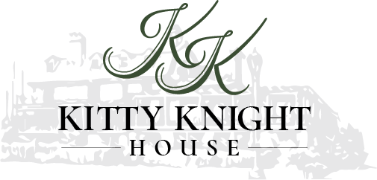

2018 Banquet Package

Catering & Events Manager
Stephanie Kirk
410.648.5200

skirk@kittyknight.com

Waterfront Weddings

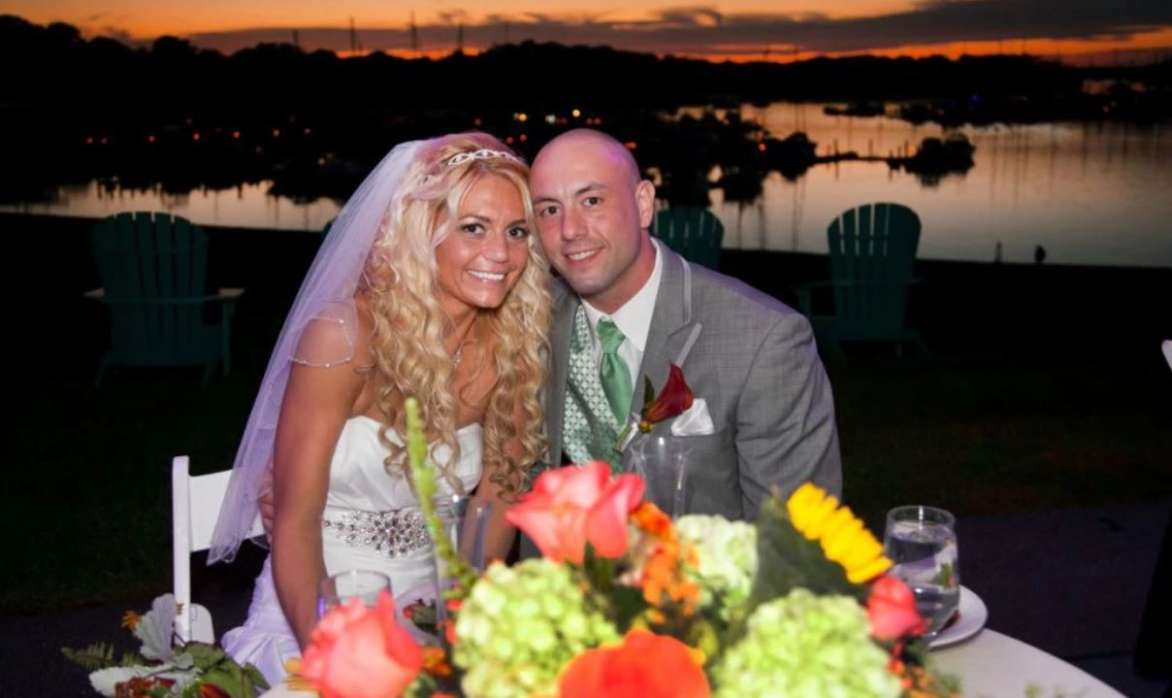

The historic Kitty Knight has been making lasting memories for generations. Superb food and breathtaking views of the Georgetown Harbor & Sassafras River make for an unforgettable wedding. We are happy to offer options to customize every aspect of your wedding package to meet your every need.
From rehearsals, ceremonies, receptions, and day after brunches to on-site guest rooms in our historic inn, The Kitty Knight & our friendly staff have something to offer everyone.
Let us help you make your wedding day festivities memorable and enjoyable. Our staff will be happy to arrange a tour of our facilities and to accommodate your every need in order to make this day everything that you dream it would be.
The Kitty Knight
14028 Augustine Herman Highway, Georgetown, Maryland 21930
(410) 648-5200 kittyknight.com

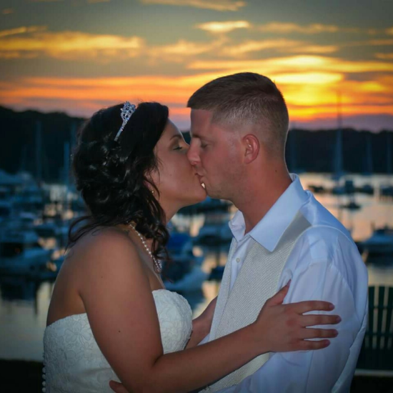
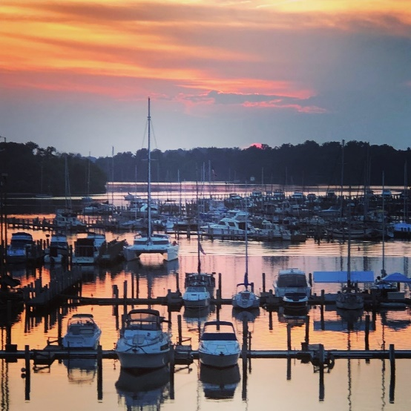
Kitty Knight Venues
Dining Room (seats 120) $1000
Parlor with or without bar $500 or $750
Porch $250
Deck $1000
Front Lawn Tent Fee
Waterfront Wedding Ceremony
$1250
Includes ceremony & setup of 100 white chairs
Kitty Knight Ceremony
$750
Includes Ceremony, setup of 100 white chairs
Tent Rental
Seats 120-320
Includes Table & Chairs
100 or less $3,000
100 or more $5,000
250 plus $10,000

Kitty Knight House Inn Guest Rooms
Offering 11 elegantly appointed guest rooms & overnight accommodations include a gourmet breakfast. Use of the pool, beach, kayaks, SUP boards & bicycles included. Complementary Inn guest room for the Bride & Groom for on-site weddings.

Payment Policy
In order to secure your requested date, a $1000 deposit is due with a signed contract. The second payment of 50% of the remaining estimated balance is due 3 months prior to your reserved date. The full remaining balance is due 10 days prior to your event. A credit card is required for all events and will be charged a 3% credit card fee.
Additions, Upgrades & Pricing

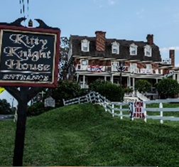
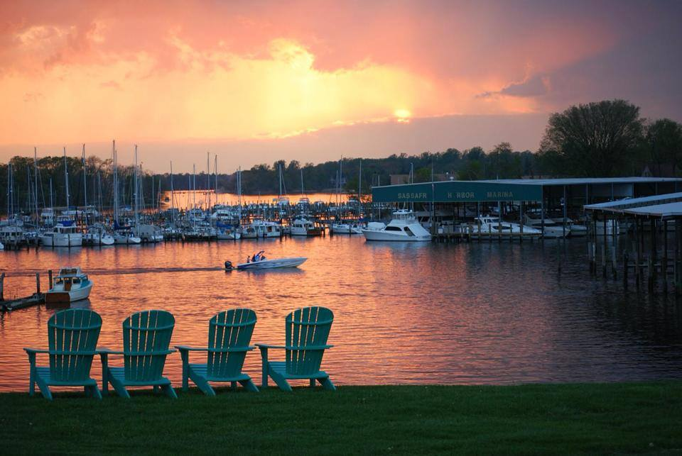
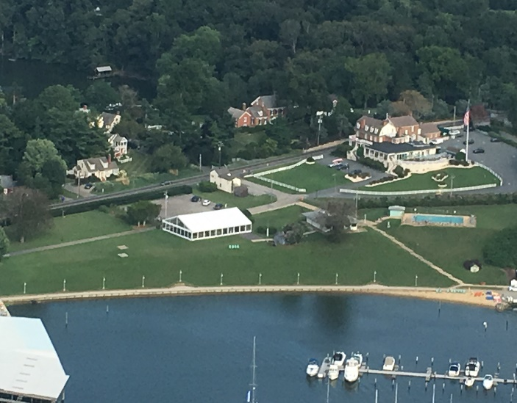
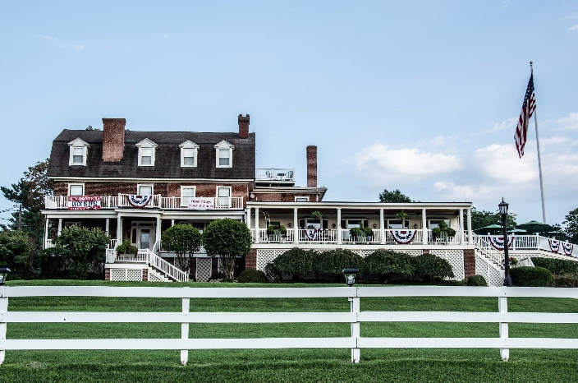
z
Wedding Reception Options
Four Hour Reception
Cocktail Hour
Deluxe Open Bar (closed during dinner)
Buffet or Plated Dinner
Experienced Staff
Menu Tasting for the Bride & Groom
White Floor Length Table Linens
White or Champagne Napkins
Complementary Parking for all Guests
Waterfront Marina Resort for Perfect Photographs
Cocktail Hour Options
Stationary Hor d’Oeuvre Display
Garden Fresh Vegetables
International & Domestic Cheeses
Crackers & Assorted Sauces
Additions
Child Menu, Chicken Tenders, Fries or Apple Sauce $20
Vendor Menu, Grilled Chicken Sandwich, Side Salad or French Fries $25
Bar Service Upgrade Options
Premium Bar- $6 per person
Absolut Vodka, Tanqueray Gin, Dewars Scotch, Jack Daniels, Captain Morgan, Bacardi Run, Jose Cuervo Tequila, Kahlua Run, Dogfish Beer, Corona Beer
5th House Reception- $6 per person
Full Host Call- $7 per person
Premium- $10 per person
Rehearsal Dinner Discounts
20% Off the Food Portion of your Rehearsal Dinner

Additions, Upgrades & Pricing

Kitty Knight
Stationed or Passed Hors D’Oeuvers

Vegetarian
Cherry Tomato filled with Herbed Goat Cheese, Toasted Panko
Macaroni & Cheese Bites
Assorted Mini Quiche (Vegetarian or meat)
Mushroom & Onion Puff Pastry Tart
Swiss Cheese Gougere
Deviled Eggs with (Bacon) Sour Cream & Cheese
Caprese Salad Skewers

Meat
Gougere Mini Burgers
Mini Crouque Monsieur
Fried Chicken & Waffle Bites
Barbequed Meatballs
Mini Chicken Salad Croissants
Bacon Wrapped Chicken Tenders

Seafood
Scallops wrapped in Bacon
Spicy Shrimp on a bed of Radish Salad & Rice Cracker
Pastrami Salmon on Rye with Dill Crème Fraiche
Seared Ahi Tuna with Wasabi Butter
Mini Maryland Crab Cake with Tartar Sauce on a Rice Cracker
Shrimp Cocktail
Kitty Knight
Salads
Fresh Field Green with House Dressing
Caesar Salad
Endive & Watercress Salad with Pears, Walnuts, & Bleu Cheese, with Walnut Vinaigrette
Baby Spinach Salad
Mixed Berry Salad
Caprese Salad

Soups
Crab Bisque
Snapper Soup
Maryland Crab Soup
Soup Du Jour

Kitty Knight
Starches
Roasted Red Bliss Potatoes

Garlic Mashed Potatoes
Cheese Risotto
Baked Potato
Wild Mushroom Polenta
Wild & Long Grain Rice
Cous Cous

Vegetables
Grilled Asparagus
Seasonal Roasted Vegetables
Sugar Snap Peas
Broccoli Rabe with Oil & Garlic
Sautéed Green Beans
Broccoli with Shallot Butter

Kitty Knight
A La Carte

Vegetarian
Roasted Potatoes with Mushrooms, Parsley & Roasted Garlic
Cheese Ravioli in a Wild Mushroom Sauce
Roasted Seasonal Vegetables
Baked Ratatouille
Creamy Spinach Stuffed Mushrooms

Seafood
Maryland Crab Cakes
Salmon in a Lemon Butter Caper Sauce
Crab Meat Stuffed Shrimp
Garlic Butter Shrimp Pasta
Flounder with Mushrooms & Wine (Market Price)

Meat
Chicken Marsala (OPT Seared Chicken Thighs in a Mushroom & Garlic Butter Sauce)
Chicken Chesapeake (OPT Southern Style Fried Chicken)
Soy Sesame Ginger Pork Tenderloins
Lamb Chop in a Balsamic Reduction
Seared & Roasted Short Ribs in a Bordelaise Sauce

Kitty Knight
“Creek”

Plated $65.95
Buffet $58.95

First Course (choice of soup)
Crab Bisque, Snapper Soup, Maryland Crab Soup
Second Course: (choice of salad)
Mixed Field Green Salad with House Dressing or Caesar Salad
Third Course (Entrées, choose two)
Pasta Primavera, Chicken Chesapeake, Bruschetta Salmon, Pork Chop, Bistro Steak Medallions, Seafood Mac & Cheese
Chef’s Choice of:
Starch & Vegetable
Bread & Butter

Kitty Knight
“River”
Plated $78.95
Buffet $71.95

Cocktail Reception
Choice of 3 Hor d’Oeuvres
Display or Passed

First Course (choice of soup)
Crab Bisque, Snapper Soup, Maryland Crab Soup
Second Course: (choice of salad)
Mixed Field Green Salad with House Dressing, Caesar Salad, Mixed Berry Salad, Baby Spinach Salad, Endive & Watercress Salad with Pear & Walnuts
Third Course (Entrée)
Chicken Marsala, Sliced Roast Beef, Sage & Pecan Crusted Roasted Pork Loin, Seafood Mac & Cheese, Crab Cakes
Chef’ Chef’s Choice of:
Starch & Vegetable
Bread & Butter
Kitty Knight
“Bay”
Plated $89.95
Buffet $80.95

Cocktail Reception
Choice of 3 Hor d’Oeuvres
Display or Passed

First Course: (choice of soup)
Crab Bisque, Snapper Soup, Maryland Crab Soup
Second Course: (choice of salad)
Mixed Field Green Salad with House Dressing, Caesar Salad, Mixed Berry Salad, Baby Spinach Salad, Endive & Watercress Salad with Pear & Walnuts
Third Course: (Entrées choose two)
Crab Cakes, Stuffed Shrimp, Chicken Chesapeake, 5 oz Petite Filet, Surf & Turf, Sliced Pork Prime Rib, Chicken Cordon Bleu
Chef’s Choice of:
Starch & Vegetable
Bread & Butter
Kitty Knight
Buffet Luncheon Menu
Option 1
$26.50 per person

Baked Ziti, Chicken, Sliced Beef
Roasted Red Potatoes, Chef Selection of Vegetables
Field Green or Caesar Salad
Fresh Baked Bread
Assorted Cookie & Brownie Tray

Kitty Knight
Buffet Luncheon Menu

Option 2
3 Entrées / 3 Sides $21.50
2 Entrées / 3 Sides $18.50
2 Entrées / 2 Sides $16.50
Chicken Salad, Seafood Salad, Crab Cakes, Crab Melts
Mixed Berry, Pasta Salad, Mixed Field Green Wedge Salad
Deli Meats: Ham, Turkey, Roast Beef
Assortment of Sliced Cheeses
Choice of Breads
Lettuce, Tomato, Onion
Assorted Cookie & Brownie Tray

Kitty Knight
Stationed or Passed Desserts

Mini Cookies
Chocolate Chip
Soft Lemon
Double Chocolate Brownie

Mini Dessert Options
Rustic Apple Almond Galette, Cinnamon Sugar
Cheesecake Squares, Fresh Fruit
Brie & Apple Puff Pastry Bites
Lemon Curd Tart, Swiss Meringue
Chocolate Buttermilk Cake, Chocolate Mousse, Ganache, Orange Curaçao
Lemon Sponge Cake, White Chocolate Mousse, Raspberry Mousse, Raspberry Geleè

Mini Cupcakes
Assorted Flavors

Macarons
Seasonal Flavors

Kitty Knight
Bar Arrangements
All beverages served must be provided by The Kitty Knight
All Bar Items excluding Cash Bar Fees are subject to additional service charge
*Please vinquire for policies regarding underage guests

Bar Tier Brands
HOUSE CALL PREMIUM
Gin Beefeater Tangueray, Beefeater, Bombay Bombay Sapphire
Vodka Three Olives Absolut, Ketel One, Titos Grey Goose
Rum Bacardi Captain Morgan, Meyers, Malibu Kraken
Tequila Cuervo Gold Cuervo Gold, 1800 Patron & Gran Marnier
Bourbon Jim Beam Wild Turkey, Jack Daniels Maker’s Mark
Scotch Dewar’s Dewar’s, Johnny Walker Red Jameson & Tullamore Dew
Blend Seagrams Seagram’s 7 & VO, Canadian Club

Bar Packages
All package bar pricing is per person
Full Hosted Bar Package Soft Hosted Bar Package
Serving Assorted Selected Tier of Serving Imported & Domestic Beer,
Liquors, Imported & Domestic Beer Assorted Red & White House Wines,
Assorted Red & White House Wines, Champagne, House Brewed Teas, Fruit
Champagne, House Brewed Teas, Fruit Juices & Assorted Sodas
Juices & Assorted Sodas

House Tier Call Tier Premium Tier Soft Hosted
1 hour $12pp $16pp $21pp $9pp
2 hours $15pp $20pp $25pp $13pp
3 hours $21pp $27pp $33pp $19pp
4 hours $25pp $32pp $39pp $22pp
5 hours $29pp $37pp $45pp $26pp

