Your Wedding… Your Way
Your special event is our focus! We invite you to contact us to visit L&L Farm venue to truly customize a memorable event for your wedding event. We offer an experience tailored to your specific desires and you can pick and choose which services you would like us to provide with no vendor ‘buy out’ fees. We love our preferred vendors and think they are some of the best in the wedding industry! Contact us Now so we can get started on making your dream wedding a reality! We know you want to know about wedding venue fees, so check out our special pricing below during our construction phase to remodel barn, courtyard, groomsmen suite, and restrooms.
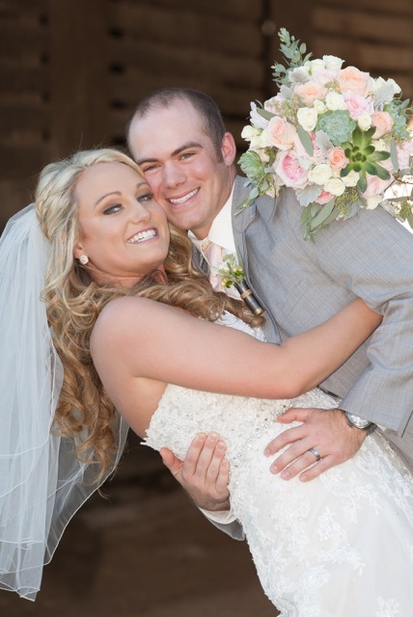
“Price Is What You Pay, Value Is What You Get” – Warren Buffett
Book Now to Receive Special Pricing during Construction for a limited time

One Day Rental
FRIDAY – 10 HOUR RENTAL $4,250
SATURDAY – 12 HOUR RENTAL $5,400
SUNDAY – 8 HOUR RENTAL $3,400

Two Day Rental
Exclusive use of Venue for Rehearsal, Ceremony, and/or Reception
THURSDAY 4:00 – 10:00 & FRIDAY 1:00 – 11:00 $6,000
FRIDAY 4:00 – 10:00 & SATURDAY 11:00AM – 11:00PM $7,200

What’s included:
- Exclusive access to our venue and grounds
- Rehearsal
- Multiple ceremony and reception sites, indoor & outdoor
- Tables and garden chairs for 200 guests – Inquire for pricing for your guest count or to upgrade tables and chairs
- Set up of tables, linens, and chairs
- Whiskey barrels for decor
- L&L team members onsite throughout the evening
- Private parking area with and paved handicap spaces
- Farmhouse use by bridal party which includes prep kitchen and restroom
- Groomsmen suite
- Indoor guest restrooms
- Open Vendor Policy as long as licensed and insured
- Corn hole game
- Lighting in reception spaces
- Janitorial services
Many more services, rentals, and wedding vendors can be arranged– please contact us for estimates that are unique for you and your vision for your Big Day!
As a way of honoring our heroes, L&L is proud to extend a 10% discount to all active Military personnel
Is there anything on this list you are looking for and don’t see? Maybe you have more questions? Visit our FAQ page or contact us for more info.

