Facility Rental Pricing
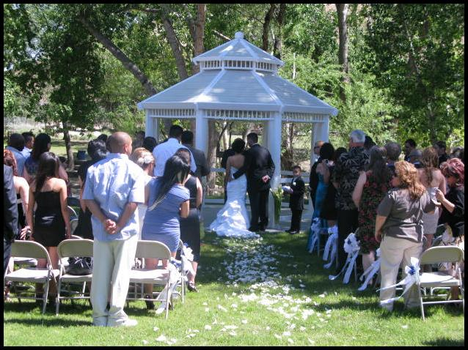

Admission Fees

Regular Rates $10.00 - Adult
$7.00 - Senior (60+)
$6.00 - Children (3-12 years old)
Free - Children 2 and under
Free - US Military Personnel w/ ID

Group Rates (with reservation) $8.00 - Adult
$4.00 - Children (3-12 years old)
Free - Children 2 and under
Free - US Military Personnel w/ ID
Facility Fees

Mountain Lion Overlook $210.00 for 2 hrs. or $275.00 for 3 hrs.

Gazebo Area $110.00 for 2 hrs. or $150.00 for 3 hrs.

Classroom $110.00 for 2 hrs. or $150.00 for 3 hrs.

Large covered pavilion (60 seats) $70.00 for 2 hrs. or $100.00 for 3 hrs.

Small covered pavilion (24 seats) $45.00 for 2 hrs. or $65.00 for 3 hrs.

Patio pavilion (24 seats) $35.00 for 2 hrs. or $50.00 for 3 hrs.

Large & Small pavilions (84 seats) $110.00 for 2 hrs. or $160.00 for 3 hrs.

Amphitheater (250 step seating) $210.00 for 2 hrs. or $300.00 for 3 hrs.

Trees of California (seasonal) $210.00 for 2 hrs. or $300.00 for 3 hrs.

AERA Commons (seasonal) $210.00 for 2 hrs. or $300.00 for 3 hrs.

After hours fee (2 staff minimum) $210.00 for 2 hrs. or $300.00 for 3 hrs.

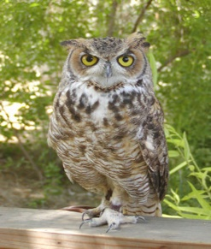
Animal Presentations

Bird presentation fee $40.00
(Hawk or Owl)

Reptile presentation fee $40.00
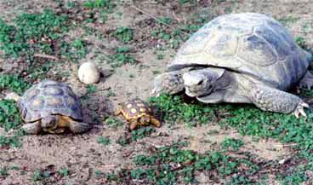
(Snake or Tortoise)

Hardware (including set-up)

Electrical Service (cords & set-up) $15.00

1 table with 6 chairs $20.00

10 chairs $20.00

Deposit fees

All facility and presentation fees are due upon confirmation to secure your scheduled event date.
All fees are non-refundable, however a rain check may be issued upon arranged cancelation.

After hour parties require a security deposit of $500.00 due with facility fees.
It is refundable if all rules are followed and the area is clean following your event.

Fees for additional hours are negotiable.

Rules

No glass containers & no piñatas allowed.

No barbecues or open flames during regular zoo hours.

Balloons and streamers are allowed in designated party areas only, not in the zoo area.

Coupons or other discounts cannot be used in combination with group rate prices.

For more information or to schedule a wedding or event,
call Lana at 661-871-1822 or email lafain@kern.org

For more information or to schedule a birthday party, call Jordan at 661-871-1883 or email joreed@kern.org

