Large and Small Lanterns … No Charge
Enhanced Experience and Optional Decor

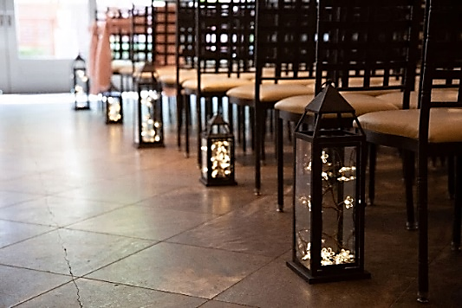
Traditional Sparkling Chandeliers $150 each (5 total) 4’ Tier Center Chandelier $150 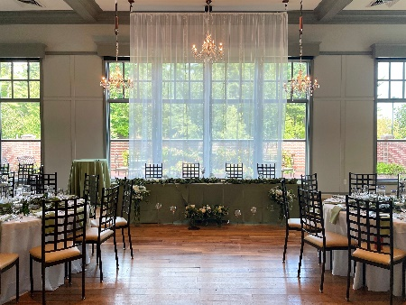

5’ Spiral Chandelier $80 each (6 total) Tillie Chandeliers LG $150 (4 ) MED $80
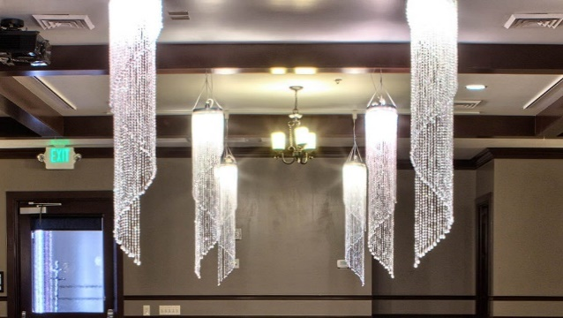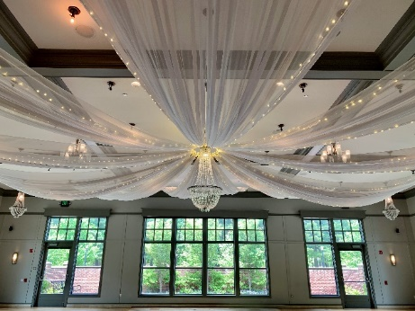
Spoke Ceiling with Choice of Chandelier $900
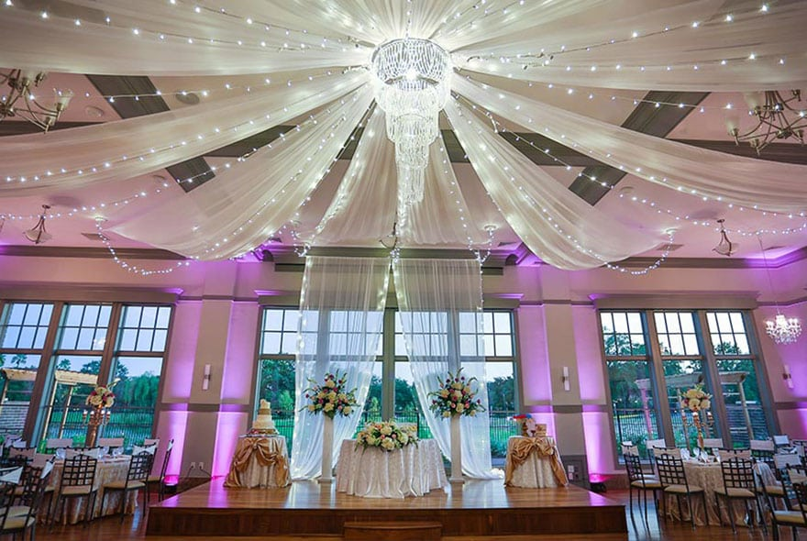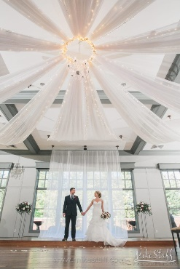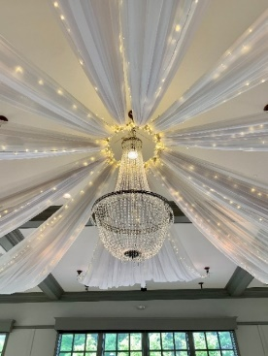

Edison Bulb Ceiling $600 Draped Organza Ceiling $800
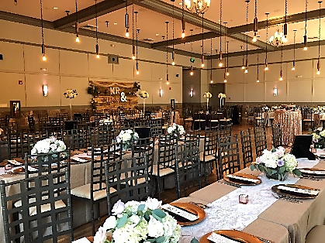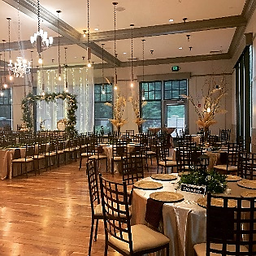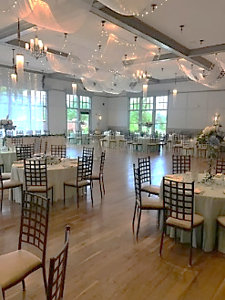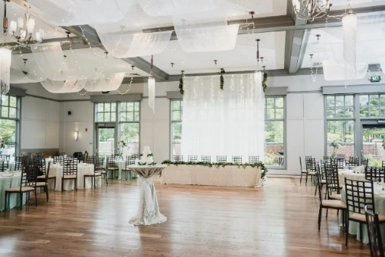
Lighted Ballroom Backdrop $180
Traditional Chandelier and Backdrop Package for Stage $500
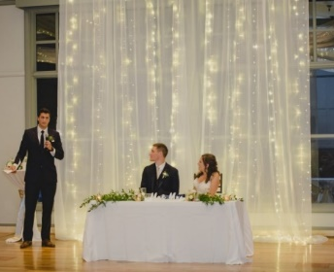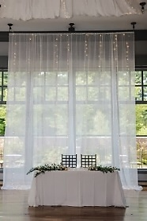

Additional Hours (eight hours included)
Additional Hours available for $250 per hour (before midnight)
Additional Hours available after midnight $350 per hour (before 2:00 AM)
Engagement Photography Site Session $350
Two inside vignettes and complimentary beverage, one hour use of the venue
Linen Package (over 70 colors to choose from)
High quality polyester tablecloth and napkins
Rehearsal and Ceremony Coordination $350
Rehearsal Coordination
Line up Wedding Party
Practice the Recessional
Practice the Processional
Officiant Practice Run-through of Ceremony
Run through processional and recessional, one last time

Ceremony Coordination – Just Like Rehearsal … Only it’s Your Big Day!!
Day of Bridal Package $850
9:00 AM Access to Upgraded Bridal Suite
Juice Bar for Up to 10 People
Complimentary Champagne
Bride’s Emergency Kit
Bottled Water
Steamer Rental
Bridal Mirrors Rental

