Welcome to Prestwick Country Club

Prestwick would be honored to entertain you and your guests for any wedding event, private party, or company function! We offer an extensive dining selection prepared by our Executive Chef. The menus provided are the Chef’s specialties, if you are looking for additional items please express your ideas.

We pride ourselves in making your event as memorable as possible.

We look forward to working with you!

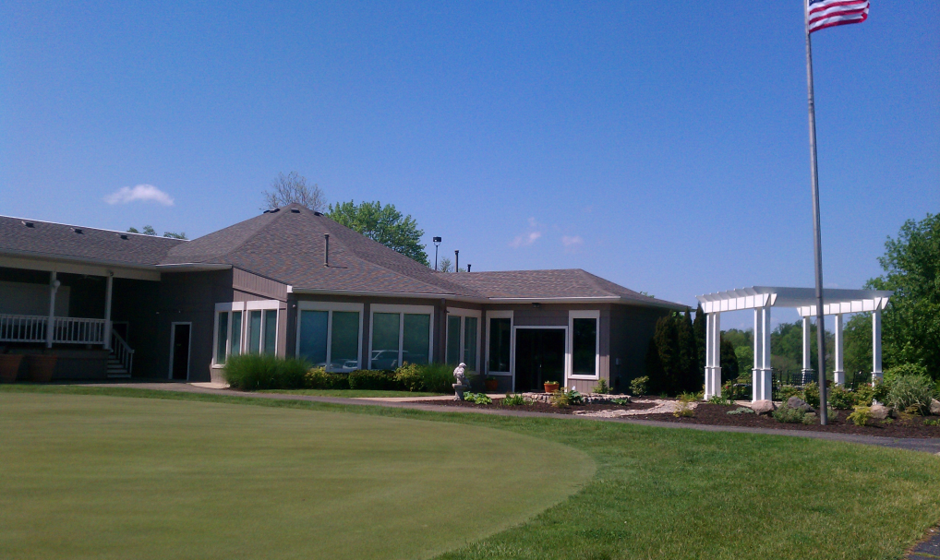

Breakfast Selections

CONTINENTAL BUFFET
$5.95 per person

Muffins
Danish
Fruit

CLUBHOUSE FAVORITE
$8.95 per person

Buttermilk Biscuits with Sausage Gravy
Scrambled Eggs
Choice of Sausage or Bacon
Home Fried Potatoes

FULL BREAKFAST BUFFET
$9.95 per person

Seasonal Fresh Fruit
Assorted Pastries
Buttermilk Biscuits with Sausage Gravy
Scrambled Eggs
Sausage and Bacon
Home Fried Potatoes

ALA CARTE SELECTIONS

Danish & Pastries $17.00/dozen
Gourmet Muffins $30.00/dozen
Mini Bagels with Cream Cheese $19.00/dozen
Seasonal Fruit $2.95/person

All Selections served with Coffee, Orange Juice and Water

Lighter Lunch Options

BOX LUNCH
$8.95 per person

(Placed on Golf Cart or in Gazebo)
Deluxe Deli Sandwich (Ham or Turkey)
Potato Chips
Apple
Cookie

DELI BUFFET
$10.95 per person

Shaved Ham, Turkey or Roast Beef

CHOICE OF TWO:
Cole Slaw
Baked Beans
Potato Salad
Potato Chips
Tossed Salad

Also includes Cookies, assorted cheese and relish tray

GAZEBO GRILL
$12.95 per person

CHOICE OF TWO:
Grilled Hamburgers, Hot Dogs or Bratwurst
Grilled Marinated Chicken Breast
BBQ Pulled Pork

CHOICE OF TWO:
Cole Slaw
Baked Beans
Potato Salad
Potato Chips
Tossed Salad

Also includes Cookies, assorted cheese and relish tray

Iced Tea, Lemonade, Water, and Coffee are Included with All lunches.

Buffet Selections

Add a second entrée from same price group add $4.00 per person

Entrée selections $16.95 per person
Marinated Grilled Chicken Breast
Blackened Chicken Breast
Sliced Oven Roasted Turkey w/ Gravy
Sliced Honey Baked Ham w/ Pineapple Glaze
Sliced Round of Beef w/ Au Jus

Entrée selections for $18.95 per person
Chicken Piccata
Chicken Marsala
Baked Cod with Lemon and Dill
Apple Amaretto Chicken Breast
Roasted Pork Loin w/ Gravy
10 oz. Prime Rib w/ A Jus

Entrée selections for $22.95 per person
6 oz. Filet Mignon
12 oz. Ribeye
Chicken Cordon Bleu
Teriyaki Glazed Salmon

Choice of Starch
Oven Roasted Redskin Potatoes, Mashed Potatoes, Rice Pilaf, and
Au Gratin Potatoes

Choice of Vegetable
Seasonal Vegetable Medley, Green Beans, Steamed Broccoli with Cheese,
Buttered Corn, and Glazed Carrots

All Selections come with Tossed Salad and Dinner Rolls

Full Salad Bar can be added for an additional $1.00 per person

Iced Tea, Lemonade, Water, and Coffee are Included

All Food and Beverage Charges are Subject to 18% Service Charge and 8% Sales Tax.
All Prices and Menu Selections are Subject to Change without Notice.

Specialty Buffets

COUNTRY BUFFET
$17.95 per person

Boneless Fried Chicken Breast
Roasted Pork Loin w/ BBQ Sauce
Mashed Potatoes w/ Gravy
Green Beans
Buttered Corn
Rolls
Tossed Salad

ITALIAN BUFFET
$19.95 per person

Traditional Italian Sausage Lasagna
Chicken Parmesan
Mediterranean Vegetable Medley
Italian Green Beans
Pasta served with Marinara Sauce
Garlic Bread
Caesar Salad or Tossed Garden Salad

CLUB HOUSE FAVORITE
$29.95 per person

Carved Beef Tenderloin w/ Horseradish Sauce
Teriyaki Glazed Salmon
Mashed Potatoes
Green Beans
Broccoli
Rolls
Tossed Salad

MEXICAN TACO BAR
$15.95 per person

Corn and Flour Taco Shells and Tortilla Chips
Seasoned Ground Beef and Seasoned Chicken
Refried Beans and Spanish Rice
Shredded Lettuce and Cheese
Diced Tomatoes, Onions, and Black Olives
Salsa, Sour Cream, and Guacamole
Chili Con Queso Dip

Full Salad Bar can be added for an additional $1.00 per person

Hors d ’oeuvres

Cold Items

Seasonal Fruit Display
Artfully arranged sliced seasonal fresh fruit including: Cantaloupe, Watermelon, Honeydew, Grapes, Strawberries, and Pineapple.
Small (Up to 50 People) $100
Medium (Up to 100 People) $125
Large (Up to 150 People) $150

Assorted Cheese and Cracker Display
Assorted Domestic and Imported Cheeses served with an assortment of crackers.
Small (Up to 50 People) $100
Medium (Up to 100 People) $125
Large (Up to 150 People) $150

Fresh Vegetable Display
Fresh Vegetables including: Broccoli, Cauliflower, Baby Carrots, Radish, Celery, Grape Tomatoes, and Cucumber Slices served with a Ranch Dip
Small (Up to 50 People) $100
Medium (Up to 100 People) $125
Large (Up to 150 People) $150

Shrimp Cocktail Display
Succulent boiled shrimp served with House made Cocktail Sauce and garnished with lemon wedges.
$$ Market Price per Dozen
(Please Inquire if Interested)

Smoked Salmon Display
Cold-Smoked Salmon slices with Capers, Red Onion, Chopped Boiled Egg, and Crackers.
$60 per 2 pounds

Tomato Caper Bruchetta Display
Diced Tomatoes, Red Onions, and Capers tossed in Italian Vinaigrette served with toasted Parmesan Bread Crisps
$10 per Dozen

Hors d ’oeuvres

Hot Items

BBQ, Sweet and Sour, or Swedish Meatballs $10 per dozen

BBQ, Cocktail Franks $10 per dozen

Buffalo or BBQ Chicken Wings $15 per dozen
Served w/ Ranch or Bleu Cheese

Mini Egg Rolls $14 per dozen
Choice of Chicken, Veggie, or Shrimp served w/ Sweet and Sour sauce

Chicken Fingers $15 per dozen
Served with BBQ, Honey Mustard, or Sweet and Sour sauce

Chicken Quesadillas $18 per dozen
Served with Salsa and Sour Cream

Spanikopita $18 per dozen
Philo dough filled with Spinach and Cheese

Spinach and Artichoke Dip $2.95 per person
Served with Tortilla Chips

Chili Con Queso Dip $2.95 per person
Served with Tortilla Chips

Carved Meat Selections
All carved meat selections served with Silver Dollar Rolls and choice of Horseradish Cream, Honey Mustard, Spicy Mustard, or BBQ sauce.
Beef Tenderloin $9.95 per person
Round of Roast Beef $6.95 per person
Roast Turkey Breast $4.95 per person
Honey Ham $4.95 per person
Roast Pork Loin $4.95 per person

Bar & Drink Selections
Prestwick ID’S all guests at the bar, be prepared!

Bartender
Prestwick requires all parties serving any alcoholic beverages to use a Prestwick licensed bartender.
Four Hours $100
Additional Hours $25 per hour

Kegs
Domestic kegs are priced as follows:
Full Size Keg (120+ Servings) $215 per keg
Pony Size Keg (60+ servings) $100 per keg
All Non-Domestic Kegs $Current Market Price$
Cash Bar $3 per drink

Wine and Champagne
Prestwick has four house wines produced by Canyon Road available including White Zinfandel, Chardonnay, Merlot and Cabernet Sauvignon
Canyon Road (House Wines) $20 per bottle
All other wines $Market Price$
Champagne (J. Roget Spumante) $20 per bottle
All other Champagne $Market Price$
Cash Bar $5 per drink

Soda
Prestwick serves Coke products including Coke, Diet Coke, and Sprite
Unlimited Drinks $1 per person
Cash Bar $1 per drink

Liquor
Prestwick has a large selection of Liquor available for all of our parties! There is no additional charge to you to have them available at a cash bar for your guests.
House Drinks (Bellows) $5 per drink
Call Drinks (Absolute, Jack Daniels, etc…) $6 per drink
Premium Drinks (Patron, Grey Goose, etc…) $8 per drink

Open Bar
An open bar includes beer, wine, soda and the priced level of Liquor that you choose! These prices apply to all guest age 21 or over attending your party.
House Drinks (Bellows) $15 per guest
Call Drinks (Absolute, Jack Daniels, etc…) $18 per guest
Premium Drinks (Patron, Grey Goose, etc…) $24 per guest

All Food and Beverage Charges are Subject to 18% Service Charge and 8% Sales Tax.
All Prices and Menu Selections are Subject to Change without Notice.

Rental Pricing

The Gazebo $5.00/person
~ $500.00 minimum
~ Four (4) hour rental
~ Choice of linen included
~ Seats approximately 200 guests
~ Projector/Screen use free of charge
~ Dance floor
~ Bar access

Meeting Room $3.00/person
~ $100.00 minimum
~ Four (4) hour rental
~ Choice of linen included
~ Seat approximately 40 guests
~ Bar access

Extra Items
~ Outdoor ceremony site……….$100.00
~ Outdoor chairs……….$3.00/chair
~ Chair covers……….$4.00/chair
~ Centerpieces……….$3.00/table
~ Accessory lighting……….$25.00
~ Bartender fee……….$25.00/hour

