WELCOME TO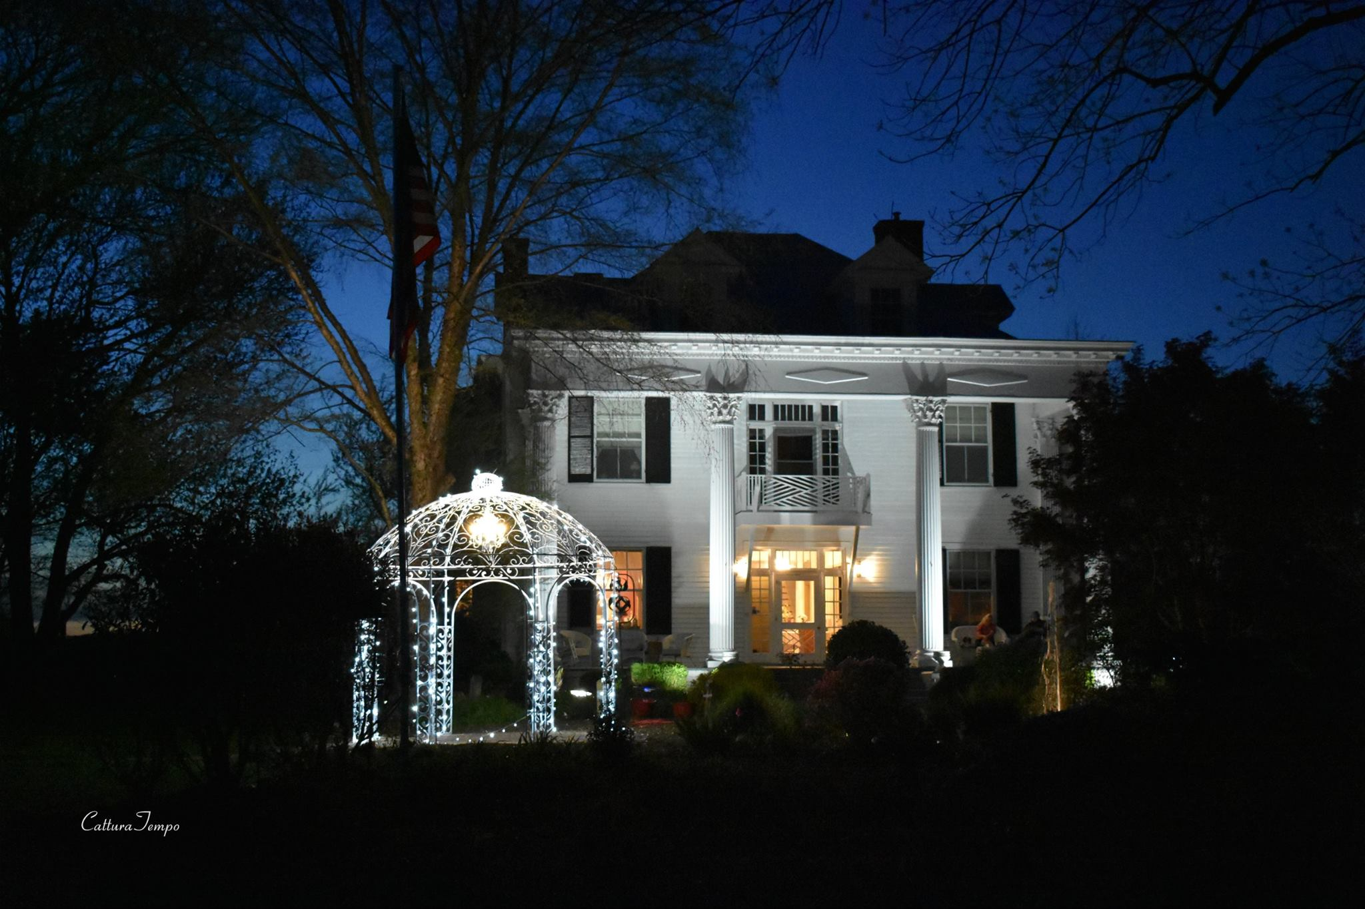
WINRIDGE MANOR
BED AND BREAKFAST
AND EVENT VENUE

DEAR PROSPECTIVE BRIDE AND GROOM,

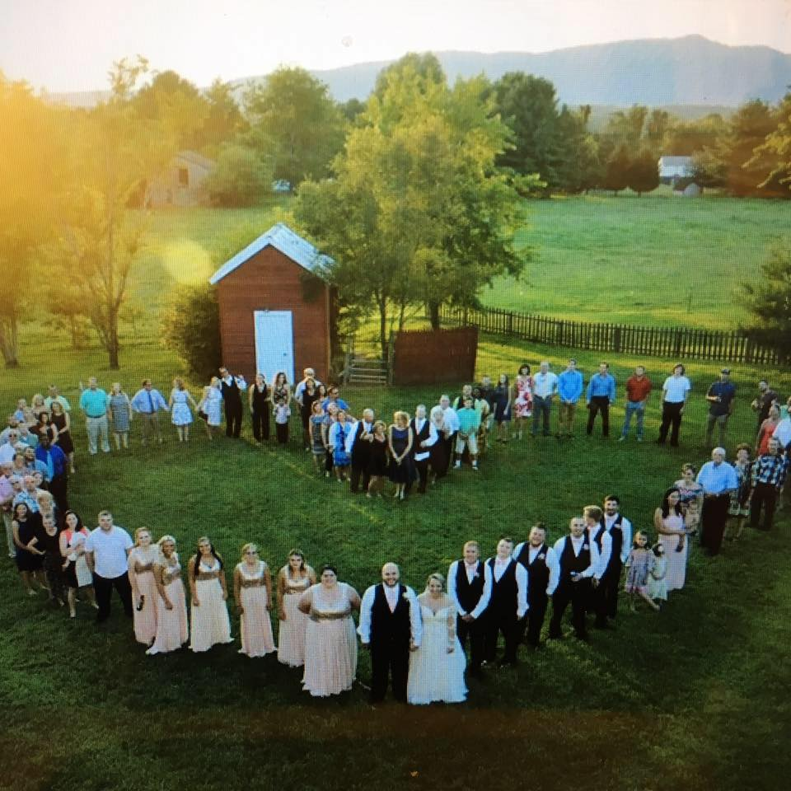

Welcome to Winridge Manor where our Motto is “Your day, your way.” We truly want you to feel like part of our family! We offer a variety of packages for you to pick from and specialize in creating Custom Packages to fit your needs and budget. Our staff will work with you throughout the planning process to ensure that your wedding is everything you’ve ever dreamed! Give us a call to schedule a tour today!

WISHING YOU A WONDERFUL WEDDING,
The Winridge Manor Team
WINRIDGE MANOR

WHY CONSIDER US FOR YOUR SPECIAL DAY?

#1 PERSONALIZATION. To begin, our Motto is "Your Day, Your Way". We take this very seriously and always strive to exceed your expectations in every detail. As you know, YOU are a truly unique couple with your own vision, budget and style. Our dedicated staff and vendors will spend time with you creating a wedding experience that you will love!

#2 VARIETY. With numerous ceremony sites for you to pick from, a Pavilion or outdoor reception options and customized Wedding Packages, no two weddings are ever exactly alike at the Manor! If you are a DYI couple, we have a "Build Your Own Package" for you! If you're a couple who prefers to simplify things, we also offer an "All-Inclusive Package" that includes EVERYTHING you need to host your wedding, making your wedding planning a stress-free experience. (Well, ladies you do need to bring a groom and a dress :) - We will do the rest!)

#3 VALUE! Let’s face it—weddings are expensive and hidden fees can really add up! At Winridge Manor, we include all amenities in our pricing, so you never have to worry about hidden fees. Couples often end up saving hundreds—or even thousands—of dollars because of these inclusive rates Some of our packages even offer FREE use of the Manor for your Rehearsal Dinner.

#4 Weekend Wedding Packages! Because we are also a Bed and Breakfast, we offer our guests the opportunity to spend their wedding weekend at the Manor. This gives you added time to make lasting memories and it gives us a chance to pamper our couples and their family/friends. Some of our packages even offer a FREE weekend at the Manor!

#5 REVIEWS! Please take some time to read our reviews on Facebook, Wedding Wire, Trip Advisor and on our website! We are happy to tell you all about what we do BUT it is so much better to hear what our past (and present) couples have to say about their experience at Winridge Manor! As you will discover, our Winridge Staff considers our newlyweds and soon to be "Mr. and Mrs." part of our FAMILY :)

6 PRICING! Venue Only Packages begin at $4,000
All-Inclusive Packages begin at $9,900!
WINRIDGE MANOR
BRIDAL PRICING GUIDE FOR 2019
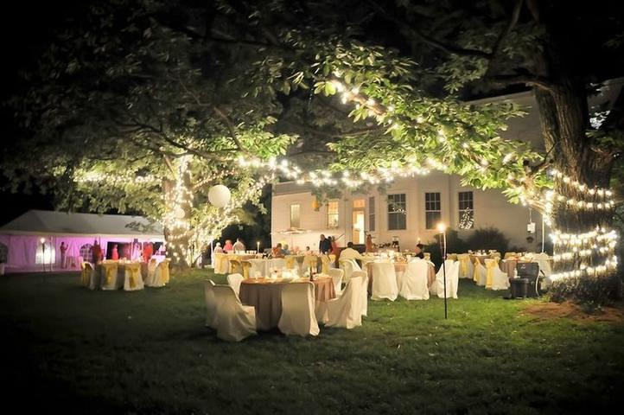
2019 “THE MANOR” PACKAGE COST =
April 1st -October 31st = $5000+Tax November 1st -March 31st= $4000 + Tax*
This package includes exclusive use of the grounds and facilities for TWO (2) hours of rehearsal time and nine (9) hours for one day events. (This time includes three (3) hours prior to ceremony.) You are also welcome to use the grounds for your Bridal Portrait and Save the Date photos with prior arrangement. You may also rent the Bed and Breakfast and have a full 24 hours, 48 hours or more on site.
Tables, chairs, linens, china, glassware and silver are included (There may be an extra cost to order specific colors of linens)
Parking Attendants, Wait Staff, Set Up/Break Down Crew and Bartenders will be provided A Wedding Planner/Director will include 10+ hours of pre-planning time, rehearsal and 8-10 hours on the day of your event.
With this package, you may pick your own vendors, or you may “Mix and Match” with our vendors*** The Caterer and Bakery you pick must be licensed and insured, OR you must provide a WAIVER to Winridge Manor.
WINRIDGE MANOR
BRIDAL PRICING GUIDE FOR 2019

WHAT IS INCLUDED FOR A 1 DAY

ALL-INCLUSIVE EVENT?
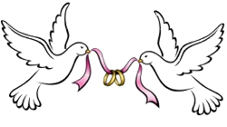
- Exclusive use of the grounds and facilities for two (2) hours of rehearsal time and nine (9) hours for one day events. (This time includes three (3) hours prior to ceremony. You are also welcome to use the grounds for your Bridal Portrait and Save the Date photos with prior arrangement.
- Buffet style reception which includes two entrees, three side dishes, rolls, tea and lemonade. No alcohol is provided. However, you may purchase beer, wine and champagne and we will be happy to serve this for you.
- Parking Attendants, Wait Staff, Set Up/Break Down Crew and Bartenders will be provided
- Wedding Cake will be plated and served (If using our caterers)
- The DJ will be available for your rehearsal*, ceremony and reception
- Photographer and a package that includes a minimum of a 100-print album, a Flash Drive, 2 dvd’s of all digital prints and nine (9) hours of time on wedding day. (A RELEASE WILL BE GIVEN TO PRINT ALL DIGITAL PHOTOS)
- Wedding Planner/Director will include 10 hours of pre-planning time, rehearsal and 8-10 hours on the day of your event.
- Flowers (Includes all personal flowers for wedding party (Bride and Groom plus 4 bridesmaids/ 4 groomsmen) , (4) parents and (4) grandparents and a toss bouquet)
- BEAUTIFUL New Wedding Pavilion seats up to 200+ (Fans and Heaters available)
- Tables, chairs, linens, china, glassware and silver (Extra charge to order linens)
- Use of unity ceremony table, crystal champagne flutes for the bride and groom, cake serving utensils
THE WINRIDGE MANOR TEAM
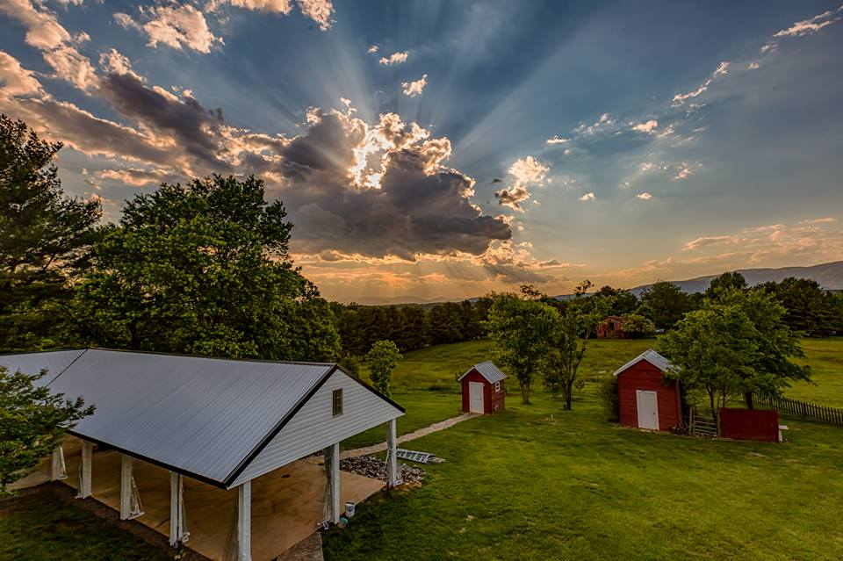
CATERERS - FRIENDS CATERING

BAKERY - CHESTNUT HILL BAKERY
THE GYPSY BAKER

FLORIST - CHERYL’S SECRET GARDEN

PHOTOGRAPHER - CATTURA TEMPO PHOTOGRAPHY

DJ - DJ HARVELL ENTERTAINMENT

EVENT PLANNER AND EVENT STAFF-- KELLY HECKMAN /OWNER/ WINRIDGE MANOR
WINRIDGE MANOR
BRIDAL PRICING GUIDE FOR 2019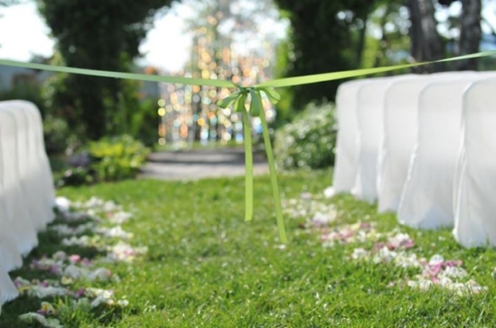
FOR WEDDINGS WITH 100 GUESTS
April -October BASE PRICE $10,900 plus tax
November-March $9,900 plus tax
(This is just an example and may be customized)
If you pick our All-Inclusive Plan, we offer a FREE night at the Manor for the night of your wedding. Friday night, or additional nights, may also be added for an additional $750 per night
WINRIDGE MANOR
BRIDAL PRICING GUIDE FOR 2019
FOR WEDDINGS WITH 150 GUESTS
April -October BASE PRICE $12,300 plus tax
November-March $11,300 plus tax

(This is just an example and may be customized)
(If you pick our All-Inclusive Plan, we offer a FREE night at the Manor for the night of your wedding. Extra nights may be added for an additional $750 per night.)
ENJOY A NIGHT (OR MORE) AT WINRIDGE MANOR!
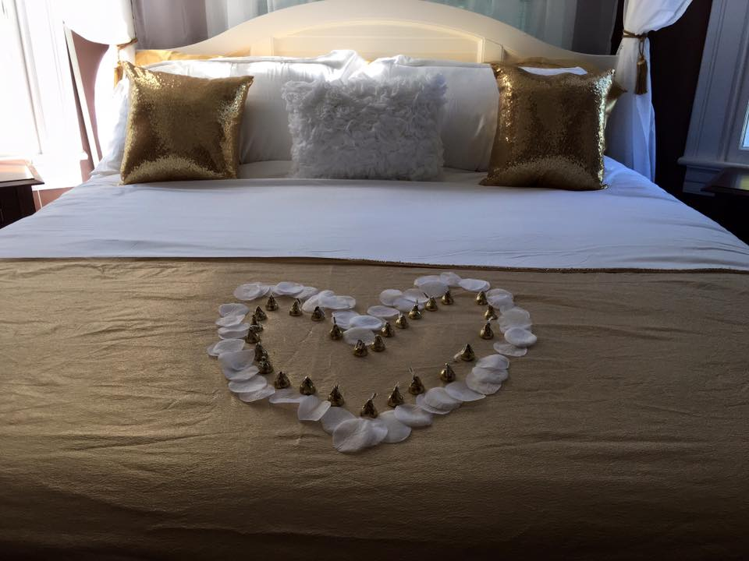

*** ALL ROOMS MUST BE RENTED***
1 NIGHT TOTAL COST FOR ALL FOUR ROOMS =$750
ENJOY A WEEKEND AT WINRIDGE! $1400
PRICE INCLUDES TAX AND A YUMMY BREAKFAST EACH MORNING OF YOUR STAY
EXTRAS BY WINRIDGE
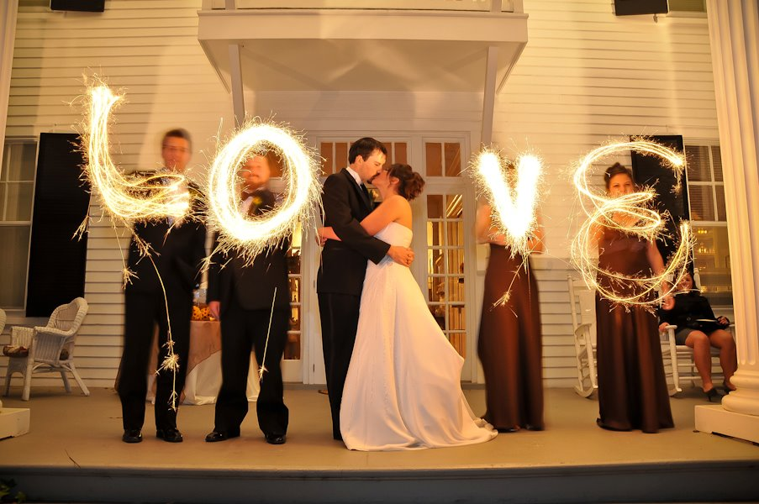
WE CAN HELP YOU PLAN ANYTHING!
SPARKLERS = $2.00 PP
WEDDING DAY NOON SNACKS = $5.00 PP
BONFIRE = $35.00
SNACKS (SMORES AND POPCORN) = $5.00 PP
SUNSET WINE AND SNACKS = $15.00 PP
HORSE AND BUGGY BY LEXINGTON HORSE AND CARRIAGE $500
PASTOR FEE GENERALLY $75
HAIR AND MAKEUP
THE “PROCESS”

STEP 1 = TOUR/ FALL IN LOVE WITH WINRIDGE

STEP 2 = CONFIRM DATE / DEPOSIT / CONTRACT

DEPOSIT = $2000 ($1,500 TOWARDS WEDDING COSTS + $500 RETAINER.) THE ENTIRE $2000 IS NON-REFUNDABLE IF YOUR WEDDING IS CANCELLED FOR ANY REASON***

STEP 3 = VENDOR MEETING AT WINRIDGE

STEP 4 = POW WOW WITH KELLY

STEP 5 = 2 PAYMENTS DUE = ONE DUE 4 MONTHS AND ONE DUE 4 WEEKS PRIOR TO YOUR WEDDING (BOTH PAYMENTS ARE NONREFUNDABLE)

STEP 6 = GET MARRIED
NOTES

