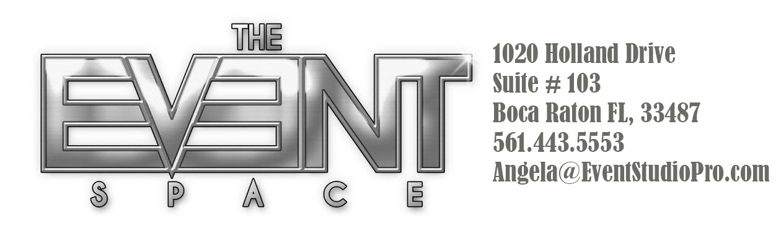

Main Package

The Event Space is a all-inclusive fully furnished private Club Styled venue for events up to 90 guests.

What’s included:

- Interactive DJ, plays the music you want to hear.
- Lite-Up High tops with stools, Lite-Up dinner tables with Chivari chairs.
- Furniture such as couches, lounges, pillows and tables with linens
- Mirrored Bar with coolers and ice
- 60 inch plasma TV’s around the room to display photos or videos
- Dual Wall Projection imaging of your choice.
- Club Lighting including Lazers, Neon, and LED full room uplighting
- SMOKE MACHINE
- Red Carpet entrance with an outside lounge
- Staff person to design, setup, run, and close event

You may bring in your own food/drink or have your event catered

There are many discounted upgrades available to further enhance your event located on our website TheEventSpaceBoca.com

Saturday night full package with Event Space DJ $2500
Saturday night full package with your own DJ $2250

Any other time with Event Space DJ $2250
Any other time without our DJ $1950

