Mezza Luna Catering Gourmet Box
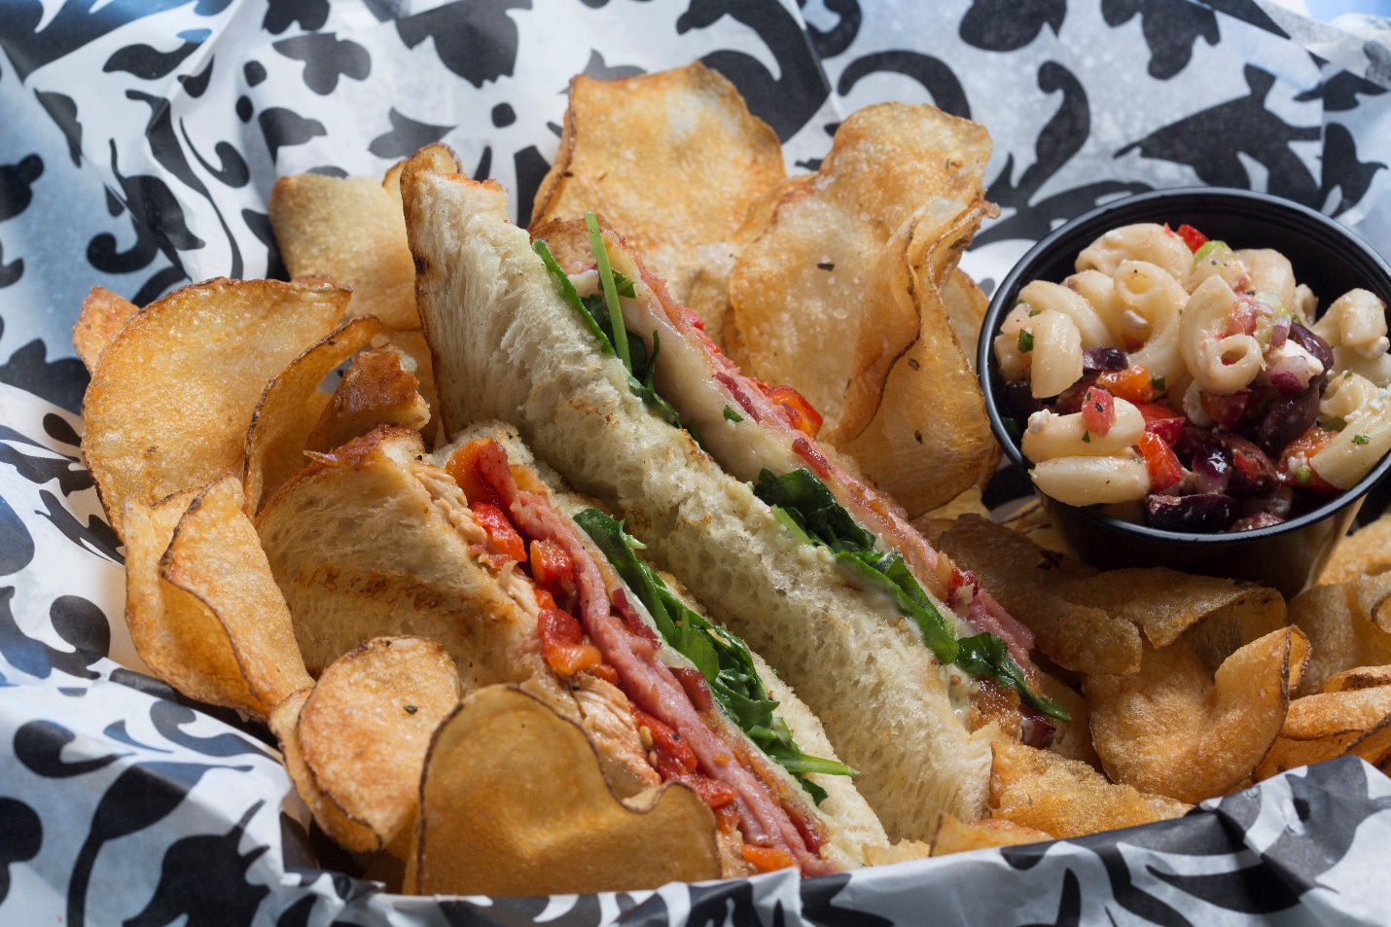
Pricing does not include taxes or delivery fees. Delivery fees vary depending on the location.

Gourmet Box
Served with homemade chips and a cookie
$10.75 each
- Grilled Steak Sandwich with Charred Red Onions, Arugula & Horseradish Cream
- Grilled Vegetable Sandwich with Pesto & Mozzarella
- BLT Pimento Cheese Sandwich
- Chicken Club Sandwich with Italian Ham, Bacon, Roasted Sweet Peppers, Arugula & Caesar Dressing
- Grilled Chicken Pesto with Provolone
- Roasted Turkey with Caramelized Onions & Port Cranberry Sauce
- Chicken Salad on Croissant
- Hot Ham and Cheese with Dijon Mustard

Salad Boxes
Served with a yeast roll and a cookie
$10.75 each
Grilled Steak or Grilled Chicken on top of Mezza Luna’s Salad: Cumin, Carrots, Feta, Cucumbers, Cherry Tomatoes, Roasted Shallot Vinaigrette
Traditional Caesar, Garlic Crouton, Shaved Parmigianino with Grilled Chicken
Chicken Club Salad with Italian Ham, Bacon, Roasted Sweet Peppers, Arugula & Caesar Dressing on top of Romaine Lettuce.
We ask that you limit you order to two selections

