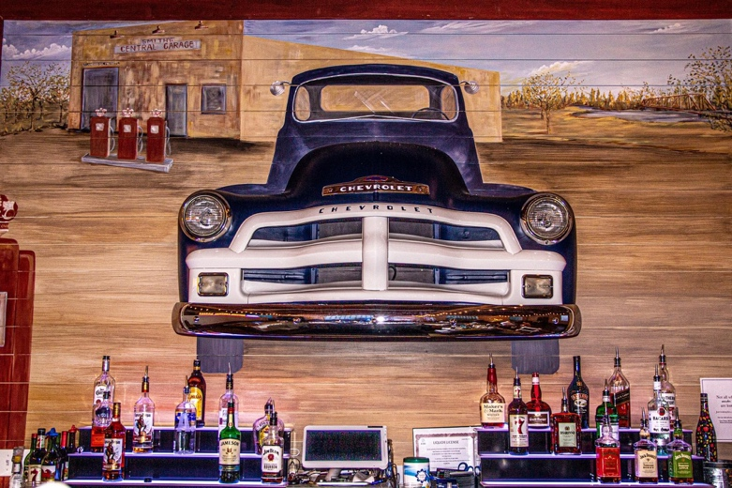
Beverage Packages

Every Bar Packages Include:
Up to two bartenders (if you desire a third bartender there is a $150 fee)
Fully stocked bar with your bar package of choice
Juice (for mixers and those not drinking alcohol)
Soda (for mixers and those not drinking alcohol)
Additional Mixers
Basic Garnishes (lemon, lime, olives, cherries, orange)
Ice
Cocktail napkins
Disposable Cups for service (Champagne flutes also included if a Champagne toast is selected)
Water for the entire event
*We calculate your per person charge based on the number of guests who are drinking alcohol. Guests who are under 21 will not be counted in your per person bar total. Clients are responsible for providing an accurate guest count for their bar in order for it to be stocked appropriately.

Premium Bar Package
Absolut, Tanqueray, Bombay, Jack Daniels, Jack Fire, Jack Honey, Crown Royal, Crown Apple, Mi Campo Tequila, Jameson, Bulleit Bourbon, Malibu, DiSaronno Amaretto, Grand Marnier.  (includes house bar, beer & wine and non-alcoholic list below) |  | 3 Hours | $33.00 per person
 |  | 4 Hours | $35.00 per person
House Bar Package
DC Cobbs Vodka, Gin, Rum, Seagram’s 7, Bacardi, Captain Morgan, Southern Comfort, Montezuma Tequila.  (includes beer & wine and non-alcoholic list below)  *Includes Hard Lemonades and Seltzers |  | 3 Hours | $29.00 per person
 |  | 4 Hours | $32.00 per person
Beer & Wine Bar Package
Draft Beer:  Miller Lite, Blue Moon, Revolution Anti-Hero, Seasonal Beer  Bottle Beer:  Coors Lite, Miller Lite, Bud Light, Michelob Ultra, Angry Orchard, Featured NA, Corona Extra, Modelo, Revolution Hazy Hero  Wine:  Cabernet Sauvignon, Red Blend, Chardonnay, Pinot Grigio, Riesling, Moscato  (includes non-alcoholic list below)  *All Wine featured is from 7 Hands Vineyards and Drumheller Vineyards |  | 3 Hours | $25.00 per person
 |  | 4 Hours | $27.00 per person
Non-Alcoholic Beverage Service
Coca Cola, Diet Coke, Sprite, Ginger Ale, Cranberry Juice, Lemonade, Soda Water, Tonic Water |  | *Maximum 4 Hours | $7.00 per person
Additional Bar Services
Champagne by The Bottle |  |  | $25.00 / Bottle
Bottomless Mimosa Bar- Champagne, Orange Juice, Lemonade- (2 Hours- Unlimited) $9.00 Per Guest
Coffee Bar – Your Choice of Regular or Decaf Coffee with Assorted Cream and Sugar $100.00/ 50 Cup Service

Smith’s Central Events is the sole bar service provider at the venue. Outside alcohol, personal alcohol, and 3rd party bartending services are not permitted anywhere on our property.
All prices, packages and details below are subject to change at any time.
**All wine, beer and liquor choices are subject to change or substitution at the discretion of Smith’s Central Events based on availability at the time of ordering.

FAQ’s

- Can I provide the alcohol for you to serve?
- No. Smith’s Central Events holds an Event Liquor License and is required, by law, to get our alcohol from distribution companies. The venue is prohibited from using alcohol provided by clients.
- I have a friend/family member/etc. who makes their own special alcohol. Can we bring it?
- No. Again, all outside, personal and 3rd party alcohol is strictly prohibited at Smith’s Central Events. We’d love for you to consider using this person’s alcohol at your rehearsal dinner, welcome party or after party off premises.
- Can I add a Signature Drink(s) to my package if it is not included in the above lists?
- Yes! You can add up to two Signature Drinks to any package listed above for $350. If you choose the Premium Drink Package, it is already included.
- Can I customize the brand or type of wine, beer or liquor my package comes with?
- All alcohol selections must be chosen from the list provided by Smith’s Central Events. We are not able to accept custom alcohol requests in order to keep our per person costs low. You may customize your “Signature Drink” style but it has to include an alcohol + mixer that is on Smith’s Central Events’ list.
- Someone I know owns a bar/liquor store/brewery/insert alcohol place here. Can they supply my alcohol?
- That's awesome! They cannot provide any alcohol for your wedding or event. All alcohol and service must come from Smith’s Central Events.
- Can we do a partial hosted bar and a partial cash bar?
- We do allow “Hybrid Bar Service” as an a la carte to any Beverage Package.
- I’m renting glassware for my wedding; can the bartenders use what I rent instead of the provided plasticware?
- Of course! We’re happy to use your rented glassware at the bar. If we run out of clean glassware, we’ll transition to our plasticware.
- Can we take shots at the bar? What about the wedding party?
- Short answer is yes. Please be advised that our bar staff will use their discretion if there needs to be a cut off of service to one or all individuals depending on consumption behavior.

