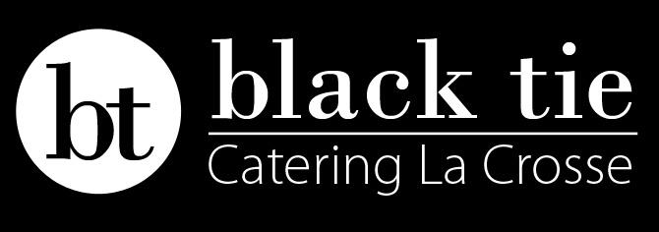
Entrees:
- Bourbon Glazed Roasted Ham
Basted bourbon, brown sugar glaze

- Spinach Stuffed Chicken
Garlic sautéed spinach, cream cheese

- Chicken Marsala
Chicken cutlets, mushroom, marsala wine sauce

- ¼ Barbeque Chicken
Homemade barbeque, grilled ¼ chicken

- Charcoal Grilled Chicken Mac n’ Cheese
Rooster’s grilled and BBQ basted chicken, creamy mac n’ cheese

- Applewood Smoked Pork Butts
Slow-roasted pork, Applewood smoke

- Apricot Roasted Pork Tenderloin
Apricot glaze, sherry, dried cranberry, caramelized onion

- Nonnie’s Meatballs
Ground sirloin, Italian herbed bread crumbs, Parmigiano-Reggiano cheese

- Beef Tenderloin Tips
Marinated, slow-roasted, mushroom, onion

- Tortellini Rosa with Chicken or Shrimp
Tortellini, creamy marinara rosa

- Butternut Squash Ravioli
Ravioli, sweet squash, brown butter, candy pecans

- Alfredo with Chicken or Shrimp
Creamy Alfredo, fettuccini noodle

- Salmon
Roasted salmon, honey Dijon, candied pecans

- Tilapia or Cod
White wine herbed butter sauce or honey Dijon

Starch Vegetable
Roasted Garlic Mashed Potatoes Campfire Beans
Baby Reds in Garlic Butter Fuji Apples
3 Cheese Baked Hash Browns Tropical Coleslaw
Pearl Pasta with shaved Grana Padana Candy Carrots
Vesuvia Potatoes with Florentine seasoning Parmesan Broccoli
Herbed Wild Rice Pilaf Green Beans Almandine
Black Tie Pasta Salad Sweet Corn
Cous Cous California Medley
- *Choice of two entrées includes 1 starch and 1 vegetable, spring mix salad bar, bread and coffee for $20.95.

Desserts-$4/serving
Tiramisu-creamy marscapone, espresso, baileys
Berries Crisp-seasonal berries, freshly baked oatmeal cookie
Triple Chocolate Brownie-need we say more?
Almond Poppyseed Cake-citrus glaze, whipped almond cream

Hors D’oeurves/Late Night Snacks-$3/serving:
- Traditional Bruschetta with fresh Mozzarella and Basil
- Fig and Bleu Cheese Bruschetta
- Cocktail Shrimp
- Crab Cakes with Mustard Mayonnaise
- Pineapple Salsa with Tortilla Chips
- Mini Quiche Lorraine
- Tropical Teriyaki Chicken Skewers
- Creamy Spinach and Artichoke Dip
- Hummus with sea salt pita chips
- Cold Cut Bar-turkey, ham, cheddar, fresh roll
- Chocolate Chip Cheeseball-graham cracker
- Fruit Platter with Cream Cheese Dip
- Vegetable Platter with Ranch Dip

