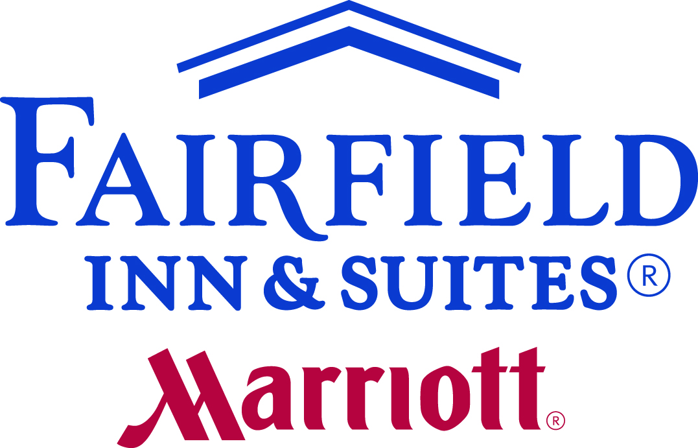
MILWAUKEE DOWNTOWN
Group Credit Card Letter of Authorization
710 N. Old World Third Street | Milwaukee WI 53203
Phone: 414.224.8400 | Fax: 414.224.8696 | Email: shalen.larsen@marriott.com

Today’s Date:

Group Name:
Group Arrival Date: ___________________________________________________________________________
Contact Name:
Phone Number: Cell Phone:
Email Address:

Credit Card Type:  Master Card  Visa  American Express  Discover
Credit Card Number:
Expiration Date: 3 Digit Security Code:
(Located on the back of the credit card)

Name on Credit Card:
Billing address for credit card:

Group Deposit (if required) $________

All event/function space that has been reserved will be secured with the above credit card.

Please select from the following for Sleeping Room charges:
❑ All charges to master bill
❑ Room & tax to master bill
❑ Room & tax & incidentals to master bill
❑ Incidentals paid by Guest (guests need to present a credit card upon arrival)
❑ All charges paid by Guest (guests need to present a credit card upon arrival)
❑ For Guarantee Only (guests need to present a credit card upon arrival)

Credit Card on file for all final bills for multiple events/functions:
❑ Please use this credit card for all final bills starting (date) through ending (date) .

On-site Contact Name: Cell Phone:
Is on-site contact authorized to add charges to this cc#?  yes  no  yes, up to $

Signature of Card Holder:

