Greetings,

We would love to host your special event, here at Three Brothers Winery, On 14 Acres, and always strive to create a welcoming and fun atmosphere.

We have pricing information below for you, for each area available to rent. Should you have any questions, please reach out to us and we will be happy to further explain and assist. Once you’ve decided on a rental option, we have a more in depth contract for you to protect all parties and ensure that the best time will be had by all!

Thank you for considering us for your event, we look forward to hosting you!

Thank you,

David & Charlotte Regan
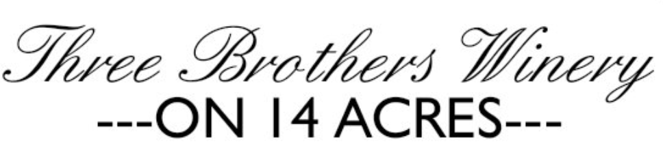

SPRING + SUMMER | EVENT PRICING & INFORMATION (April - September)
Barrel Room Rental
Business Hour Rate  11AM - 8PM Friday - Sunday | $300 Hour | $900 Day  ____ Hours ____ Day
Off Day Rate  9AM - 9PM Mon - Thursday | $200 Hour | $600 Day  ____ Hours ____ Day
Beverage Minimum  All days | $15pp  ____ People
Event Deposit | 25% of proposed cost
Pre-Ordered Menu Items | Optional
*20% gratuity added for all events | *Possible discounts for Sundays available

Full Facility Rental
Business Hour Rate  11AM - 8PM Friday - Sunday | $800 Hourly | $4000 Day  ____ Hours ____ Day
Off Day Rate  9AM - 9PM Mon - Thursday | $400 Hourly | $2500 Day  ____ Hours ____ Day
Beverage Minimum  All days | $15pp  ____ People
Event Deposit | 50% of proposed cost
Pre-Ordered Menu Items | Optional
*20% gratuity added for all events | *Possible discounts for Sundays available

Barn or Lawn Facility Rental
Business Hour Rate  11AM - 8PM Friday - Sunday | $600 Hourly | $3000 Day  ____ Hours ____ Day
Off Day Rate  9AM - 9PM Mon - Thursday | $300 Hourly | $1500 Day  ____ Hours ____ Day
Beverage Minimum  All days | $15pp  ____ People
Event Deposit | 25% of proposed cost
*20% gratuity added for all events | *Possible discounts for Sundays available | *Menu Not Available, catering is welcomed

ADDITIONAL INFORMATION

BEVERAGE BREAKDOWN:
Beverage Minimum of $15/guest (includes the purchase of wine or beer). The total amount can be spent through glass purchases or bottle purchases.
Beer may be ordered and paid for through Three Brothers in advance. All remaining beer at the end of an event is property of the client.
The following list is a sample of what may be available in the tasting room at the time of the event.
WINE PRICING SAMPLE Per Bottle
Pinot Gris $18
Riesling $19
Pinot Noir $25
Tempranillo $26
Syrah $27
Reserve Cabernet $40
Beer selection $6
We also welcome you to join our wine club! You will receive 15% off of all bottle sales and 25% off of case sales. Feel free to ask us more about this.

OUTSIDE VENDERS
We welcome outside vendors to be a part of your private event. All outside vendors are fully sell sufficient for set up, clean up and tear down. Three Brothers staff are not available as additional wait staff or set up/clean up crews. Three Brothers staff are responsible for running the facility, pouring drinks, maintaining glassware & dishes, preparing and serving any pre-ordered menu items. All additional needs will be through your vendors or organized with your personal team/event planner. Clients should provide contract/information for vendors who will be servicing your event.
*Please note these figures are an estimate and may vary depending on the specifications of your event.
Thank you for considering Three Brothers Winery for your event!

