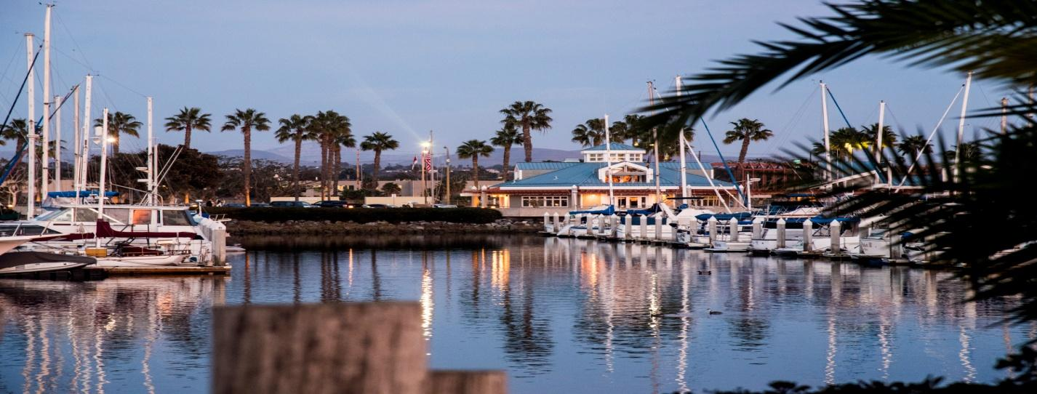

The La Rue C. Thomas Bayside Pavilion at
California Yacht Marina-Chula Vista
The Pavilion at California Yacht Marina –Chula Vista is South Bay’s premier event location.
Located on the South Bay waterfront, the Pavilion, with its idyllic ocean breezes and marina views, provides an ideal setting for wedding ceremonies, receptions, community functions, business meetings, birthday parties and family gatherings.
The spacious, recently remodeled facility seats approximately 150 people overlooking California Yacht Marina and serves up some of the best sunsets in San Diego County!
Capable of hosting events that are small intimate gatherings or large festive functions, The La Rue C. Thomas Bayside Pavilion provides fabulous ambience with ample, free parking steps away from the entrance to the facility.
The creative and committed Pavilion staff will assist you with every detail of your event to ensure its success.
So let us help you WOW your guests by planning your next event at The La Rue C. Thomas Bayside Pavilion at California Yacht Marina!
Contact our team today 619-534-3558 or email sochoa@cymchulavista.com for more details.
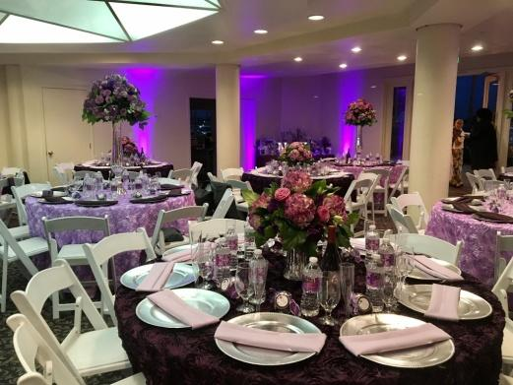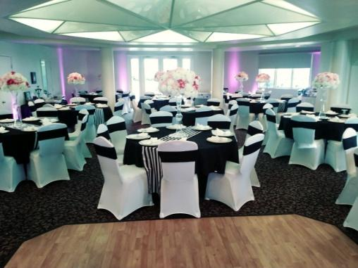
The Bayside Pavilion
Rate Structure 2018
Usage Rental Fee Deposit
Pavilion Downstairs

Monday – Thursday ` $900.00 $300.00

Friday $1,500.00 $400.00

Saturday $1,800.00 $500.00

Sunday $1,500.00 $400.00

Pavilion Upstairs

Monday – Thursday $350.00 $200.00

Friday* $650.00 $300.00

Saturday* $800.00 $300.00

Sunday * $650.00 $300.00

- Friday through Sunday available when booked no more than 60 days in advance.

Pavilion Combined/Entire Building

Monday – Thursday $1,100.00 $600.00

Friday $1,900.00 $600.00
Saturday $2,200.00 $600.00

Sunday $1,700.00 $600.00

Rates subject to change without prior notice.
Facilities: Sink, Refrigerator and Prep Counter Space
Rental Time: 10:00 a.m. - 12:00a.m.
The Pavilion Clean Up must be completed by 12:00 midnight the same day of the event unless other arrangements have been made with pavilion manager.
Parking: California Yacht Marina North Parking Lot
Event Insurance is required for all events and a copy of insurance policy must be provided to the Pavilion prior to the event.
Deposits: A deposit must be placed to “save the date” and a License Agreement signed. Deposits will be refunded if the event is cancelled within 7 days from the date of the License Agreement signing. After 7 days the deposit paid will be forfeited in the event of cancellation. Complete rental fee must be paid three (3) months in advance of the date.

Downstairs Rental includes:
- Room for 150 Guests comfortably.
- 1 – portable bar
- Catering kitchen with refrigerator, two sinks and counter
- 16 – 60” round tables, 6 - Belly Bars, 150 chairs
- 2 bathrooms
- Outside patio space
Upstairs Rental Includes:
- Room for 50 people comfortably
- 6 – 60” tables with 50 Chairs
- Built in Bar
- Wall Mounted TV
- Balcony
- Use of downstairs bathroom.

