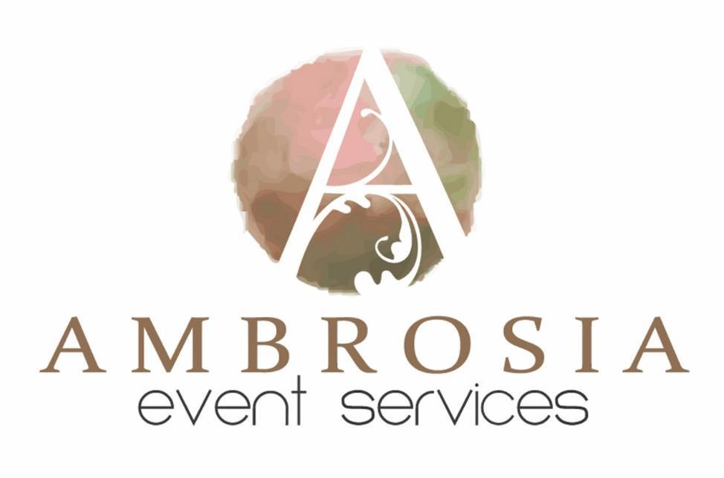
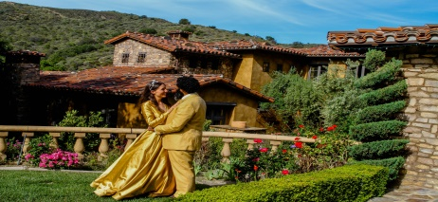
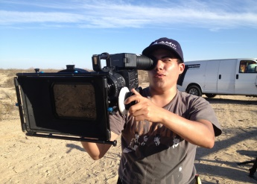
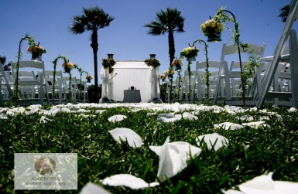
Through Eventective ONLY

SPECIAL BUNDLED SAVINGS OFFER
BY AMBROSIA
America's award-winning, single solution events concierge  service, offering over 20 in house services  in a single location!  • Photo booths  • Photography  • Videography  • Event  • Live Entertainment - DJ - Karaoke  • Travel & Limos - Shuttle - Party Bus  • Up Lighting & Catering Services  • Professional Hair & Make-Up Services  Services for Corporate and For ALL Special Occasion Events!  Services throughout California - Nevada - Oregon | HAIR AND MAKE UP DEAL  Bridal Hair and Make Up! Includes  full on location session and a  Complimentary Pretrial.  **PHOTOGRAPHY DEAL  2 Photographers –up to 8 hours of  Coverage – All the Digital images  on DVD’s fully Enhanced – Custom  Coffee table Book  VIDEOGRAPHER DEAL  Video Coverage up to 8 hours  including all raw footage and  custom edited video with a  YOUTUBE highlight presentation. If  you would like hourly rates we can  make them available upon request.  DJ/ MC DEAL  5 hour DJ service, 25,000 Song  Selection List, Dance Lighting  PHOTOBOOTH DEAL  Includes 3 hours, unlimited photos,  and your names and wedding date  will be added to each photo.  The above listed bundle retails for  $7800!  Today you can get all 5 Services for  one flat bundled fee of $3895.00!!
WEB SITE: WWW.EVENTSBYAMBROSIA.COM | A $500 retainer reserves all 5  services  **Add Engagement Session for  $225.00 a $475 value

–
• Valet - Bar Services - Decor - Invitations
3780 K

ilr

Save time, add convenience, and peace of mind while
insuring you'll receive upscale event services with the highest
quality services available. Below are just some of the services
that we specialize in:

• While our services speak volumes for
themselves, some of our best
recommendations come from our past
customers on our Yelp 5 Star Rating!

Event

oy Airport Way Suite 200

LONG BEACH, CA. 90806

LOCAL CALLS: 562-572-8784
562-256-7093

