S P R B A N Q U E T / P A R T Y H A L L
5945 Dallas parkway, Suite 200
Plano, TX 75093
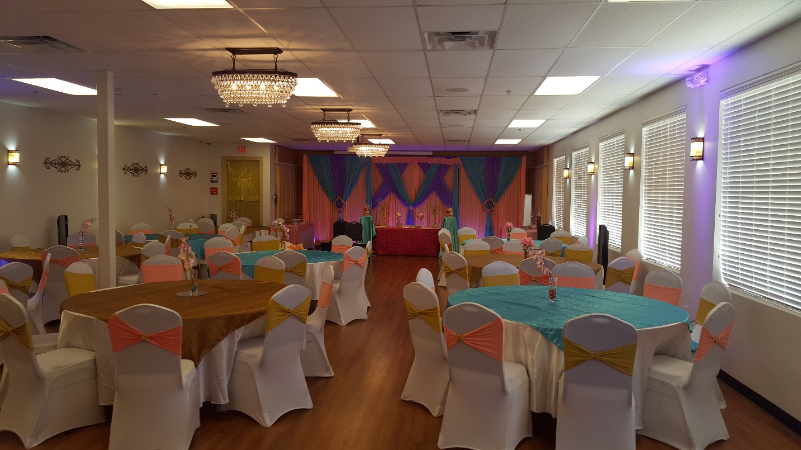
Party / Banquet / seminar facility located on Toll road. Easy access from George Bush turnpike (Hwy 190) and Sam Rayburn Tollway (Hwy 121)
Capacity: 100 people
Total Sq. Ft: 2,200
You can bring your own liquor and catered food. Electric food warmer for your catered food is available.
We provide 10 round tables, 10 chairs per table (72 inches circumference), up lights, and access to our Audio/Video system. 3 wireless microphones and 6 additional long rectangular tables (72 inches X 29 Inches)
State of the art “Audio / Video” facility, Kitchen with tall hot box (electric food warmer) and Refrigerator, Store room, Men and ladies’ bathroom, Outside Patio facility.
Projector with 100-inch screen, 10 speakers’ discreetly hidden in the ceiling, Chandeliers, wall light sconces, up lights for decor. Cable TV, DVD player, Apple play for your iPhone to access YouTube. HDMI connection for your laptop to access Audio/Video.
Outstanding location in the heart of West Plano. Ideal for birthday parties, Watching Sporting Events, Bar & Bat Mitzvah, Mehndi Parties, Small weddings, IT training, Company Seminars etc.

Pricing:
We have 2 timeslots every day. Morning (10:00 am to 4:00 pm) & Evening (6:30 pm to 12:00 am)

- Total payments for Morning timeslot: $700 plus $400 deposit ($400 deposit is refundable)

- Total payments for evening timeslot: $900 plus $400 deposit ($400 deposit is refundable)

- Entire day – (10:00 am to 12:00 am): $1200 plus $400 deposit ($400 deposit is refundable)

Please email us to book the Hall – spr@nsiamerica.com

Use PayPal to remit payments. PayPal Id is spr@nsiamerica.com

