BOUNCEHOUSES
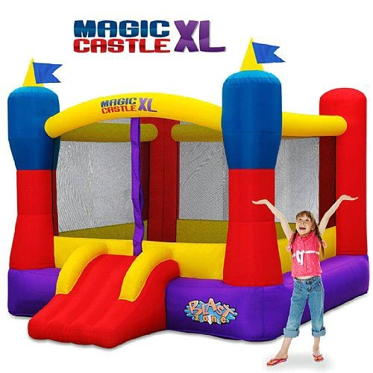
-Mid-sized bounce house with huge bounce for the buck
-Small enough for indoor play, big enough for a party
-Inflates in less than 2 minutes
-Hours of jumping fun for up to 5 kids at a time
-With a 10x13x8.6 bounce area, it can keep multiple kids happily jumping with a slightly smaller footprint.
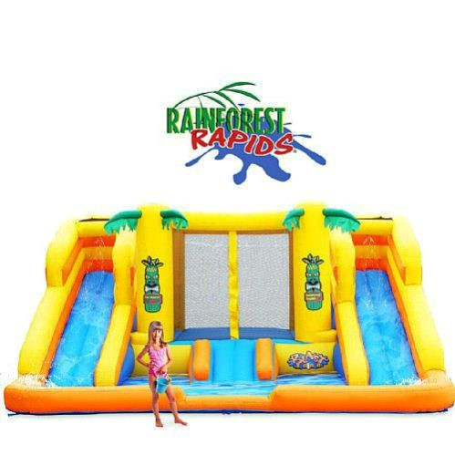
-Wet or dry jungle party jumper for year round fun
-Many activities in 1 giant play area
-Hours of jumping fun for up to 6 kids at a time
-Up and running fast, inflates in less than 2 minutes
-The Rainforest Rapids is your all in one 16x15x8 amusement park. This ultimate combo jumper combines the Zulu jumper (8x8 bounce area) with 2 mega slides and the Tiki Lagoon.
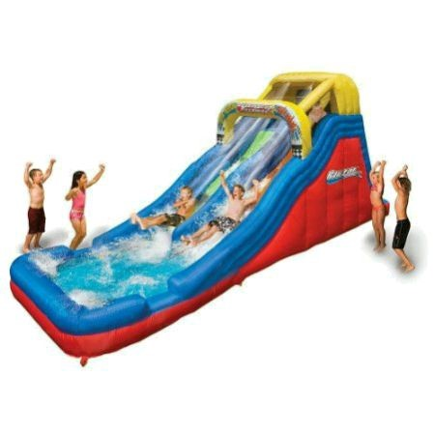
- Drop Raceway Wet or Dry with 2 Mega Waterslides
- 255in x 72in x 120in
- 2 Persons Can Slide at One Time, With Climb Up From Back
-Up and running fast, inflates in less than 2 minutes
-Hours of back yard fun
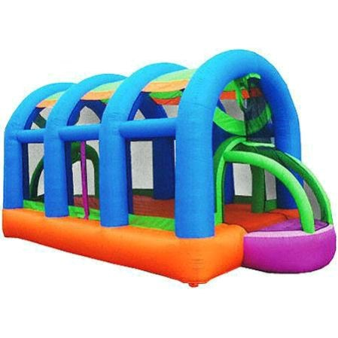
-Give your child a jumping good time with the KidWise Arc Arena II Sports Bouncer.
-This unique activity-based bouncer has plenty of room inside to bounce around and play.
-It features an open goal at each end that can be used for soccer.
-The hoops above each goal are perfect for a little game of basketball.
-This inflatable bouncer has storage nets at the back of hoops to catch the balls and hold them, until you release them back into the unit.
-It has a maximum weight capacity of 300 lbs and allows four children to play at the same time.
-Kids' bouncer assembled dimensions: 20'L x 10'W x 10'H
