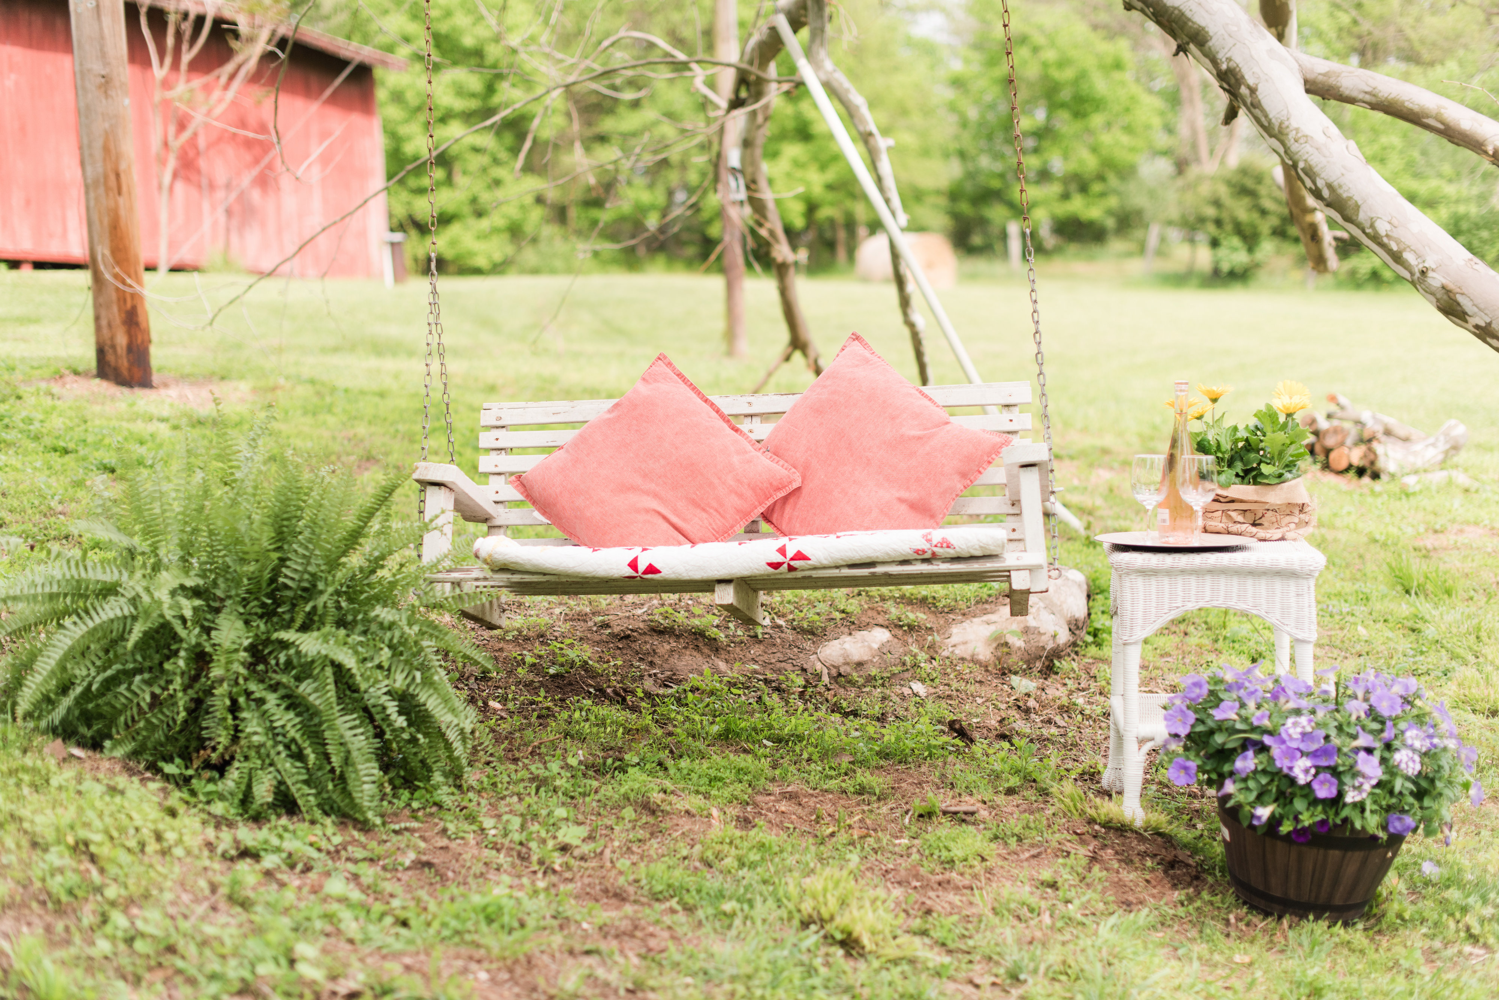
WINDING CREEK FARM WEDDINGS

Beautiful 20 acre farm with stunning creek views

Historic 118 year old bank barn ~ two level barn fully restored with
stunning chandelier, restrooms, and catering workspace

Use of the property from noon on Thursday until 10am on Monday.

Professional Event Planner included for 30 days out planning &
day-of coordination

Day-of Farmhouse access with Bridal Suite, Hair & Makeup room,
and large full bathroom

Choice of multiple ceremony sites

Tables and chairs included for 150 guests

Vintage furnishings, antiques, wine barrels, wood directional signage,
chalk boards, vintage bar, and a variety of antique props

Large firepit area for use during event

Golf cart for accessibility access

Total Cost for your special weekend at Winding Creek Farm ~ $7,000

