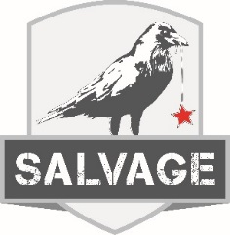

$46.00 per guest. Excludes tax & gratuity. Includes Non- Alcoholic Beverage of Choice
Salad
Wedge Salad

Entrees

8oz Filet Mignon
Filet Mignon / Baked Potato / Seasonal Vegetables

12oz Slow Roasted Prime Rib
Prime Rib / Baked Potato / Seasonal Vegetables

Chicken Linguine Primavera
Linguine / Artichoke Hearts / Sun-Dried Tomatoes /
Zucchini / Yellow Squash / Carrots / White Wine
Butter Garlic Sauce / Grilled Chicken Breast

Grilled Scottish Salmon
Salmon Filet / Wild Rice Pilaf / Seasonal Vegetables

Béarnaise Chicken
Grilled Chicken Breast / Asparagus / Béarnaise
Sauce / Wild Rice Pilaf / Seasonal Vegetables

Dessert
Bread Pudding

