Thank you for considering The Renwick Mansion for your event. We are excited to work with you to make your experience as stress free, fun, and memorable as possible. Please use this information as a guide while you plan your event. We encourage you to contact us with any other questions that come up along the way!
_______________________________________________________________________________

Amenities
- Social Rooms
- There are three grand reception rooms, library/parlor, marble foyer, and spacious kitchen which can accommodate 130 guests indoors at dinner tables
- Bedrooms/Upstairs Areas
- There are 8 furnished bedrooms for rent: six with a queen bed, two with two twin
beds, and three of the bedrooms have balconies
- On the second floor there is a large hall with a couple of sitting areas, and six of the bedrooms
- On the third floor there is an additional full kitchen, along with a spacious room commonly used as the bridal-quarters, a sitting area, and two of the bedrooms
- The Tower
  - Enjoy the beautiful view overlooking much of Davenport and the Mississippi River
  - Featuring a beautiful chandelier and a continuous balcony which can be accessed for photos
- Outdoor Space
o The large outdoor area can be tented and accommodates up to 300 guests
  - The south lawn deck and grand porte-cochere in front of the entrance of the mansion are commonly used for outdoor marriage ceremonies
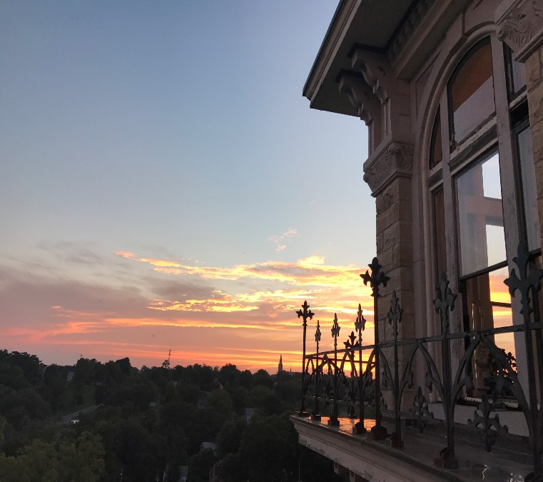
  - A large second story deck atop the porte-cochere overlooks the 4 acres of land as well as much of Davenport, including the Mississippi River
  - Three of the bedrooms have accessible balconies
- Tables and Chairs
o A variety of rectangular and round
tables are available to seat 170 guests
- Chairs to seat 130 guests with a gold frame and ivory seat/back cushions

Pricing
Security Deposit for event: $250 Saves your rental date, is paid towards the rental fee, and
is non-refundable in the 90 days prior to the event
Damage Deposit: $200 Added to the cost of the rental and is refunded as long as the building is clean, with no damages, and the contract has been met
Whole Day: 8 a.m.-Midnight
Friday: $900
Saturday: $1000
Sunday: $700

Packages
Friday and Saturday without bedrooms (8 a.m. to midnight each day): $1700
Saturday and Sunday without bedrooms (8 a.m. to midnight each day): $1500
Friday, Saturday and Sunday without bedrooms (8 a.m. to midnight each day): $2000
Friday and Saturday with all 8 room rentals (Fri. 8 a.m. to Sun. 11:00 a.m.): $2600
Saturday and Sunday with all 8 room rentals (Sat. 8 a.m. to Sun. 11 a.m.): $2400
Friday, Saturday, Sunday with all 8 rooms (Fri. 8 a.m. to Mon. 11:00 a.m.): $3000

Weeknight rentals (Monday-Thursday)
- hours: $180
Whole Day (8 a.m. to midnight): $500, and includes the option to rent bedrooms

Overnight Room Rentals- Must be with the Whole day building rental
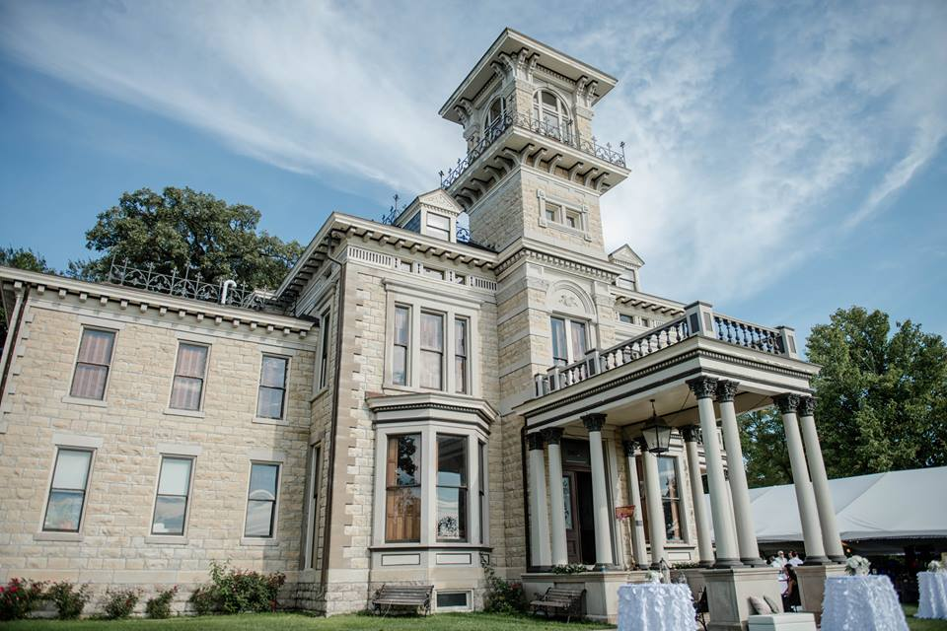
1-3 bedrooms: $80 each per night
4-8 bedrooms: $70 each per night
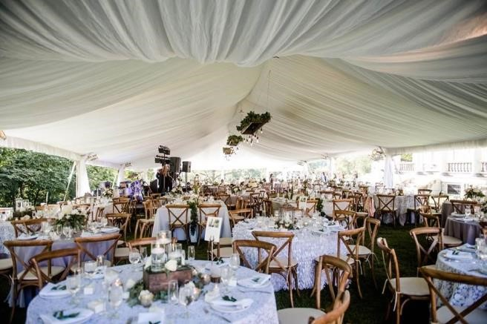
Bar
The Renwick Mansion staff is required to serve all alcohol per the law and our liquor licensing. An Alcohol Order Form is sent to the contract holder 90 days prior to the event so that we know what to order and how to manage to bar:
- Open Bar – The bartenders keep a tab of all of the drinks ordered by guests for the contract holder to pay for at the end of their event
- Cash Bar – Guests purchase their own drinks
- Ordering – You can order a certain amount of alcohol to offer your guests (i.e: 2 kegs and 20 bottles of wine) and there’s a cash bar for guests who want other drinks or for when the ordered supply runs out
- Cap on Total – You can pay for drinks up to a certain amount of money, which the bartenders keep a tab for, and once that money has been used it becomes a cash bar.
- Tickets – Some couples will give their guests tickets to use toward drinks that are pre-paid for by the contract holder
- Special Requests – This section on the form allows you to suggest any alcohol that you’d like us to have stocked for your event (i.e: my family drinks a lot of Miller Lite, please have 3 cases on hand), and if you’d like to offer a “specialty cocktail” for your wedding we can work with you on that
- Indoor or Outdoor Bar – We can have the bar outdoors, vs. indoors, and we can move the bar indoors if you’d like us to at a specific time (outdoor bar is limited but you can make special requests). This request can also be made on the Alcohol Order Form

Cash Bar
With whole day rental and 50+ guests - Free upon request
With whole day rental and less than 50 guests - $50
With weekday 4 hour rental- $50

Drink prices
Soda: $1.00
Beer: $3.50
Mixed Drinks: $4.50
Glass of wine: $4.50
Bottle of wine/champagne: Varies by brand, commonly $15/bottle
Keg of Beer (domestic): $225.00

Frequently Asked Questions
Can the site be used for both the wedding and reception?
-Yes, you’re welcome to use the space how you would like in the time you’ve rented it for.

Can you bring your own food or use your own caterer?
-Yes, there is no in-house caterer, so you can hire a caterer or bring in food.

Are tents, dance floors, table linens, or chair covers available?
-Not at this time, but they can be rented and used on the property.

Are there restrictions on music?
-Outdoors: Davenport City Ordinance states that music and load noise should not go later than 10:30 p.m. However, music can be moved inside.
-Indoors: Music has to be shut down by 1:30.

Are there restrictions on alcohol?
-For events, the law requires Renwick staff to serve all alcohol. We will open the bar and/or serve any other drinks (like champagne toasts) upon request. No outside alcohol is permitted on the premises.

Is there a piano or other musical instruments on site?
-There is a baby grand piano.

Are there regulations on photography?
-No

Are there rooms available for the bride, groom and attendants to change into wedding attire?
-Yes, there is a large bridal suite located on the third floor, and there are 8 furnished bedrooms available to rent.

Is the cash bar to be inside or outside?
-Either one, this question is included on the Alcohol Order Form that we send 90 days prior to events.

Are there lights outside?
-There are several lamp posts bordering the yard and drive.
-Each entry has an outdoor light fixture.

Are there heaters?
-No but there are plenty of electrical outlets outside to power lights, heaters, sound, etc.

