Pharmaceutical Dinner

First Course "Family Style"
(
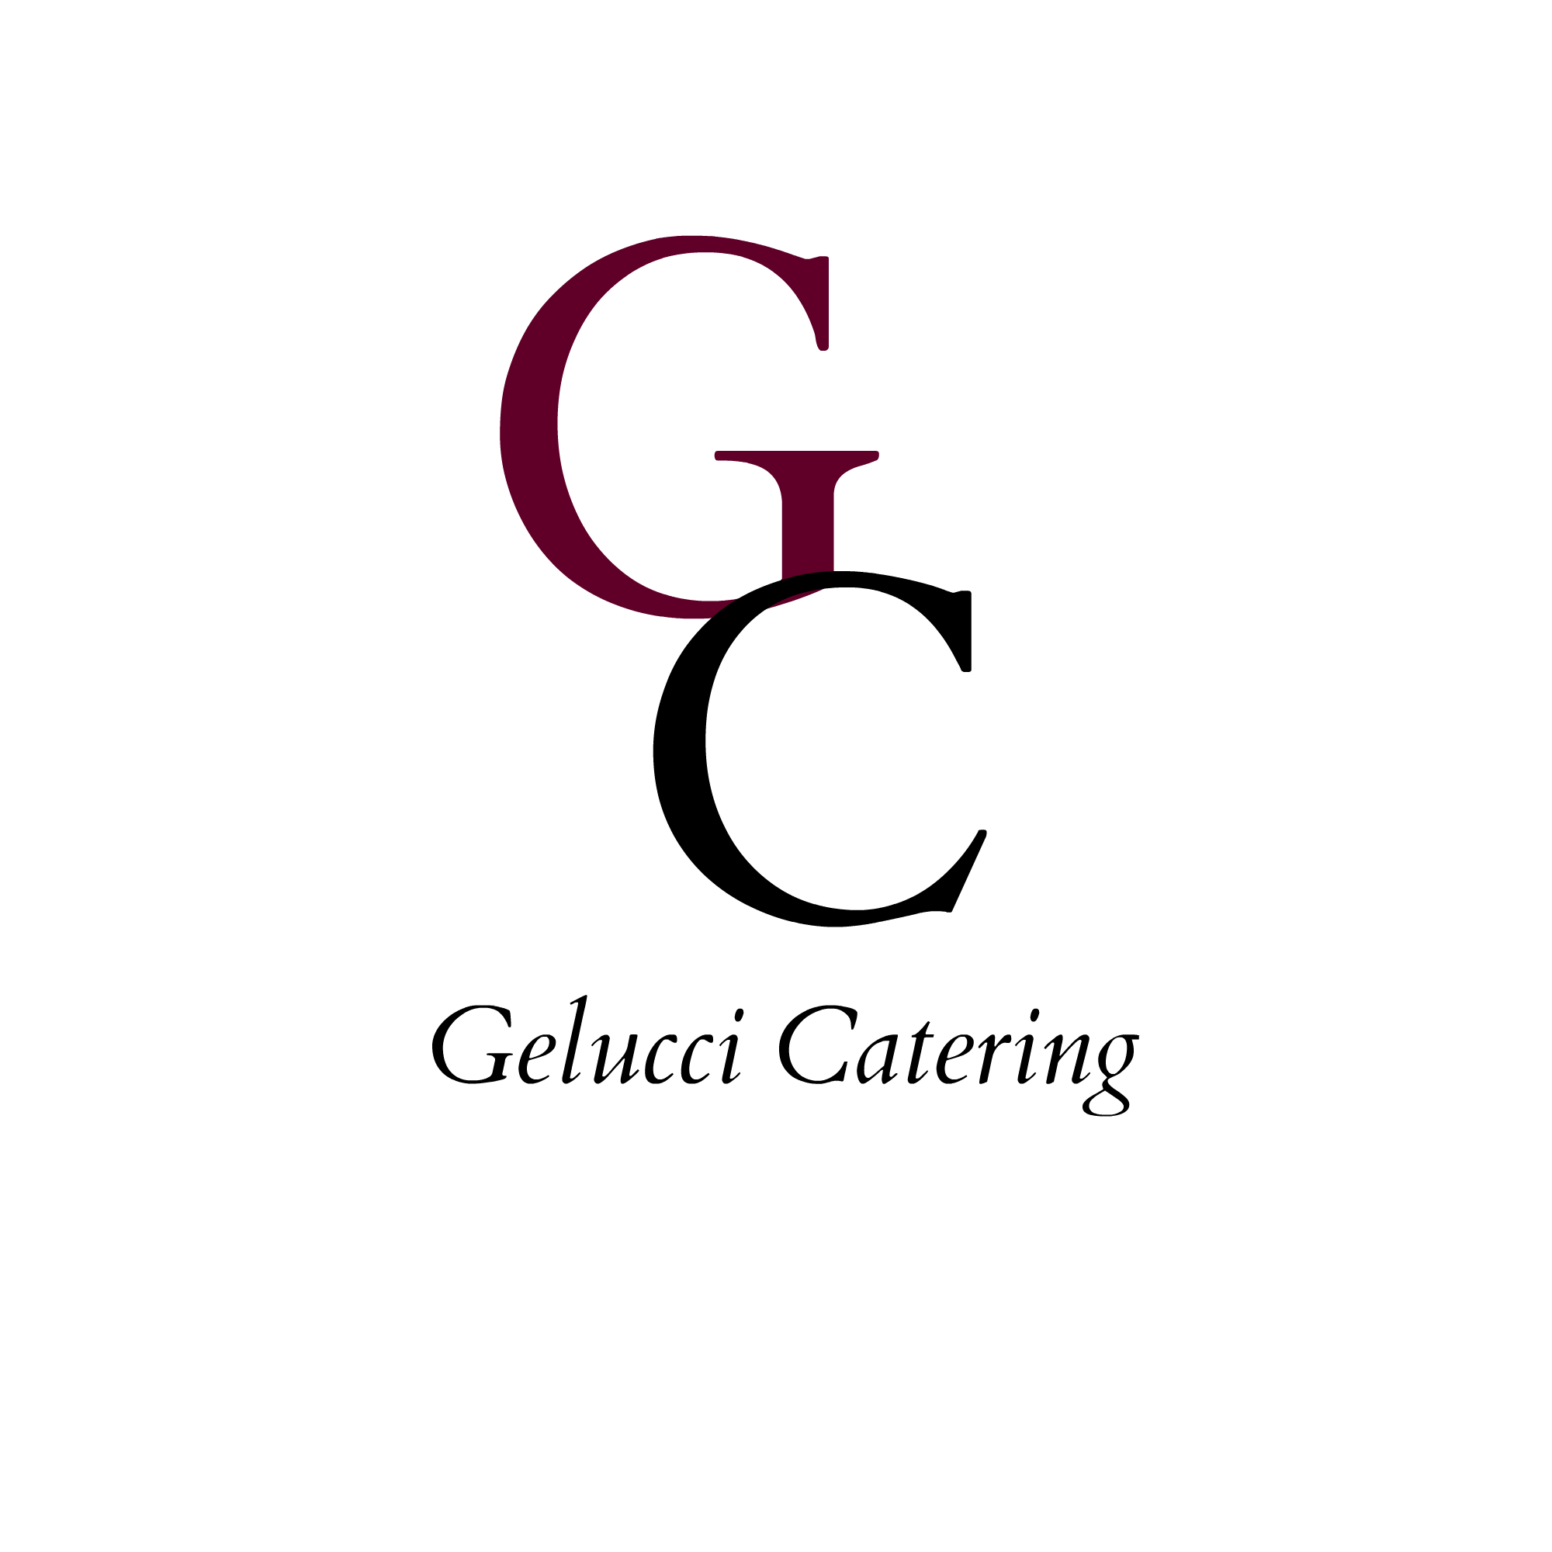
Fried Calamari
Mozzarella and Tomatoes

Second Course
Host Choice of:

House Salad
Caesar Salad

Entree Course

12 oz NY Strip
Filet Mignon
Free Range Chicken
Wild Salmon
Seafood Fra Diavolo
With scallops, mussels, clams, shrimp, spicy marinara sauce.

Dessert Course
Served family style
N. Y. Style Cheesecake, Chocolate Cake Bread Pudding
Seasonal Fruit Platters

$125 per person
includes, , 2 glasses of beer or wine per person, tax and gratuity

